The Longitudinal System Analysis

2018 HMIS Programming Specifications



Version 1.22 ● October 2018

Table of Contents

1. Introduction 2

1.1. Background: Annual Homeless Assessment Report (AHAR) and the Longitudinal System Analysis 2

1.2. LSA Upload for CoCs 2

1.3. 2018 AHAR Redesign: Transition to LSA 3

1.4. LSA CSV Submission Format 3

1.5. About This Document 4

1.6. Definitions/Acronyms 6

2. HMIS Data Universe 9

2.1. Report Parameters 9

2.2. HMIS Data Elements 9

2.3. Cohorts 12

3. HDX 2.0 Upload 14

3.1. LSAReport.csv 14

3.2. LSAHousehold.csv 14

3.3. LSAPerson.csv 15

3.4. LSAExit.csv 15

3.5. LSACalculated.csv 15

4. HMIS Business Logic 16

4.1. Get Report Parameters for LSAReport 16

4.2. Get Relevant Project Records for Export / lsa_Project 17

4.3. Get Organization.csv Records / lsa_Organization 19

4.4. Get Funder.csv Records / lsa_Funder 19

4.5. Get Inventory.csv Records / lsa_Inventory 21

4.6. Get Geography.csv Records / lsa_Geography 22

4.7. Get Active HouseholdIDs 23

4.8. Get Active Enrollments and Associated AgeDate 25

4.9. Set Age Group for Each Active Enrollment 26

4.10. Set Household Type for Active HouseholdIDs 27

4.11. Get Active Clients for LSAPerson 28

4.12. Set Demographic Values for LSAPerson 29

4.13. Get Chronic Homelessness Date Range for Each Head of Household/Adult 32

4.14. Get Enrollments Relevant to Chronic Homelessness 32

4.15. Get Dates to Exclude from Counts of ES/SH/Street Days 33

4.16. Get Dates to Include in Counts of ES/SH/Street Days 34

4.17. Get ES/SH/Street Episodes 36

4.18. Set Initial LSAPerson CHTime and CHTimeStatus 37

4.19. Update LSAPerson CHTime and CHTimeStatus 37

4.20. Set LSAPerson Project Group and Household Type Identifiers 38

4.21. Set LSAPerson Head of Household Identifiers 39

4.22. Set Population Identifiers for Active HMIS Households 40

4.23. Set Population Identifiers for LSAPerson from Active Households 42

4.24. Get Distinct Households for LSAHousehold 43

4.25. Set Population Identifiers for LSAHousehold 45

4.26. Set LSAHousehold Project Group Status Indicators 47

4.27. Set RRH and PSH Move-In Status Indicators 47

4.28. Set LSAHousehold Demographics 48

4.29. System Engagement Status and Return Time 50

4.30. Get Dates In RRH Pre-Move-In 52

4.31. Get Dates Housed in PSH or RRH 52

4.32. Get Enrollments Relevant to Last Inactive Date and Other System Use Days 54

4.33. Get Last Inactive Date 56

4.34. Get Dates of Other System Use 57

4.35. Get Other Dates Homeless from 3.917 Living Situation 58

4.36. Set System Use Days for LSAHousehold 59

4.37. Update ESTStatus and RRHStatus 60

4.38. Set SystemPath for LSAHousehold 61

4.39. Get Exit Cohort Dates 61

4.40. Get Exit Cohort Members 62

4.41. Get EnrollmentIDs for Exit Cohort Households 66

4.42. Set *ExitFrom* and *ExitTo* for Exit Cohort Households 67

4.43. Set ReturnTime for Exit Cohort Households 68

4.44. Set Population Identifiers for Exit Cohort Households 69

4.45. Set Stat for Exit Cohort Households 71

4.46. Set SystemPath for Exit Cohort Households 72

4.47. LSACalculated Population Identifiers – People by Household Characteristics 73

4.48. LSACalculated Population Identifiers – Households 74

4.49. LSACalculated Population Identifiers – People by Personal Characteristics 77

4.50. Get Average Days for Length of Time Homeless 80

4.51. Get Average Days for Length of Time Homeless by System Path 83

4.52. Get Average Days for Cumulative Length of Time Housed in PSH 84

4.53. Get Average Days for Length of Time in RRH Projects 85

4.54. Get Average Days for Days to Return/Re-engage by Last Project Type 86

4.55. Get Average Days for Days to Return/Re-engage by Population 87

4.56. Get Average Days for Days to Return/Re-engage by System Path 92

4.57. Get Average Days for Days to Return/Re-engage by Exit Destination 93

4.58. Get Dates for LSACalculated Counts by Project ID and Project Type 94

4.59. Get Counts of People by Project and Household Characteristics 95

4.60. Get Counts of People by Project Type and Household Characteristics 97

4.61. Get Counts of Households by Project 99

4.62. Get Counts of Households by Project Type 101

4.63. Get Counts of People by Project and Personal Characteristics 103

4.64. Get Counts of People by Project Type and Personal Characteristics 104

4.65. Get Counts of Bednights by ProjectID and Household Characteristics 109

4.66. Get Counts of Bednights by Project Type and Household Characteristics 110

4.67. Get Counts of Bednights by ProjectID and Personal Characteristics 111

4.68. Get Counts of Bednights by Project Type and Personal Characteristics 112

4.69. Set LSAReport Data Quality Values for Report Period 113

4.70. Get Relevant Enrollments for Three Year Data Quality Checks 118

4.71. Set LSAReport Data Quality Values for Three Year Period 119

4.72. Set LSAReport ReportDate 123

4.73. Select Data for Export to LSA CSV Files 123

Appendix A. Data Quality Summary Output 129

Appendix B. HDX 2.0 Table Shells for Report Output 131

Project Group Demographics 131

System Use 139

Returns and Re-Engagement 147

APPENDIX C: Summary Matrix of LSA Report Output 152

Demographics 152

Length of Time Homeless 152

Housing Outcomes and Other System Use 157

Returns 161

APPENDIX D: Significant Differences in LSA and System Performance Measures Reporting Logic 163

**Version History**

| Version | Date | Revisions |
| --- | --- | --- |
| v1.1 | 7/9/2018 | * Throughout: Formatting changes to improve readability by assistive technology   With thanks to the vendors who submitted questions and other feedback:   * Section 1.6: Clarification of definition for *Population* * Section 4.14: Correction to specify that previous enrollments must have been located in ReportCoC at some point to be relevant in chronic homelessness determination (was *EnrollmentCoC* <> ReportCoC – corrected to *EnrollmentCoC* = ReportCoC) * Section 4.25: Correct category descriptions for **HHChild** and **HHNoDOB**, which erroneously referenced adults * Section 4.32: Rename section *Get Enrollments Relevant to Last Inactive Date and Other System Use Days* (was *Get Enrollments Prior to Report Period Relevant to Other System Use Days*); based on questions received, add clarification/explanation of associated logic * Section 4.33: Corrections/clarifications to description of business logic * Section 4.35-36: Include counts of days homeless prior to 10/1/2012 documented in data element *3.917 Living Situation* in **Other3917Days**; based on questions received, add clarification/explanation of associated logic * Section 4.40: Include modified logic for identifying exit cohort members for systems that do not enforce system logic requirements for *3.15 Relationship to Head of Household* * Section 4.66: Specify hmis_Client as source for **VetStatus1** DQ check. * Appendix B – System Engagement Status: Strike references to street outreach (SO) projects in description of HDX 2.0 report output |
| V1.2 | 9/20/2018 | * Section 4.2: Project.*OperatingEndDate* must be NULL or >= ReportStart (‘equal to’ was previously included in the Logic section but omitted from the Relevant Data table) * Section 4.4: Funder.*EndDate* must be NULL or >= ReportStart (‘equal to’ was previously included in the Logic section but omitted from the Relevant Data table) * Section 4.5: Inventory.*InventoryEndDate* must be NULL or greater than or equal to ReportStart (‘equal to’ was previously included in the Logic section but omitted in the Relevant Data table); corrected field names for inventory start and end dates in the Logic section * Section 4.12: Enrollments relevant to CH must have an *ExitDate* > **CHStart** (not >= **CHStart**) * Section 4.22: Clarify criteria for setting **HHAdultAge** for active *HouseholdID*s * Section 4.24: Clarify logic associated with **HHAdultAge** for tmp_Household (and LSAHousehold) * Section 4.29: Add 730 to upload values for **ReturnTime** |
| V1.21 | 9/28/2018 | * Section 4.32: tmp_Household.**Stat** was corrected from “<>5” to “= 5” |
| V1.22 | 10/5/2018 | * Section 4.9: Add note regarding handling of invalid data in the LSA * Section 4.22 and Section 4.25: Correct setting population identifier “not applicable” responses HHVet, for HHChronic, HHDisability, and HHFleeingDV * Section 4.46 Clarify requirements for identifying relevant Systen Path enrollments |

# Introduction

## Background: Annual Homeless Assessment Report (AHAR) and the Longitudinal System Analysis

Every year, the U.S. Department of Housing and Urban Development (HUD) submits an Annual Homeless Assessment Report (AHAR) to the United States Congress. The AHAR is a national-level report that provides information about homeless service providers, people and households experiencing homelessness, and various characteristics of that population. It informs strategic planning for federal, state, and local initiatives designed to prevent and end homelessness.

Nationwide, HUD has tasked Continuums of Care (CoCs) with coordinating homeless services in specific geographic areas. HUD bases the AHAR on data provided by these CoCs in the form of three separate aggregate data submissions. US Census and other data are used for contextual analysis.

HUD’s *Notice for Housing Inventory Count (HIC) and Point-in-Time (PIT) Data Collection for Continuum of Care (CoC) Program and the Emergency Solutions Grants (ESG) Program* defines the requirements for the first two components of continuum-level data used in the AHAR:

* **Housing Inventory Counts** (HIC) are data related to the capacity and utilization of residential projects dedicated to serving people experiencing homelessness; and
* **Point-in-Time Counts** (PIT) provide counts of sheltered and unsheltered people who are experiencing homelessness on a single night, usually in the last 10 days of January.

The third component of data provided by CoCs is community-level information focused on people and households served by continuum projects over the course of the year. Formerly also referred to as “the AHAR,” the scope of this annual report is expanding significantly beginning with fiscal year 2018. The name will be changed to Longitudinal System Analysis (LSA) to reflect the fact that this expanded scope will allow CoCs to use this community-level information for a range of purposes beyond just submitting data for the AHAR to Congress. **The specifications for the LSA upload file are defined in this document.**

For those served during the fiscal year, the LSA includes:

* Demographic characteristics like age, race, gender, and veteran status;
* Length of time homeless and patterns of system use;
* Information specific to populations whose needs and/or eligibility for services may differ from the broader homeless population, such as veterans, people and households experiencing chronic homelessness, and others; and
* Housing outcomes for those who exit the homeless services system.

The LSA, along with information for the cohort served during the report period, includes additional data about households and populations who exited the system in three discrete periods – the cohort that exited two years prior to the report period, the cohort that exited one year prior to the report period, and the cohort that exited in the first six months of the report period. The LSA provides information about patterns of system use prior to exit, destination types, and, for those who were served again later by continuum projects, lengths of time between exit and re-engagement or returns to homelessness.

## LSA Upload for CoCs

CoCs collect information about continuum homeless providers and the adults and children that they serve in community-based Homeless Management Information System (HMIS) database applications. Annually, the CoCs use the HMIS to produce the aggregate LSA upload file and submit them to HUD via the new Homelessness Data Exchange 2.0 (HDX 2.0), a HUD website.

Beginning with reporting on FY2018, the output requirements for HMIS applications are for the generation of aggregate data in CSV (comma-separated values) files, which CoCs will upload to the HDX 2.0. The HDX 2.0, in turn, will produce tables for display and download for community users and HUD researchers.

## 2018 AHAR Redesign: Transition to LSA

Although HUD has made refinements and additions, the AHAR changed very little in structure or scope for more than a decade. The LSA upload file defined in this document, which will go into effect with reporting on FY2018, is the result of a long process of planning by HUD and a team of researchers.

The LSA shares some broad similarities to the previous AHAR submission, but – especially from a technical standpoint – the LSA is new. It is based on different business logic, incorporates a much wider array of topics, includes more clients, and extends the timeframe of the data beyond a single year.

Even the demographic information included for clients served during the report period has undergone fundamental changes:

* Expanded from three project types (ES, TH, PSH) to **five project types (ES, SH, TH, RRH, PSH)** in three project groups: ES/SH/TH (combined), RRH, and PSH.
* Replaced FAM and IND household types to align with other HUD reporting: households of adults only (**AO**), households with at least one adult and one child (**AC**), households of children only (**CO**), and households of unknown type (**UN**).
* Shifted from focusing on all clients to **adults and heads of household** – age is the only demographic reported for non-heads of household under 18.
* Implemented new elements of reporting, including chronic homelessness, domestic violence, and project geography.

This document fully details these and the rest of the new specifications and report output.

## LSA CSV Submission Format

Additional data points, more household/population types, and four separate cohorts mean that the 2018 LSA upload includes several times as many tables as in the past – and several of the new tables are complex by comparison. Of the 187 tables in the 2017 AHAR submission, the largest had 45 fields. The entire submission was fewer than 2,500 fields.

As an example, one of the new analysis tables, *Time to Return by System Path*, is generated for:

|  |  |
| --- | --- |
| 8 | household/population types, and separately for |
| * 3 | permanent, temporary & unknown destination types and |
| * 3 | different cohorts. This results in the output of |
| = 72 | report tables. The table shell is made up of |
| * 143 | cells, so the total output for this one new table shell is |
| = 10,296 | cells – more than four times the number in the entire 2017 AHAR submission. |

The sheer volume of data in the LSA presents a variety of challenges.

Manual data entry of thousands of values in hundreds of tables – even if it were humane – would involve a high likelihood of data entry errors. After more than a decade of experience with AHAR submissions, the process of ‘cleaning’ and verifying data still takes a team of reviewers working with communities over a period of months. It’s not feasible to apply the same process to the much larger LSA.

Uploading standard tables in CSV format eliminates data entry errors, but programming the output of thousands of fields repeated in hundreds of tables with minor differences – even if the underlying business logic were simple – presents similar issues of burden and makes potential errors difficult to identify and fix.

Instead, the LSA submission process will require the upload of:

* Five “tables” of aggregate report data – counts of people and households grouped by combinations of values in every table column – in LSA CSV files which must be produced by an HMIS application; and
* Five “tables” of HMIS project descriptor data for relevant projects exported in the existing standard HMIS CSV 6.11 format.

The HDX 2.0 will use the counts in these files to produce readable display tables for HUD researchers and community users. Data will be viewable but not editable in HDX 2.0.

Detailed descriptions of the five LSA CSV files and parameters for export of project descriptor data are in Section 3.

## About This Document

### Intended Audience

This document is intended for software and database developers who produce HMIS reporting and are familiar with relational database concepts, Structured Query Language (SQL), as well as other HMIS technical documentation, particularly the HMIS Data Dictionary and the HMIS CSV Format v6.11. The document may also be useful to expert-level HMIS system administrators interested in further understanding LSA logic, how HDX 2.0 will use uploaded data to produce report output, or in using the LSA files exported from HMIS to develop custom local reports.

### Purpose and Scope

The primary purpose of this document is to define the business logic and programming specifications associated with:

* Selection of project descriptor data for export
* Identification of client cohorts, household types, and special populations included in the LSA based on HMIS data
* Grouping clients and households into reporting categories
* Producing and populating LSA CSV files
* Validating LSA CSV files

Descriptions of the type of output which will be produced by HDX 2.0 based on uploaded LSA CSV files are also included in Appendix B. The HDX 2.0 will produce this output for display and/or download to continuum users -- **there is no requirement that HMIS applications produce this output**; the information is provided as a reference.

### Structure and Content

**Section 1: Introduction** (this section) outlines general concepts related to the LSA and this document.

**Section 2:** **LSA HMIS Data Universe** describes the parameters of the LSA upload, the data elements that are referenced in the business logic, and the four cohorts of clients that are included in the analysis.

**Section 3: LSA CSV Upload Files** describes each of the CSV files that are included in the upload. There are five CSV files specific to the LSA:

* LSAReport.csv
* LSAHousehold.csv
* LSAPerson.csv
* LSAExit.csv
* LSACalculated.csv

The LSA upload also includes five CSV files of Project Descriptor Data Elements (PDDEs) defined in the HMIS CSV Specifications v6.11:

* Organization.csv
* Project.csv
* Funder.csv
* Inventory.csv
* Geography.csv

**Section 4: HMIS Business Logic** provides an order of operations for the production of the columns in the CSV files and detailed business logic for each step of the process.

**Appendix A** provides a summary of the output of the data quality information required for inclusion in the LSAReport.csv file. Note that data quality is assessed systemwide at a much broader level than actual LSA reporting. For example, the data quality columns look at race, ethnicity, etc. for children who are not heads of household. This is done to get a sense of systemwide data quality and we anticipate the release of separate specifications for HMIS output based on this logic.

**Appendix** **B** provides a selection of **LSA Table Shells** that can be generated by the HDX 2.0 and the source file(s) and column(s) used to populate each one.

**Appendix C** is a **Summary Matrix of LSA Report Output**, which identifies the household types and populations for which the HDX 2.0 will be able to produce each LSA table shell**.**

**Appendix D: Significant Differences in LSA and System Performance Measures Reporting Logic** is a detailed discussion of differences between the LSA upload and the SPM Report. The LSA upload includes data with similarities to some System Performance Measures; however, the logic defined by HUD for the LSA is different from that defined for the SPM Report.

### Companion Documents

**The following companion documents are available on the HUD Exchange:**

**LSA v1.0 Dictionary** (Excel workbook) - a reference that defines LSA files, columns, and valid values for columns with values based on a list.

**LSA v1.0 SQL Examples** (Word document) – an illustration of LSA business logic in SQL statements written during the development of these specifications based on HMIS ‘source’ tables structured like HMIS CSV 6.1 files.

### External References

This document is comprehensive with respect to the business logic for the LSA upload, but additional references are indicated below. The short-hand terms used to refer to each document are in parentheses following the formal names and are hyperlinked to the documents online.

**HMIS Data Standards: Data Dictionary v1.2** ([Dictionary](https://www.hudexchange.info/resources/documents/HMIS-Data-Dictionary.pdf)) – The Dictionary defines federal data collection requirements for HMIS applications; the version referenced has an effective date of October 1, 2017. This document references data elements, fields, collection points, response categories, and ‘system logic’ defined by the Dictionary.

**2017 HMIS Data Standards v1.2 Logical Model** ([HMIS Logical](http://www.hudhdx.info/Resources/Vendors/5_1_2/HMISLogicalModel2017v1_2JulyRev.png) Model) – The HMIS Logical Model illustrates the relationships between HMIS data elements. Descriptions of business logic in this document are based on the assumption that those relationships are also present in HMIS applications. A complete list of the HMIS data elements and fields relevant to the LSA upload is included in the section titled LSA Data Universe.

**HMIS CSV Format v6.11** ([HMIS CSV](http://www.hudhdx.info/Resources/Vendors/5_1_2/HMISCSVSpecifications6_11.docx)) – This LSA upload specifications document includes sample SQL code intended to illustrate descriptions of business logic. The samples are based on database tables structured like the HMIS CSV Format v6.11 files.

**HMIS Standard Reporting Terminology** ([Glossary](https://www.hudexchange.info/resources/documents/HMIS-Standard-Reporting-Terminology-Glossary.pdf)) – The Glossary defines common reporting algorithms used for other HUD reports. In general, references to Glossary algorithms are comparisons intended to highlight differences between the LSA upload and Glossary algorithms.

**Notice for Housing Inventory Count (HIC) and Point-in-Time (PIT) Data Collection for Continuum of Care (CoC) Program and the Emergency Solutions Grants (ESG) Program** ([HIC/PIT Notice](https://www.hudexchange.info/resources/documents/Notice-CPD-17-08-2018-HIC-PIT-Data-Collection-Notice.pdf))

**System Performance Measures Programming Specifications v1.2** ([SPM Report](https://www.hudexchange.info/resources/documents/System-Performance-Measures-HMIS-Programming-Specifications.pdf)) – The LSA upload includes data related to some System Performance Measures; however, the logic defined by HUD for the LSA upload is very different from that defined for the SPM Report. As with the Glossary, references to the SPM algorithms are primarily made to identify and clarify the differences. A detailed discussion of differences between the LSA upload and the SPM Report is provided in Appendix D.

### Style Notes

* Report parameters are underlined: ReportCoC, ReportStart, and ReportEnd.
* HMIS data element names include the element number and name and are italicized: e.g., *2.4 Bed and Unit Inventory* and *3.917 Living Situation.*
* References to any one field of an HMIS data element are italicized and use HMIS CSV field names: e.g., *BedInventory* and *DateToStreetESSH.* A crosswalk of Dictionary field labels and HMIS CSV field names is included in section 2.2 HMIS Data Elements.
* References to LSA CSV columns are in bold: e.g., **RowTotal** and **PSHHousedDays.**

## Definitions/Acronyms

The definitions here are intended to serve as a general reference and are not comprehensive with respect to business logic, which is detailed in later sections.

**AO** – Adult-only household; a household in which all household members have valid dates of birth and are age 18 or older.

**AC** – Adult and child household; a household in which at least one household member is age 18 or older and at least one household member is age 17 or younger and both have valid dates of birth; may include household members without valid dates of birth.

**Between** – When used to describe business logic, *between* includes the values used in the description. For example, the report start date and the report end date are both “between ReportStart and ReportEnd.”

**CO** – Child-only household; a household in which all household members have valid dates of birth and are age 17 or younger.

**Cohort** – A group of clients who meet the criteria for inclusion in reporting in a specific timeframe. See also “Exit Cohorts."

**Cohort period** – The period of time that defines a cohort (e.g. “the first six months of the report period.”)

**Continuous** (in reference to a period of homelessness or enrollment) – A period in which relevant system use for a given client is documented in HMIS and is uninterrupted by any period of seven or more contiguous days of a permanently housed situation, no documented system use, or a combination of those.

**Enrollment** – A period of time in which a client receives services from a given project, beginning with the *Project Start Date* recorded in HMIS and ending on the *Project Exit Date*.

**ES** – Emergency shelter projects. Demographics for clients served in ES, SH, and TH are reported in a single ES/SH/TH (or EST) project group. ES clients are considered to be experiencing homelessness while enrolled; any date between ES project entry and the day prior to exit is included in counts of days in ES/SH or on the street for purposes of determining chronic homelessness *as long as there is no conflicting data that identifies the client as enrolled in TH or housed in RRH/PSH*.

**EST** or **ES/SH/TH** – Emergency shelter, safe haven, and/or transitional housing projects; i.e., residential project types in which all clients are homeless while enrolled. Demographics for clients served in these three project types are reported in the combined ES/SH/TH project group.

**Exit Cohorts** – Groups of households who exited from continuum projects and have no record of relevant system use in HMIS during the following 14 days. There are three exit cohort periods – and thus three exit cohorts – included in the LSA.

**HIC** – Housing Inventory Count; an annual continuum-level report to HUD listing continuum ES, SH, TH, RRH, PSH, and OPH projects and associated bed and unit inventory dedicated to serving people experiencing homelessness.

**HDX 2.0** – Homelessness Data Exchange; a HUD website that accepts and stores CoC-level reports, including the HIC, the PIT, the SPM report, and the LSA upload.

**Informational value** – For HMIS data elements, a response category defined bt the HMIS Data Standards that provides the information collected in a given field, e.g. ‘Yes’ or ‘No’ for 3.7 Veteran Status. ‘Client doesn’t know (8), ‘Client refused’ (9), and ‘Data not collected (99) are not informational; they are explanations for missing data. Destination response categories ‘Other’ (17) and ‘No exit interview completed’ (30) are also not informational.

**LOTH** – Length of time homeless. LOTH reporting includes counts of households grouped by total number of days in ES, SH, and TH projects, in RRH and PSH projects prior to moving into housing, and in ES/SH or on the street prior to project entry as identified in *3.917 Living Situation*. Although it is not, by definition, ‘homeless,’ time housed in RRH is also included in LOTH output.

**OPH** – Permanent housing project types other than PSH or RRH; specifically, projects typed in HMIS as *PH – Housing Only* (9) or *PH – Housing with Services (no disability required for entry)* (10). With the exception of project descriptor data, data associated with OPH projects is specifically excluded from the LSA.

**PIT Count** – Point in Time Count; a continuum-level report to HUD, required at least every two years, that reports on the total number of people experiencing sheltered and unsheltered homelessness in the geographic area of the continuum on a single night, usually in the last 10 calendar days of January.

**Population** – As used in this document, a group of people in households with one or more members who have specific characteristics that may indicate that the households have needs and/or eligibility for services that differ from the broader homeless population; for example, households fleeing domestic violence or unaccompanied children. The LSA upload includes population-specific output.

**Project group** – ES, SH, and TH (combined), RRH (only), and PSH (only). Demographics reporting for the active cohort is produced separately for each of these three project groups.

**PSH** – Permanent supportive housing for formerly homeless people.

* PSH clients who are homeless at project entry based on *3.917 Living Situation* are considered to be experiencing homelessness until a documented *3.20 Housing Move-In Date* or exit, whichever comes first.
* For clients who were in ES/SH or on the street at project entry, all time between *Approximate Date Started* and move-in is counted in determining chronic homelessness.
* A client may not be counted as experiencing homeless on any date between PSH move-in and the day prior to exit, regardless of other data.

**Report period** – The period of time between the report start date and report end date report parameters.

**RRH** – Rapid Re-Housing projects.

* RRH clients who are homeless at project entry based on *3.917 Living Situation* are considered to be experiencing homelessness until a documented *3.20 Housing Move-In Date* or exit, whichever comes first.
* For clients who were in ES/SH or on the street at project entry, all time between *Approximate Date Started* and move-in is counted in determining chronic homelessness.
* A client may not be counted as experiencing homeless on any date between RRH move-in and the day prior to exit, regardless of other data.

**SH** – Safe Haven projects. Demographics for clients served in ES, SH, and TH are reported in a single ES/SH/TH (or EST) project group. All SH clients are considered to be experiencing homelessness while enrolled; any date between SH project entry and the day prior to exit is included in counts of days in ES/SH or on the street for purposes of determining chronic homelessness *as long as there is no conflicting enrollment data that identifies the client as enrolled in TH or housed in RRH/PSH*.

**SO** – Street Outreach projects; the LSA upload excludes all data associated with SO projects except for exit dates and destinations in exit cohort periods.

**SPM** – HUD’s System Performance Measures report, a CoC-level report uploaded to or manually entered into the HDX 2.0.

**System path** – The distinct combination of project types in which a head of household has been enrolled during any continuous period of system use/homelessness that overlaps with the report period, including enrollments prior to the start of the report period.

**TH** – Transitional housing for homeless people. Demographics for clients served in ES, SH, and TH clients are reported in a single ES/SH/TH (or EST) project group. All TH clients are considered to be experiencing homelessness while enrolled; however, no date between TH project entry and the day prior to exit may be included in counts of days in ES/SH or on the street for purposes of determining chronic homelessness, regardless of other data.

**UN** – Unknown household type; includes at least one member without a valid date of birth and does not include both an adult and a child. Data related to people in households of unknown type is included in HMIS output for the LSA and included in total counts of people served regardless of household type.

# HMIS Data Universe

This section describes the report parameters of the LSA, the HMIS data elements upon which it relies, and the four separate cohorts of clients included.

## Report Parameters

The LSA is based on the following user-defined parameters:

**Report Start Date** – For submission to HUD, this must be the first day (October 1) of the fiscal year for which the LSA is being produced.

* It must be possible for a user to select any date on or after October 1, 2015. Note that the report includes data from prior to this date.
* ReportStart is used to refer to this parameter.

**Report End Date** - For submission to HUD, this must be the last day (September 30) of the fiscal year for which the LSA is being produced.

* It must be possible for a user to select any date on or after ReportStart. However, since the LSA is resource-intensive, HMIS vendors may limit the ability of users to specify date ranges beyond one year in length.
* ReportEnd, in the context of this document, refers to this parameter.
* The phrase “report period,” in the context of this document, refers to the period between ReportStart and ReportEnd.

**CoC Code** – The HUD-assigned code identifying the continuum for which the LSA is being produced. Users must be able to select one CoC from a drop-down list that includes all *2.3 Continuum of Care Codes* for which they are authorized to generate the LSA. Output must be limited to enrollment data for households served in that CoC based on data element *3.16 Client Location*.

* ReportCoC is used to refer to this parameter.

**Project(s)** – Users should be able to generate a systemwide LSA for clients served in all relevant projects or a project-focused LSA limited to clients served in a subset of projects. The only difference is in the identification of relevant clients; aspects of the LSA that report on previous system use or return to the system after an exit will use systemwide data for clients included in reporting.

* **Systemwide LSA** (all projects) – For submission to HUD, LSA reporting procedures must identify projects relevant to the LSA based on project types and business logic defined by this document without requiring the user to select individual projects.
* **Project-Focused LSA** (selected projects) – Users must be able to specify a subset of one or more HMIS projects such that clients included in reporting are limited to those served in the selected projects. Project types are integral to LSA business logic; only ES, SH, TH, RRH, and PSH projects should be available to select as parameters.
  + lsa_Project.*ProjectID* is used to refer to projects when used as a report parameter.

## HMIS Data Elements

### Data Dictionary Fields and Reference Names

The LSA data universe – the complete set of HMIS records used to produce the LSA report – is made up of a subset of HMIS data elements and fields.

The export of HMIS CSV 6.11 files involves all Project Descriptor Data Elements (PDDEs) for the following project types:

| HMIS Value | Project Type |
| --- | --- |
| 1 | Emergency Shelter |
| 2 | Transitional Housing |
| 3 | PH - Permanent Supportive Housing |
| 8 | Safe Haven |
| 9 | PH – Housing Only |
| 10 | PH – Housing with Services (no disability required for entry) |
| 13 | PH - Rapid Re-Housing |

The LSA is generated for one CoC at a time, so data element *2.3 Continuum of Care Code* is not exported for upload to the HDX 2.0, but records are used to identify projects relevant to the LSA.

Reporting in the LSA CSV files is based on PDDEs, Universal Data Elements (UDEs), and one Program-Specific Data Element. Throughout the document, general references to an HMIS data element are in italics and include the data element number; for example: *3.917 Living Situation.*

More commonly, however, descriptions of business logic refer to individual components of the data elements – i.e., fields. The Dictionary field labels are often long. For the sake of readability, descriptions of business logic use the HMIS CSV column name for a given field rather than the full Dictionary label to refer to a specific field.

The data elements and fields used in the LSA are listed in the table below:

* The first column is the HMIS Data Standards data element/field number;
* The second column lists the field label defined by the HMIS Data Dictionary; and
* The third column lists the name used in this document to refer to the field.

| DS# | Dictionary Field Label | Reference Name |
| --- | --- | --- |
| 2.3.1 | **Continuum Code – HUD-Assigned CoC Codes for the Project Location** | **ProjectCoC** |
| 2.2.1 | **Project ID** | **ProjectID** |
| 2.4.1 | **Continuum Project** | **ContinuumProject** |
| 2.4.2 | **Project Type** | **ProjectType** |
| 2.5.1 | **Method of Tracking ES Utilization** | **TrackingMethod** |
| 2.8.7 | **Project Geography** | **Geography** |
| 5.8 | **Personal ID** | **PersonalID** |
| 3.3.1 | **Date of Birth** | **DOB** |
| 3.3.2 | **DOB Data Quality** | **DOBDataQuality** |
| 3.4.1 | **Race** | **Race** |
| 3.5.1 | **Ethnicity** | **Ethnicity** |
| 3.6.1 | **Gender** | **Gender** |
| 3.7.1 | **Veteran Status** | **VeteranStatus** |
| 5.6 | **Enrollment ID** | **EnrollmentID** |
| 3.10.1 | **Project Start Date** | **EntryDate** |
| 5.9 | **Household ID** | **HouseholdID** |
| 3.16 | **Information Date (no field number)** | **InformationDate** |
| 3.16.1 | **HUD Assigned CoC Code for the Client’s Location** | **EnrollmentCoC** |
| 3.917.1 | **Type of Residence** | **LivingSituation** |
| 3.917.2 | **Length of Stay in Prior Living Situation[1]** | **LengthOfStay** |
| 3.917.2C | **On the Night Before Did You Stay on the Streets, ES, or SH?** | **PreviousStreetESSH** |
| 3.917.3 | **Approximate Date Homelessness Started** | **DateToStreetESSH** |
| 3.917.4 | **Number of times the client has been on the streets, in ES, or SH in the past three years including today** | **TimesHomelessPastThreeYears** |
| 3.917.5 | **Total number of months homeless on the street, in ES, or SH in the past three years** | **MonthsHomelessPastThreeYears** |
| 3.15.1 | **Relationship to Head of Household** | **RelationshipToHoH** |
| 3.8.1 | **Disabling Condition** | **DisablingCondition** |
| 4.11.1 | **Information Date** | **InformationDate** |
| 4.11.2 | **Domestic Violence Victim/Survivor** | **DomesticViolenceVictim** |
| 4.11.2B | **Are You Currently Fleeing?** | **CurrentlyFleeing** |
| 3.20.1 | **Housing Move-In Date** | **MoveInDate** |
| 4.14.1 | **Bed-Night Date** | **BedNightDate** |
| 3.11.1 | **Project Exit Date** | **ExitDate** |
| 3.12.1 | **Destination** | **Destination** |

### Model of Relationships Between HMIS Data Elements for the LSA

The graphic below illustrates relationships between HMIS data elements as they are used in the LSA. The model is consistent with the HMIS Logical Model, but extends it in some instances and compresses it in others.

In addition to data associated with active enrollments during the report period, the LSA uses data from enrollments prior to the report period:

* For adults and heads of household, all enrollment data in the 3 years prior to a client’s last active date in the report period is relevant to chronic homelessness.
* For heads of household, any enrollments after October 1, 2012 that are part of a continuous period of service are relevant to determining system path.
* For heads of household active in the year prior to the report period and in the year prior to that, the same data set within those date ranges is relevant to reporting on households who exited in those periods and whether or not they returned to the system after exit.

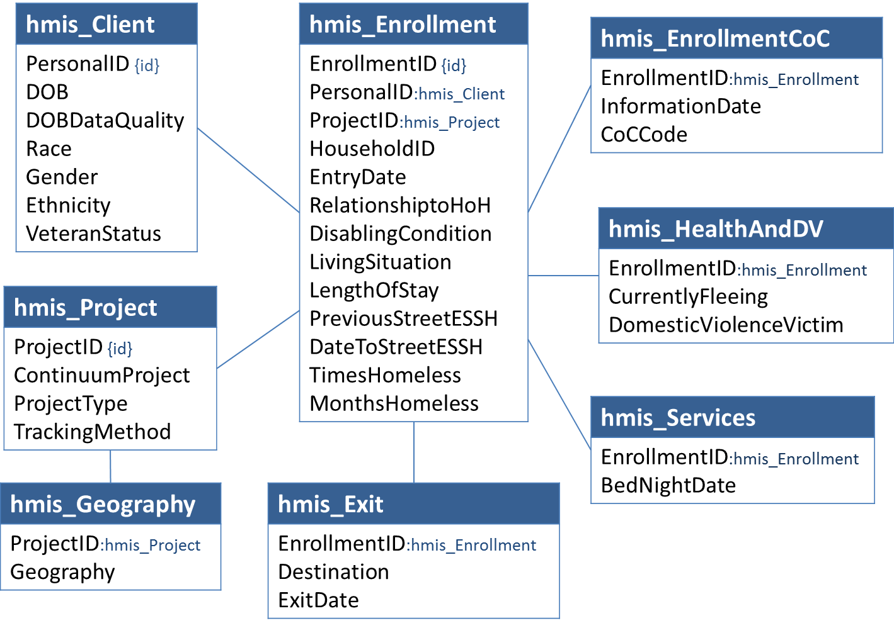

## Cohorts

A ‘cohort’ refers to a group of clients who meet specific criteria and were served in a given time frame. There are four separate LSA cohorts.

### Active Cohort (LSAPerson and LSAHousehold)

Clients active in the LSA report period are referred to as the ‘active cohort’ – clients or households served in continuum ES, SH, TH, RRH, and PSH projects at any time during the report period.

Only data associated with enrollments in those five project types is used in any aspect of reporting on the active cohort.

The HMIS data universe for the active cohort includes:

* Client-level data, e.g., date of birth, gender, and ethnicity.
* Enrollment-level data for active enrollments, e.g., entry/exit dates, living situation, and disabling condition.
* For adults and heads of household, enrollment data for at least three years prior to the client’s last active date in the report period; this is relevant to chronic homelessness and, for heads of household only, system path and use.
* For people served with heads of household on enrollments prior to the report period (even those who were not active in the report period), date of birth and entry/exit dates to determine household type for previous enrollments.

### Exit Cohorts (LSAExit)

Exit cohort reporting focuses on subsequent system use data (if any) for households who:

* Exited from a continuum **SO**, ES, SH, TH, RRH, or PSH project during three cohort time periods; and
* Were not enrolled in any continuum ES, SH, TH, RRH, or PSH project in the 14 days after exit.

The three individual exit cohorts are based on the timeframe of the exit:

* **Exit Cohort 0** exited in the first six months of the report period;
* **Exit Cohort – 1** exited in the year beginning one year prior to ReportStart; and
* **Exit Cohort – 2** exited in the year beginning two years prior to ReportStart.

These three cohorts are not mutually exclusive with each other, nor with the active cohort; a person may be included in any or all of them.

The head of household – the cohort member – is a proxy for counting households in the LSAExit.csv file of the upload. Only heads of household are included in those counts; however, records for all household members are part of the data universe because they are needed to determine household type, household composition, and to identify special populations.

The HMIS data universe for exit cohorts includes:

* Client- and enrollment-level data for the head of household;
* Enrollment-level data for active enrollments, e.g., entry/exit dates, living situation, disabling condition, etc.
* For people served with cohort members (heads of household), data related to household type (date of birth) and population identifiers (disabling condition, etc.).

When the LSA is generated for all relevant continuum projects systemwide, exit data for clients who exited from Street Outreach (SO) projects in the three cohort periods are included in the data universe. **No other information associated with Street Outreach projects is relevant to any part of the LSA**.

When the LSA is generated for a subset of continuum projects selected by a user, Street Outreach data are excluded from the data universe.

# HDX 2.0 Upload

The Longitudinal Systems Analysis (LSA) upload will consist of a .zip file containing a total of 10 CSV files generated by the HMIS application. The first five files are specific to the LSA; they are described in brief in this section.

* LSAReport.csv
* LSAHousehold.csv
* LSAPerson.csv
* LSAExit.csv
* LSACalculated.csv

The remaining files contain HMIS project descriptor data in file structures defined by the HMIS CSV Specifications v6.11.

* Organization.csv
* Project.csv
* Funder.csv
* Inventory.csv
* Geography.csv

A separate data dictionary with a complete list of the columns and values associated with each of these files is available in the LSA tool kit as an Excel workbook.

## LSAReport.csv

LSAReport contains 61 columns, including information related to:

* The date that the LSA was generated and the HMIS application that produced it;
* Report parameters; and
* HMIS data quality.

The HDX will use these data to process the upload file, and may flag uploads with unusually low data quality in the HMIS fields included in this file. The columns are listed and described in the LSA Data Dictionary. More details about the business logic and order of operations to create this file are found in Section 4.

## LSAHousehold.csv

LSAHousehold contains 41 columns of information, plus the **ReportID**. Columns include the following types of data:

* Identifiers for project types and populations in which each household was served.
* Demographics including living situation, destination, household composition, project geography, and system engagement.
* Lengths of time homeless (LOTH) and enrolled in RRH/PSH during the report period and any continuous episode of homelessness prior to ReportStart that overlaps with the report period.

Rows represent specific combinations of these data points. Each active household is counted in one row; the sum of **RowTotal**values in the file is equal to the total number of households active at any point during the report period.

It is critical that all values in this column are integers >0. The largest possible number of rows – when each row includes a count of one or more households represented by the distinct combination of column values – is limited to the number of active households. However, the number of possible distinct combinations of column values exceeds 6 x 1023.

The columns in this file are listed with the appropriate integer values and associated category descriptions in the LSA Dictionary. Detailed descriptions of the business logic and order of operations to create this file are found in Section 4.

## LSAPerson.csv

LSAPerson contains 23 columns of information, plus the **ReportID**. Columns include the following types of data:

* Identifiers for project types, household types, and populations in which clients were served.
* Age categories for all clients; age is the only demographic reported for children who are not heads of household.
* Demographics reported for adults and heads of household, including gender, race, ethnicity, veteran status, disability status, and domestic violence status.

Rows represent specific combinations of these data points. Each active client is counted in one row; the sum of **RowTotal**values in the file is equal to the total number of active clients in the report period. It is critical that all values in this column are integers >0. The largest possible number of rows – when each row includes a count of one or more households represented by the distinct combination of column values – is limited to the number of active households. However, the number of possible distinct combinations of column values exceeds 6 x 1023.

The columns in this file are listed with the appropriate integer values and associated category descriptions in the LSA Dictionary. Detailed descriptions of the business logic and order of operations to create this file are found in Section 4.

## LSAExit.csv

LSAExit contains 16 columns of information, plus the **ReportID**. The file identifies clients who exited a project during prior periods. Columns include the following types of data:

* Identifiers for project types, household types, and populations in which clients were served.
* For clients that returned to the homeless continuum, length of time to return and project type to which the client returned.

Rows represent specific combinations of these data points. Each active client is counted in one row; the sum of **RowTotal** values in the file is equal to the total number of active clients during the report period. It is critical that all values in this column are integers >0. The largest possible number of rows – when each row includes a count of one or more households represented by the distinct combination of column values – is limited to the number of active households. However, the number of possible distinct combinations of column values exceeds 6 x 1023.

The columns in this file are listed with the appropriate integer values and associated category descriptions in the LSA Dictionary. Detailed descriptions of the business logic and order of operations to create this file are found in Section 4.

## LSACalculated.csv

This file is used to upload calculated values for report output that cannot be derived from the aggregate data. It is used to populate columns that report on average number of days for all household types and populations in:

* System Use – Length of Time Homeless
* System Use – Cumulative Length of Time in PSH
* System Use – Length of Time in RRH Projects
* Returns – Days to Return/Re-engage by Exit Destination
* Days to Return/Re-engage by Last Project Type
* Days to Return/Re-engage by System Path
* Days to Return/Re-engage by Population

It is also used for counts of persons, households, and bednights, including:

* Project-level counts of households and clients active at any point in the report period and on four specific dates during the report period; and
* Project-level counts of total bednights in the report period.

For this file only, every value used in reporting defined by HUD for all household types, populations, System Paths, and cohorts must be calculated by HMIS because averages cannot be calculated by the HDX 2.0 based on aggregate data in which numbers of days are grouped in broad categories.

More details about the business logic and order of operations to create this file are found in Section 4.

# HMIS Business Logic

There is an inherent order of operations required to construct LSA output from HMIS data. For example, household members’ ages must be calculated in order to determine household types for individual HMIS *HouseholdIDs*. Household types are required to identify distinct combinations of head of household and household type, which is the basis for counting individual households throughout the LSA.

In this document, LSA business logic is described as a series of discrete steps, each with a specific result. Results are cumulative; the ‘output’ of earlier steps serves as input for later steps. The sequence of steps is consistent with the order of operations, but in practice, many could be combined and executed simultaneously. They are separate here to clarify the business logic associated with individual columns.

To avoid repetition, simplify descriptions, and emphasize various aspects of the logic, several of these steps specify the creation of intermediate data constructs (tables) with column names that function as variables in later steps. There is no requirement to use the process or the constructs described here as long as output is consistent with the logic described here.

A companion document titled *LSA Programming Specifications: Sample Code* may help clarify and illustrate the business logic described in this document. It was written during the development of these specifications and is being made available as a reference. There is no requirement to use the code.

## Get Report Parameters for LSAReport

### Relevant Data

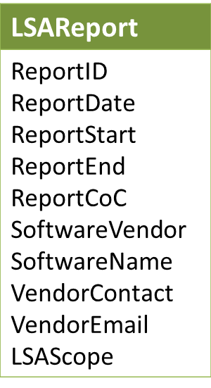

### ReportID

The content of LSA CSV files is interdependent; any change to HMIS data that would impact one file has the potential to impact all of them. As such, it is critical that all output is generated in a single process. **ReportID** is a system-generated integer that distinctly identifies an instance of LSA output and is repeated in each of the CSV files to confirm that they were produced together.

(**ReportDate** is a system generated date/time that indicates the time reporting procedures *completed* the generation of LSA data. It should not be populated at report initiation.)

### ReportStart, ReportEnd, and ReportCoC

ReportStart, ReportEnd, and ReportCoC are user-defined report parameters integral to the business logic of the LSA. They are included in LSAReport for upload to the HDX.

### LSAScope

If a user generates a standard systemwide LSA – i.e., selects ‘All projects’ rather than a specific subset of projects at report initiation – set the value of **LSAScope** to 1.

If a user generates a project-focused LSA for a user-selected subset of projects, set the value of **LSAScope** to 2. When this occurs, the *ProjectID*s of the selected projects are also a parameter; it is applied to the selection of project records for export in the next step.

| LSAScope Values | Category |
| --- | --- |
| 1 | Systemwide |
| 2 | Project-focused |

### SoftwareVendor and SoftwareName

**SoftwareVendor** and **SoftwareName** must be hard-coded to ensure that the values are consistent across all HMIS implementations.

Both of these columns are strings; they may not exceed 50 characters and may not include any of the following: < > [ ] { }.

### VendorContact and VendorEmail

Vendors may elect to provide contact information or to populate these columns with ‘n/a.’ In either case, **VendorContact** and **VendorEmail** must be hard-coded by the vendor.

Both of these columns are strings; they may not exceed 50 characters and may not include any of the following: < > [ ] { }.

## Get Relevant Project Records for Export / lsa_Project

### Relevant Data

To distinguish between all projects in the HMIS and those that meet the criteria for inclusion in the LSA, subsequent steps assume the creation of an intermediate data contruct called lsa_Project in the structure of Project.csv.

| Name | Values |
| --- | --- |
| ProjectID | Alphanumeric; max 32 characters |
| OrganizationID | Must match a record in Organization.csv |
| ProjectName | String; may not be NULL, max 50 characters (truncate HMIS value in export if >50 characters) |
| ProjectCommonName | n/a - will not be imported |
| OperatingStartDate | <= ReportEnd |
| OperatingEndDate | NULL or >= ReportStart |
| ContinuumProject | 1 |
| ProjectType | In (1,2,3,8,9,10,13) |
| ResidentialAffiliation | NULL |
| TrackingMethod | If *ProjectType* = 1, value must be 0 or 3;  If *ProjectType* <> 1, must be NULL |
| TargetPopulation | NULL or in (1,3,4) |
| VictimServicesProvider | In (0,1) |
| HousingType | In (1,2,3) |
| PITCount | n/a - will not be imported |
| DateCreated | Date/time |
| DateUpdated | Date/time |
| UserID | n/a - will not be imported |
| DateDeleted | Must be NULL; do not export deleted records. |
| ExportID | Must match LSAReport.ReportID |

### Logic

#### Systemwide LSA

When the LSA is being generated for all relevant projects systemwide, export records for projects where:

* *OperatingStartDate* < ReportEnd
* *OperatingEndDate* is NULL or >= ReportStart
* *ContinuumProject* = Yes (1)
* ProjectCoC.*CoCCode* = ReportCoC
* *ProjectType* is ES (1), SH (8), TH (2), RRH (13), PSH (3), or OPH (9 or 10)
* *DateDeleted* is NULL

All project records that meet the criteria above should be included, including projects that do not participate in HMIS.

**Note**: The export of PDDE data for a systemwide LSA includes records for permanent housing project types ‘PH – Housing Only’ (9) and ‘PH – Housing with Services (no disability required for entry)’ (10). This is the only context in which data associated with projects of these types are relevant to the LSA.

#### Project-Focused LSA

If the LSA is being generated for a subset of projects, export records for projects where:

* *OperatingStartDate* < ReportEnd
* *OperatingEndDate* is NULL or >= ReportStart
* ProjectCoC.*CoCCode* = ReportCoC
* *ProjectID* is in [list of user-selected *ProjectID*s]
  + Section 2.1 requires that the projects available to a user for selection when entering report parameters must be limited to *ProjectType*s ES (1), SH (8), TH (2), RRH (13), and PSH (3), so records for other project types are never included when LSAScope = 2.
* *DateDeleted* is NULL

Populate **ExportID**with LSAReport.**ReportID***;* the data type for **ExportID**is a string, so **ReportID** must be converted appropriately.

**ProjectCommonName**, **PITCount**, and **UserID** may be exported as NULL; regardless of their values, they will not be imported into the HDX 2.0.

**Note**: As described in this document, there are two differences in business logic between a Systemwide LSA vs. a Project-Focused LSA.

1. Selection criteria for lsa_Project (described above);

2. The exclusion of Street Outreach projects from reporting on exit cohorts (see exit cohort logic).

## Get Organization.csv Records / lsa_Organization

### Relevant Data

| Name | Values |
| --- | --- |
| OrganizationID | Alphanumeric; max 32 characters |
| OrganizationName | String; may not be NULL, max 50 characters (truncate HMIS value in export if >50 characters) |
| OrganizationCommonName | n/a - will not be imported |
| DateCreated | Date/time |
| DateUpdated | Date/time |
| UserID | n/a - will not be imported |
| DateDeleted | Must be NULL; do not export deleted records. |
| ExportID | Must match LSAReport.ReportID |

### Logic

Export one record for every *OrganizationID* included in Project.csv.

Populate **ExportID**with LSAReport.**ReportID***;* the data type for **ExportID**is a string, so **ReportID** must be converted appropriately.

**OrganizationCommonName**and **UserID**may be exported as NULL; regardless of their values, they will not be imported into the HDX 2.0.

## Get Funder.csv Records / lsa_Funder

### Relevant Data

| Name | Values |
| --- | --- |
| FunderID | Alphanumeric; max 32 characters |
| ProjectID | Must match a record in Project.csv |
| Funder |  |
| GrantID | n/a - will not be imported |
| StartDate | <= ReportEnd |
| EndDate | NULL or >= ReportStart |
| DateCreated | Date/time |
| DateUpdated | Date/time |
| UserID | n/a - will not be imported |
| DateDeleted | Must be NULL; do not export deleted records. |
| ExportID | Must match LSAReport.ReportID |

### Logic

Export all records for every **ProjectID** included in Project.csv where:

* *StartDate* < ReportEnd
* *EndDate* is NULL or >= ReportStart
* *DateDeleted* is NULL

Populate **ExportID**with LSAReport.**ReportID***;* the data type for **ExportID**is a string, so **ReportID** must be converted appropriately.

**GrantID**and **UserID**may be exported as NULL; regardless of their values, they will not be imported into the HDX 2.0.

## Get Inventory.csv Records / lsa_Inventory

### Relevant Data

| Name | Values |
| --- | --- |
| InventoryID | Alphanumeric; max 32 characters |
| ProjectID | Must match a record in Project.csv |
| CoCCode | = ReportCoC |
| InformationDate | <= ReportEnd |
| HouseholdType | In (1,3,4) |
| Availability | NULL unless Project.*ProjectType* = 1; otherwise, in (1,2,3) |
| UnitInventory | Integer |
| BedInventory | Integer |
| CHBedInventory | Integer; may be NULL if Project.*ProjectType* <> 3 |
| VetBedInventory | Integer; may be NULL |
| YouthBedInventory | Integer; may be NULL |
| BedType | NULL unless Project.*ProjectType* = 1; otherwise, in (1,2,3) |
| InventoryStartDate | < ReportEnd |
| InventoryEndDate | NULL or >= ReportStart |
| HMISParticipatingBeds | Integer |
| DateCreated | Date/time |
| DateUpdated | Date/time |
| UserID | n/a - will not be imported |
| DateDeleted | Must be NULL; do not export deleted records. |
| ExportID | Must match LSAReport.ReportID |

### Logic: All Applications

Export any existing user-entered inventory record for every *ProjectID* included in Project.csv where:

* *CoCCode =* ReportCoC
* *InventoryStartDate* < ReportEnd
* *InventoryEndDate* is NULL or >= ReportStart

*DateDeleted* is NULL Populate *ExportID* with LSAReport.**ReportID***;* the data type for *ExportID* is a string, so values must be padded with quotes.

*UserID* may be exported as NULL; regardless of its value, it will not be imported into the HDX 2.0.

### Modified Logic: Generate RRH Inventory Records Dynamically

In the HMIS Data Dictionary*, 2.7 Bed and Unit Inventory* System Logic specifies “Inventory for RRH projects should be counted and recorded consistent with HIC guidance to reflect the numbers of RRH participants who have moved into permanent housing.”

In some systems, this has been understood and implemented as a requirement for HMIS applications to generate dynamic RRH Inventory records dynamically based on counts of people/households in housing at various points in time rather than collecting and storing user-entered inventory data.

Where this is the case, include one inventory record with an *InformationDate* = ReportStart and one inventory record with an *InformationDate* = ReportEnd for each unique combination of *ProjectID*/*HouseholdType* where:

* *ProjectID* = lsa_Project.**ProjectID** where **ProjectType** = 13
* *MoveInDate*<= [InformationDate]
* *ExitDate* **> [**InformationDate]

**Note:** HDX 2.0 calculations will be consistent with the system logic described in the HMIS Data Dictionary for *2.7 Bed and Unit Inventory* to determine:

* Year-round equivalent counts of beds and units – i.e., the number of beds available on an average night – for each project; and
* Counts of available beds and units on four specific dates during the report period.

HDX 2.0 reporting on bed utilization will be based on these counts coupled with client and household counts in other files.

For each distinct combination of values in *ProjectID, HouseholdType,* and *Availability,* the total number of beds/units available on any given date are from the most recent Inventory record where:

* *InformationDate* <= [Given Date]; and
* *InventoryStartDate* <= [Given Date]; and
* *InventoryEndDate* is null or *InventoryEndDate* > [Given Date].

## Get Geography.csv Records / lsa_Geography

### Relevant Data

| Name | Values |
| --- | --- |
| GeographyID | Alphanumeric; max 32 characters |
| ProjectID | Must match a record in Project.csv |
| CoCCode | = ReportCoC |
| InformationDate | <= ReportEnd |
| Geocode | Six-digit string – must be padded with double quotes so that leading zeroes are not omitted. |
| GeographyType | In (1,2,3) |
| Address1 | May be NULL; max 100 characters |
| Address2 | May be NULL; max 100 characters |
| City | May be NULL; max 50 characters |
| State | May be NULL; otherwise, a valid two-letter abbreviation for a US state or territory |
| ZIP | May be NULL; otherwise, a five-digit string padded with double quotes so that leading zeroes are not omitted. |
| DateCreated | Date/time |
| DateUpdated | Date/time |
| UserID | n/a - will not be imported |
| DateDeleted | Must be NULL; do not export deleted records. |
| ExportID | Must match LSAReport.ReportID |

### Logic

Export only the most recent record for every *ProjectID* included in Project.csv where:

* *CoCCode =* ReportCoC
* *InformationDate* < ReportEnd
* *EndDate* is NULL or >= ReportStart
* *DateDeleted* is NULL

Populate *ExportID* with LSAReport.*ReportID;* the data type for *ExportID* is a string, so values must be padded with quotes.

*UserID* may be exported as NULL; regardless of its value, it will not be imported into the HDX 2.0.

## Get Active HouseholdIDs

The objective of this step is to identify active *HouseholdID*s based on enrollments active in the report period. By establishing that the head of household’s enrollment meets the criteria for inclusion in the LSA and coding the appropriate *ProjectGroup*, it is not necessary to include *ProjectType* or *EnrollmentCoC* in criteria for identifying active enrollments and clients in later steps.

### Data Construct: active_Household

The active_Household data construct holds a record for each active *HouseholdID* and identifies the head of household, household type, project group, and population identifiers relevant to each active *HouseholdID*. It includes the fields shown below.

| Name | Values |
| --- | --- |
| HouseholdID | Distinct *HouseholdIDs* served in the report period. |
| HoHID | The distinct identifier for the head of household – i.e., the *PersonalID* from the enrollment associated with the *HouseholdID* where *RelationshipToHoH* = 1. |
| HHType | The household type, based on the ages of household members – i.e., for every active enrollment associated with the *HouseholdID.* (1 = AO, 2 = AC, 3 = CO, 99 = UN) |
| ProjectGroup | Based on the *ProjectType*, the relevant project group (ES/SH/TH, RRH, or PSH) for demographics reporting.  (‘EST’, ‘RRH’, ‘PSH’) |
| HHChronic | Identifies a population. Initially set at the level of the *HouseholdID* and used to populate columns of the same names in LSAPerson and LSAHousehold. |
| HHVet | Identifies a population. Initially set at the level of the *HouseholdID* and used to populate columns of the same names in LSAPerson and LSAHousehold. |
| HHDisability | Identifies a population. Initially set at the level of the *HouseholdID* and used to populate columns of the same names in LSAPerson and LSAHousehold. |
| HHFleeingDV | Identifies a population. Initially set at the level of the *HouseholdID* and used to populate columns of the same names in LSAPerson and LSAHousehold. |
| HHAdultAge | Identifies a population. Initially set at the level of the *HouseholdID* and used to populate columns of the same names in LSAPerson and LSAHousehold. |
| HHParent | Identifies a population. Initially set at the level of the *HouseholdID* and used to populate columns of the same names in LSAPerson and LSAHousehold. |
| AC3Plus | Identifies a population. Initially set at the level of the *HouseholdID* and used to populate columns of the same names in LSAPerson and LSAHousehold. |

### Relevant Data

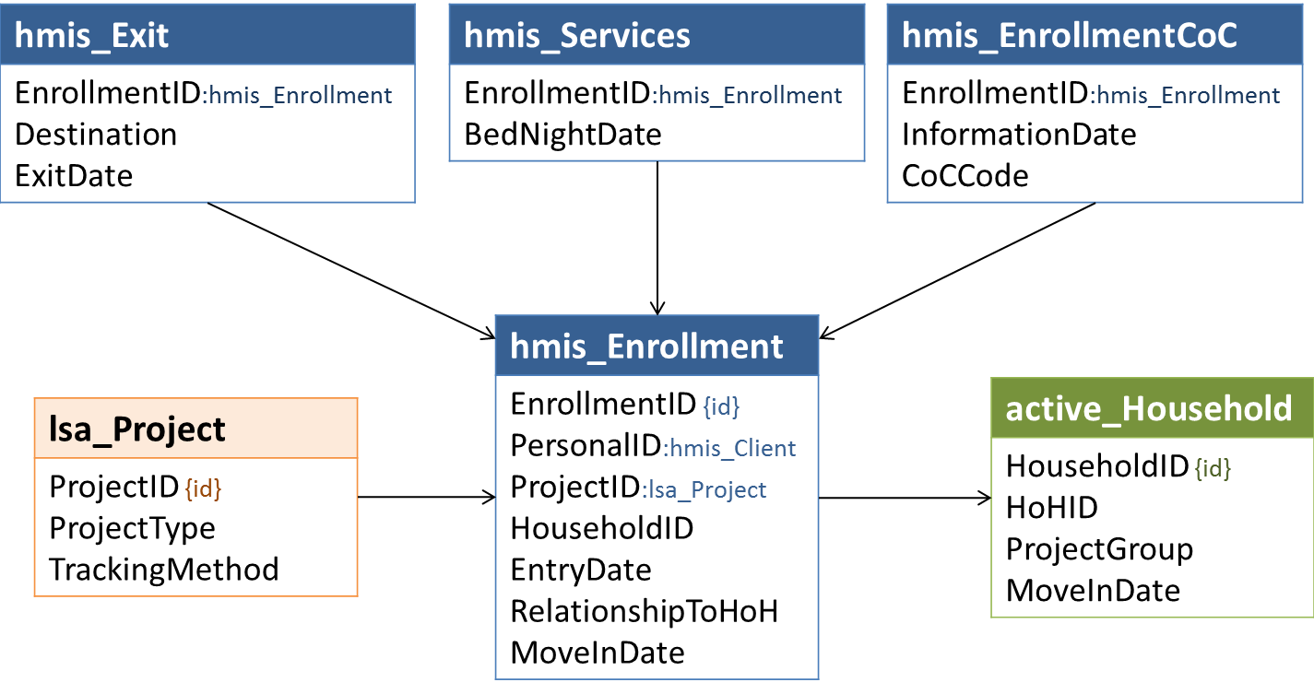

As shown above, the reference for project data relevant to selecting active *HouseholdID*s is lsa_Project – i.e., the subset of HMIS projects that meet the selection criteria defined in 4.2 Get Relevant Project Records for Export to Project.csv.

**Note:** The system logic defined by the Dictionary for *3.15 Relationship to Head of Household* requires that:

* Every *HouseholdID* must have exactly one designated head of household; and
* The designated head of household must be present for the duration of all enrollments associated with the *HouseholdID*.

In general, these specifications assume that HMIS data are consistent with Dictionary requirements. However, identification of active households is fundamental to the LSA and the potential impact on output in systems that have implemented this as a data collection and not a system requirement is high.

* Core logic for identification of active households is defined in the next section.
* Systems that do not enforce the requirements must also apply the modified logic in the section following the core logic.

### Logic: All Applications

Active *HouseholdID*s are those associated with enrollments that meet the following criteria.

* RelationshipToHoH = 1
* *EntryDate* <= ReportEnd
* *ExitDate* is NULL or *ExitDate* >= ReportStart
* There is a record where *EnrollmentCoC* = ReportCoC dated on or before ReportEnd
* There is no later record dated on or before ReportEnd where *EnrollmentCoC* <> ReportCoC
* There is a record for the **ProjectID** in lsa_Project and **ProjectType** is not in (9,10)
* If lsa_Project.**TrackingMethod** = 3, there is at least one *BedNightDate* record between ReportStart and ReportEnd

### Modified Logic: HMIS Application Does Not Enforce Head of Household Requirements

To ensure consistency in report output across systems, in any HMIS application that permits users to create and/or accepts for import records that are not consistent with the system logic requirements for *3.15 Relationship to Head of Household*, LSA reporting procedures *must* be written to ensure that the requirements are enforced in reporting as follows:

* For any *HouseholdID* where **more than one** active enrollment has a *RelationshipToHoH = 1,* use the lowest *PersonalID* (when sorted alphabetically or numerically, depending on system data type for *PersonalID)* for the *HouseholdID* where *RelationshipToHoH = 1* as the designated head of household.
* For any *HouseholdID* where **no** active enrollment has a *RelationshipToHoH = 1,* use the lowest *PersonalID* (when sorted alphabetically or numerically, depending on system data type for *PersonalID)* as the designated head of household.
* For any *HouseholdID* where 0 or more than 1 active enrollments have a *RelationshipToHoH = 1,* use the most recent record of *3.16 Client Location* associated with any active household member where *InformationDate* is on or before ReportEnd to determine whether or not the household meets the criteria for inclusion in the LSA (*EnrollmentCoC.CoCCode* = ReportCoC).

Aside from identification of heads of household, business logic is identical to that defined for applications that do enforce requirements.

## Get Active Enrollments and Associated AgeDate

### Data Construct: active_Enrollment

The active_Enrollment data construct is used to identify and reference enrollments active in the LSA report period ; it includes some data elements associated with those enrollments to simplify subsequent steps.

| Name | Values |
| --- | --- |
| EnrollmentID | Distinct *EnrollmentID*s active in the report period; foreign key for HMIS enrollment records. |
| PersonalID | Foreign key – tmp_Person, hmis_Client. |
| HouseholdID | Foreign key – active_Household. |
| RelationshipToHoH | From enrollment |
| EntryDate | *EntryDate* for the enrollment |
| MoveInDate | *MoveInDate* for RRH/PSH enrollments, if any |
| ExitDate | ExitDate for the *EnrollmentID*, if any |
| AgeDate | The later of *EntryDate* or ReportStart; used to calculate **AgeGroup** |
| AgeGroup | Client age as calculated for each *EnrollmentID* |

### Relevant Data

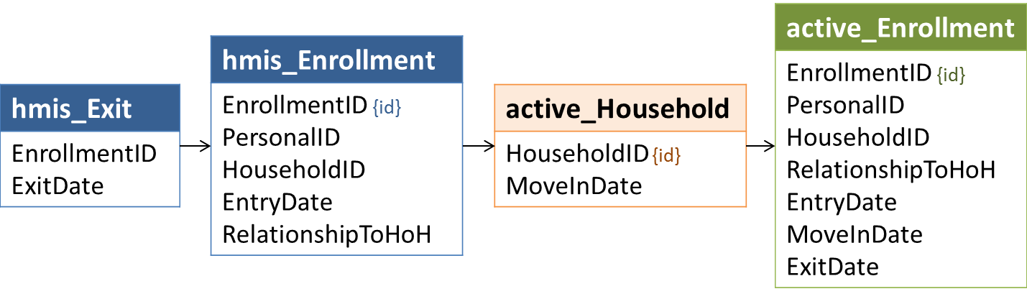

### Logic

The same criteria that apply to the identification of active *HouseholdID*s apply to identifying active enrollment records for household members.

* Enrollment records must be active in the report period; and
* The most recent *EnrollmentCoC* record for the head of household prior to the end of the report period must equal ReportCoC; and
* There is a record for the **ProjectID** in lsa_Project and **ProjectType** is not in (9,10)
* For ES enrollments in night-by-night shelters, there must be at least one *BedNightDate* in the report period.

As the order of operations is described in this document, an appropriate *ProjectType* and an *EnrollmentCoC* matching ReportCoC have already been established for the active_Household. These values will not differ for household members, so as long as active households are identified first, it is not necessary to incorporate these checks for active clients. If HMIS reporting procedures identify active clients or enrollments first, however, confirmation of *EnrollmentCoC* and *ProjectType* must be incorporated into the logic.

It is always necessary to confirm that household members’ enrollments were active within the report period based on *EntryDate* and *ExitDate.*

## Set Age Group for Each Active Enrollment

### Relevant Data

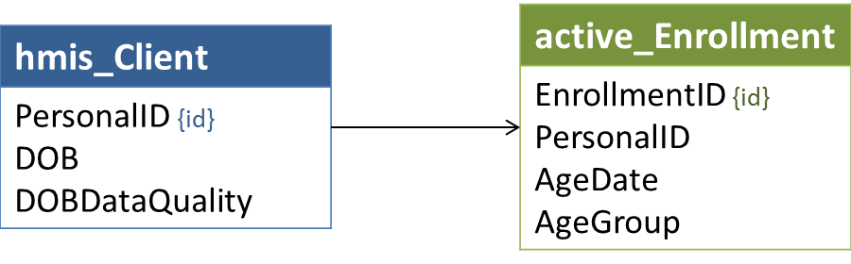

### Logic

To ensure that all household types and age-based populations are identified accurately, age – or the LSA age group used for reporting – is calculated separately for each active enrollment. Age is based on client age as of the **AgeDate** for the associated enrollment – ReportStart or *EntryDate,* whichever is later.

All dates of birth must be validated; they may not be used to calculate an age if any of the following are true:

* *DOBDataQuality* is anything other than ‘Full DOB reported’ (1) or ‘Approximate or partial DOB reported’ (2);
* *DOB* is missing or set to a system default;
* The calculation would result in an age over 105 years old;
* *DOB* is later than *EntryDate* for the enrollment; or
* *RelationshipToHoH* = 1 and *DOB* = *EntryDate* for the enrollment

The first of the criteria listed below met by the combination of values for *DOB,* *DOBDataQuality,* and **AgeDate** determines the **AgeGroup** for a given enrollment:

| Priority | Condition | AgeGroup | Category |
| --- | --- | --- | --- |
| 1 | *DOBDataQuality* in (8,9) | 98 | Client doesn't know/refused |
| 2 | *DOBDataQuality* not in (1,2) | 99 | Missing/invalid |
| 3 | *DOB* is missing or set to a system default | 99 | Missing/invalid |
| 4 | *DOB* *> EntryDate\** | 99 | Missing/invalid |
| 5 | *RelationshipToHoH* = 1 and *DOB* *= EntryDate\** | 99 | Missing/invalid |
| 5 | [*DOB* *+* 105 years] *<=* AgeDate | 99 | Missing/invalid |
| 6 | [*DOB* *+* 65 years] *<=* AgeDate | 65 | 65 and older |
| 7 | [*DOB* *+* 55 years] *<=* AgeDate | 64 | 55 to 64 |
| 8 | [*DOB* *+* 45years] *<=* AgeDate | 54 | 45 to 54 years |
| 9 | [*DOB* *+* 35years] *<=* AgeDate | 44 | 35 to 44 years |
| 10 | [*DOB* *+* 25 years] *<=* AgeDate | 34 | 25 to 34 years |
| 11 | [*DOB* *+* 22 years] *<=* AgeDate | 24 | 22 to 24 years |
| 12 | [*DOB* *+* 18 years] *<=* AgeDate | 21 | 18 to 21 years |
| 13 | [*DOB* + 6 years] *<=* AgeDate | 17 | 6 to 17 years |
| 14 | [*DOB* + 3 years] *<=* AgeDate | 5 | 3 to 5 years |
| 15 | [*DOB* + 1 years] *<=* AgeDate | 2 | 1 to 2 years |
| 16 | (other) | 0 | <1 year |

*The HMIS Data Dictionary does not (currently) require systems to prevent users from creating records where there is a logical conflict between *DOB* and *EntryDate*, although this is a recommended practice.

## Set Household Type for Active HouseholdIDs

### Relevant Data

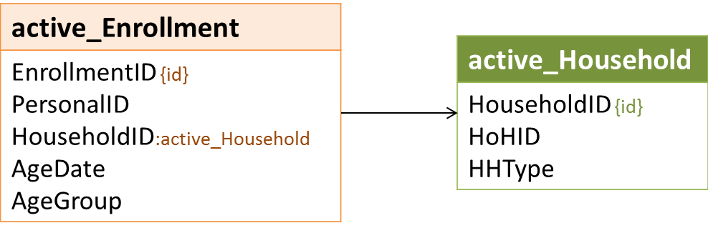

### Logic

Household type (**HHType**) for each HMIS *HouseholdID* is based on the presence or absence of household members by age status – adult, child, or unknown. This is based on **AgeGroup**sfor all household members’ enrollments.

* Adult – **AgeGroup** between 18 and 65
* Child – **AgeGroup**< 18
* Unknown – **AgeGroup** in (98,99)

The criteria below are mutually exclusive; it is not necessary to apply them in priority order.

| # Adults | # Children | # Unknown Age | HHType | Upload Value |
| --- | --- | --- | --- | --- |
| >= 1 | 0 | 0 | AO (Adult-only) | 1 |
| >= 1 | >= 1 | (any) | AC (Adult-child) | 2 |
| 0 | >= 1 | 0 | CO (Child-only) | 3 |
| (any) | 0 | >= 1 | UN (Unknown) | 99 |
| 0 | (any) | >= 1 | UN (Unknown) | 99 |

## Get Active Clients for LSAPerson

### Data Construct: tmp_Person

The tmp_Person data construct holds one record for each distinct *PersonalID* in active_Enrollment. It is essentially a client-level version of the aggregate LSAPerson data and is used to set values for each LSA reporting category – **Age**, **Gender**, **Race**, etc. – for each client. It includes all columns from LSAPerson.csv other than **RowTotal** and **ReportID**, as well as three additional columns (defined below) used as a reference to simplify reporting.

| Name | Values |
| --- | --- |
| PersonalID | Distinct *PersonalIDs* occurring in active_Enrollment; foreign key for HMIS client records. |
| HoHAdult | Identifies whether the client was served as an adult, a head of household, or both for any active_Enrollment (0 = No, 1 = Adult, 2=HoH, 3 = Adult and HoH); used to simplify later steps. |
| CHStart | Where **HoHAdult** > 0, **LastActive** – 3 years + 1 day; used for CH calculation. |
| LastActive | Where **HoHAdult** > 0, the client’s last active date in the report period; used for CH calculation. |
| Age | See LSA Data Dictionary for column descriptions. Logic associated with setting values for this and the following columns is defined in the following sections. |
| Gender | See LSA Data Dictionary for column descriptions. |
| Race | See LSA Data Dictionary for column descriptions. |
| Ethnicity | See LSA Data Dictionary for column descriptions. |
| VetStatus | See LSA Data Dictionary for column descriptions. |
| DisabilityStatus | See LSA Data Dictionary for column descriptions. |
| CHTime | See LSA Data Dictionary for column descriptions. |
| CHTimeStatus | See LSA Data Dictionary for column descriptions. |
| DVStatus | See LSA Data Dictionary for column descriptions. |
| HHTypeEST | See LSA Data Dictionary for column descriptions. |
| HoHEST | See LSA Data Dictionary for column descriptions. |
| HHTypeRRH | See LSA Data Dictionary for column descriptions. |
| HoHRRH | See LSA Data Dictionary for column descriptions. |
| HHTypePSH | See LSA Data Dictionary for column descriptions. |
| HoHPSH | See LSA Data Dictionary for column descriptions. |
| HHChronic | See LSA Data Dictionary for column descriptions. |
| HHVet | See LSA Data Dictionary for column descriptions. |
| HHDisability | See LSA Data Dictionary for column descriptions. |
| HHFleeingDV | See LSA Data Dictionary for column descriptions. |
| HHAdultAge | See LSA Data Dictionary for column descriptions. |
| HHParent | See LSA Data Dictionary for column descriptions. |
| AC3Plus | See LSA Data Dictionary for column descriptions. |

### Relevant Data

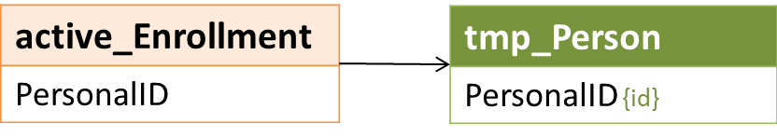

### Logic

LSAPerson, the source for most Demographics report tables produced by the HDX 2.0, is essentially one very large report table with a count of clients (**RowTotal)** grouped by 22 different factors. Each active client is counted in only one row; the sum of **RowTotal** values is the total number of clients in the active cohort.

In the intermediate client-level tmp_Person, each active client is represented by a single row with *PersonalID* as the primary key.

## Set Demographic Values for LSAPerson

### Relevant Data

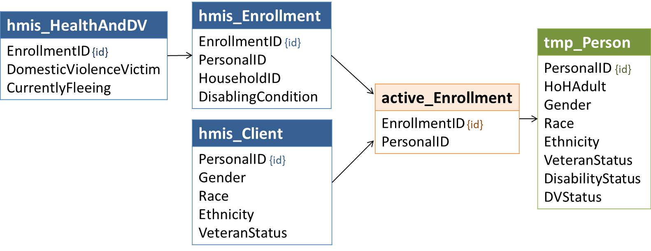

### Logic

#### HoHAdult

**HoHAdult** is used to indicated whether the client was served as a child, an adult, a head of household, or both adult and HoH. Children who were not served as heads of household are included in reporting on age and in population counts of people, but are not included in other demographic counts. There is no parallel **HoHAdult** column in the LSAPerson file, but it is useful in identifying which columns/records to update.

| Value | Category |
| --- | --- |
| 0 | Child |
| 1 | Adult |
| 2 | HoH |
| 3 | Adult and HoH |

#### Age

Although calculated for each enrollment, demographic reporting on age is based on clients’ earliest active date in the report period. For all clients, set **Age** using the lowest **AgeGroup**value in active_Enrollment for each **PersonalID**in tmp_Person.

| LSA Value | LSA Category |
| --- | --- |
| 0 | <1 |
| 2 | 1 to 2 |
| 5 | 3 to 5 |
| 17 | 6 to 17 |
| 21 | 18 to 21 |
| 24 | 22 to 24 |
| 34 | 25 to 34 |
| 44 | 35 to 44 |
| 54 | 45 to 54 |
| 64 | 55 to 64 |
| 65 | 65 and Older |
| 98 | Client doesn't know/refused |
| 99 | Missing/invalid |

#### Gender

Assign a value of -1 for all non-heads of household under 18 or of unknown age (**HoHAdult** = 0).

Crosswalk HMIS *Gender* values for adults and heads of household as follows:

| HMIS Value | HMIS Category | LSA Value | LSA Category |
| --- | --- | --- | --- |
| 0 | Female | 1 | Female |
| 1 | Male | 2 | Male |
| 2 | Trans Female (MTF or Male to Female) | 3 | Transgender |
| 3 | Trans Male (FTM or Female to Male) | 3 | Transgender |
| 4 | Gender non-conforming | 4 | Gender non-conforming |
| 8 | Client doesn’t know | 98 | Client doesn’t know/refused |
| 9 | Client refused | 98 | Client doesn’t know/refused |
| (any other) | Any other, including NULL | 99 | Missing/invalid |

#### Ethnicity

Assign a value of -1 for all non-heads of household under 18 or of unknown age (**HoHAdult** = 0).

Crosswalk HMIS *Ethnicity* values for adults and heads of household as follows:

| HMIS Value | HMIS Category | LSA Value | LSA Category |
| --- | --- | --- | --- |
| 0 | Non-Hispanic/Latino | 0 | Non-Hispanic/Latino |
| 1 | Hispanic/Latino | 1 | Hispanic/Latino |
| 8 | Client doesn’t know | 98 | Client doesn’t know/refused |
| 9 | Client refused | 98 | Client doesn’t know/refused |
| (any other) | Any other, including NULL | 99 | Unknown |

#### Race

Assign a value of -1 for all non-heads of household under 18 or of unknown age (**HoHAdult** = 0).

Crosswalk HMIS *Race* values for adults and heads of household in the following priority order:

| Priority | HMIS Race Values | LSA Value | LSA Category |
| --- | --- | --- | --- |
| 1 | Regardless of any other data  *Client doesn’t know* (8) or *Client refused* (9) | 98 | Client doesn't know/refused |
| 2 | Regardless of any other race data  *Data not collected* (99) or NULL | 99 | Missing/invalid |
| 3 | Two or more *Race* values selected | 6 | Multiple Races |
| 4 | *White* (5) is the only race selected and Ethnicity <> 1 | 0 | White, non-Hispanic/Latino |
| 4 | *White* (5) is the only race selected and Ethnicity = 1 (Hispanic/Latino) | 1 | White, Hispanic/Latino |
| 4 | *Black or African American* (3) is the only race selected | 2 | Black or African American |
| 4 | *Asian* (2) is the only race selected | 3 | Asian |
| 4 | *American Indian or Alaska Native* (1) is the only race selected | 4 | American Indian or Alaska Native |
| 4 | *Native Hawaiian or Other Pacific Islander* (4) is the only race selected | 5 | Native Hawaiian / Other Pacific Islander |

#### VetStatus

Assign a value of -1 for all clients under 18 (**HoHAdult** = in (0,2)).

Crosswalk HMIS *VeteranStatus* values for adults as follows:

| HMIS Value | HMIS Category | LSA Value | LSA Category |
| --- | --- | --- | --- |
| 0 | No | 0 | Not a veteran |
| 1 | Yes | 1 | Veteran |
| 8 | Client doesn’t know | 98 | Client doesn't know/refused |
| 9 | Client refused | 98 | Client doesn't know/refused |
| (any other) | Any other, including NULL | 99 | Missing |

#### DisabilityStatus

Assign a value of -1 for all non-heads of household under 18 or of unknown age.

Using all records of *DisablingCondition* associated with active enrollments, set the value of **DisabilityStatus** to the first LSA Value in the table below where the *DisablingCondition* value matches.

| Priority | HMIS Values | LSA Value | LSA Category |
| --- | --- | --- | --- |
| 1 | Yes (1) | 1 | Disabled |
| 2 | No (0) | 0 | Not disabled |
| 3 | (Any other) | 99 | Unknown |

#### DVStatus

Assign a value of -1 for all non-heads of household under 18 or of unknown age.

Using all records of *4.11 Domestic Violence* associated with active enrollments, set the value of **DVStatus** to the first LSA Value in the table below where *DVVictim* and *CurrentlyFleeing* values match.

| Priority | DVVictim | CurrentlyFleeing | LSA Value | LSA Category |
| --- | --- | --- | --- | --- |
| 1 | Yes (1) | Yes (1) | 1 | DV victim, currently fleeing |
| 2 | Yes (1) | No (0) | 2 | DV victim, not currently fleeing |
| 3 | Yes (1) | (any other) | 3 | DV victim, unknown if currently fleeing |
| 4 | No (0) | - | 0 | Not a victim of domestic violence |
| 5 | 8,9 | - | 98 | Client doesn't know/refused |
| 6 | (any other) | - | 99 | Missing/invalid |

## Get Chronic Homelessness Date Range for Each Head of Household/Adult

**Note**: The definition of *chronically homeless* specifies the total length of time spent either in a place not meant for human habitation, a safe haven, or in an emergency shelter relevant to chronic homelessness in months: “continuously for at least *12 months*” or on four or more occasions for a total of “at least *12 months*“ within a timeframe of 3 years.

Specific to the LSA:

* All time related to chronic homelessness is counted in days, i.e., *continuously for at least 365 days,* or in four or more episodes for a total of at least *365 days***.**
* The 3-year timeframe for any given client ends on their last active date in the report period, i.e., it is specific to the client;
* A client may be reported as chronically homeless based on records of time spent in HMIS-participating projects (i.e., entry and exit dates), based on data in *3.917 Living Situation*, or a combination of the two.

A client must meet the criteria for chronic homelessness in the year ending on their last active date in the report period in order to be reported as chronically homeless.

### Relevant Data

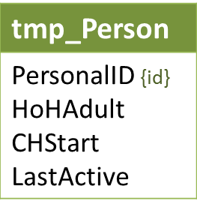

### Logic

Chronic homelessness (CH) status is reported in LSAPerson for each adult and head of household based on HMIS data about their living situations – including time enrolled in continuum residential projects – in the three years ending on their last active date in the report period. That three year period – the CH date range – is identified in tmp_Person with dates in the **CHStart**and**LastActive**columns.

**LastActive** – For each record in tmp_Person where **HoHAdult** > 0:

* If *ExitDate* for any active_Enrollment is NULL, **LastActive** = ReportEnd.
* Otherwise, **LastActive** = the most recent *ExitDate* for any active enrollment.

**CHStart** – For each record in tmp_Person where **HoHAdult** > 0:

* **CHStart** = (**LastActive** – 3 years) + 1 day

## Get Enrollments Relevant to Chronic Homelessness

### Data Construct: ch_Enrollment

The ch_Enrollment data construct is used to identify enrollments relevant to determining chronic homelessness status for adults and heads of household.

| Name | Values |
| --- | --- |
| EnrollmentID | Distinct *EnrollmentID*s active in the three years prior to the client’s last active date in the report period; foreign key for HMIS enrollment records. |
| PersonalID | Foreign key – tmp_Person. |
| ProjectType | *ProjectType* for the enrollment *ProjectID*. |
| TrackingMethod | If *ProjectType* is ES (1), the project’s *TrackingMethod*. |
| StartDate | *EntryDate* or tmp_Person.**CHStart**, whichever is later. |
| MoveInDate | For RRH (13) and PSH (3) projects, the *MoveInDate* (if any) associated with the head of household’s enrollment. |
| StopDate | ExitDate; if ExitDate is null, tmp_Person.**LastActive**. |

### Relevant Data

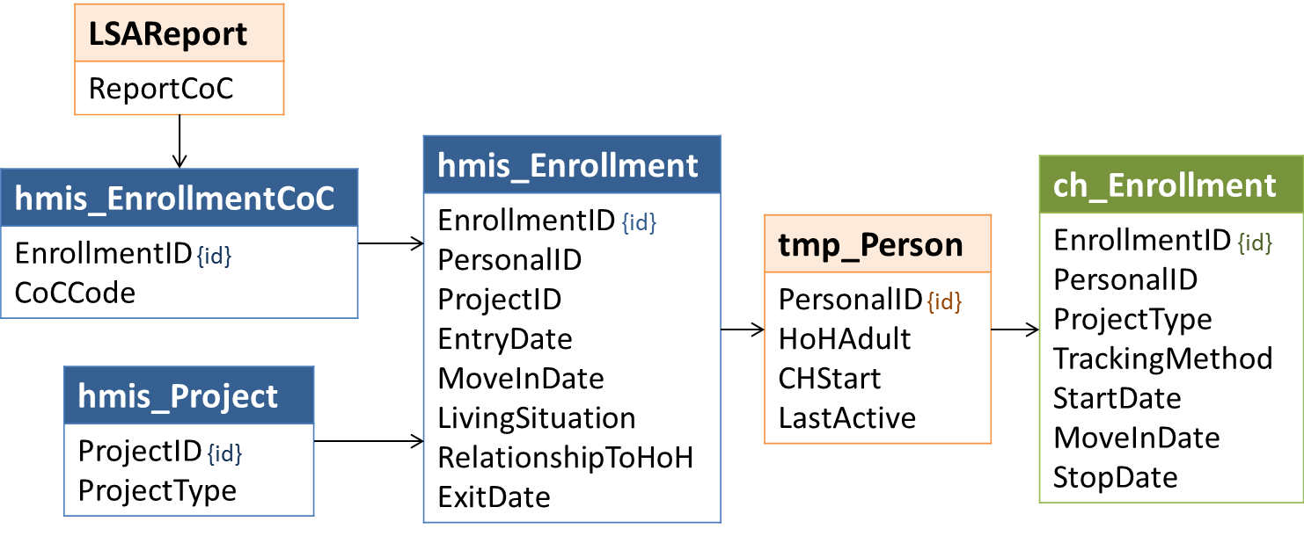

### Logic

Enrollments relevant to chronic homelessness, or ‘CH enrollments’, meet the following criteria:

* *PersonalID* = tmp_Person.**PersonalID**
* *EntryDate* <= tmp_Person.**LastActive**
* *ExitDate* is NULL or *ExitDate* > tmp_Person.**CHStart**
* There is a record for the enrollment *HouseholdID* where *EnrollmentCoC* = ReportCoC
* For the *ProjectID* associated with the enrollment, *ProjectType* in (1,2,3,8,13)
* If *ProjectType* = 1 and *TrackingMethod =* 3, there is a record of at least one bednight between **CHStart** and **LastActive**

If the *EntryDate* for a CH enrollment is before **CHStart**, only the portion of the enrollment that occurred during the CH date range is relevant.

## Get Dates to Exclude from Counts of ES/SH/Street Days

### Data Construct: ch_Exclude

The ch_Exclude data construct holds distinct combinations of *PersonalID* and dates on which the client was either in TH or housed in RRH/PSH, i.e. known to be in a place other than one not meant for human habitation, a safe haven, or in an emergency shelter.

| Name | Values |
| --- | --- |
| PersonalID | tmp_Person |
| excludeDate | Distinct dates between **CHStart**and **LastActive** when client was either in TH or housed in RRH/PSH. |

### Relevant Data

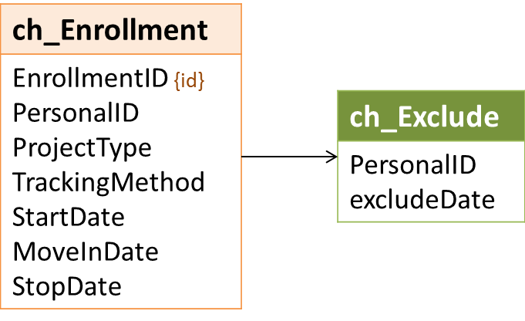

### Logic

To resolve potential data conflicts, dates on which a client is enrolled in TH or housed in RRH/PSH are excluded when identifying ES/SH/Street days.

* For any CH enrollment where *MoveInDate* is not null, all dates between *MoveInDate* and (*ExitDate* – 1 day) or **LastActive** (if *ExitDate* is null) are excluded.
* For any CH enrollment where *ProjectType =* TH (2), all dates between *EntryDate* and (*ExitDate* – 1 day) (or **LastActive** if *ExitDate* is null) are excluded.

## Get Dates to Include in Counts of ES/SH/Street Days

### Data Construct: ch_Time

The ch_Time data construct holds distinct combinations of *PersonalID* and dates on which the client was either in ES/SH or on the street.

| Name | Values |
| --- | --- |
| PersonalID | tmp_Person |
| ch_Date | Distinct dates between **CHStart**and **LastActive** when client was in ES/SH or on the street; also referred to as ES/SH/Street dates. |

### Relevant Data

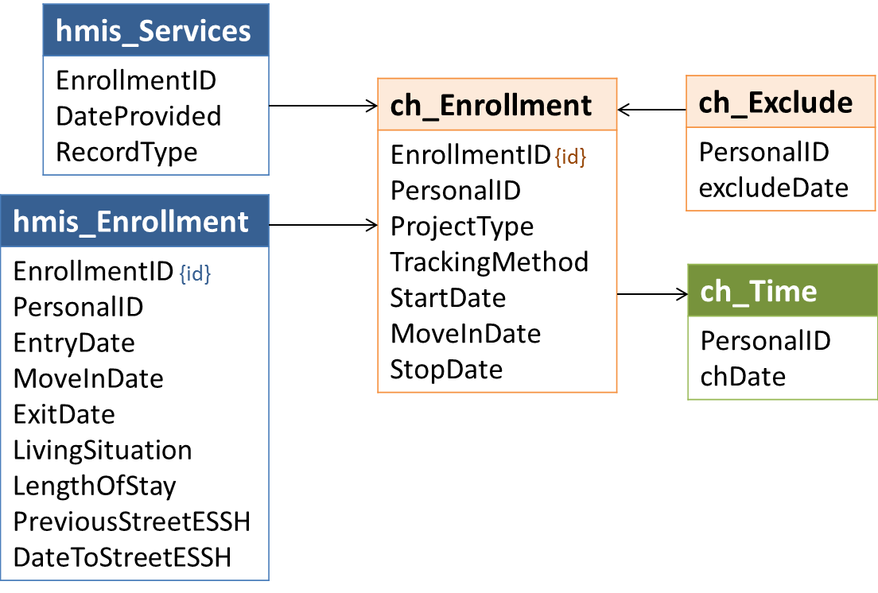

### Logic

For each **PersonalID** in tmp_Person, any date between **CHStart**and **LastActive** is counted as an ES/SH/Street day (**ch_Date**) if it meets one of the sets of criteria below as compared to CH enrollments.

#### Criteria for counting dates in the CH date range when a client was enrolled in entry/exit ES or SH:

* **ch_Date** <> any ch_Exclude.*excludeDate*
* *ProjectType* = 8 or (*ProjectType* = 1 and *TrackingMethod* <> 3); and
* **ch_Date** >= later of *EntryDate* and **LastActive***;* and
* **ch_Date** <= (*ExitDate* – 1 day) or **LastActive** (if no exit)

#### Criteria for counting night-by-night ES dates in the CH date range:

* **ch_Date** <> any ch_Exclude.*excludeDate*
* *ProjectType* = 1 and *TrackingMethod* = 3; and
* **ch_Date** = BednightDate

#### Criteria for counting dates in ES/SH or on the Street Based on *3.917 Living Situation:*

For enrollments where *EntryDate* > **CHStart**, data in *3.917 Living Situation* is used to identify dates in the CH date range on which a client was in ES/SH or on the street.

* **ch_Date** <> any ch_Exclude.**excludeDate**
* **ch_Date** >= *DateToStreetESSH*; and
* If *ProjectType* is ES (1), SH (8), or TH (2): **ch_Date** < *EntryDate*; and
* If *ProjectType* is RRH (13) or PSH (3) and *MoveInDate* is not null: [Date] < *MoveInDate*; and
* If *ProjectType* is RRH (13) or PSH (3) and *MoveInDate* is null: **ch_Date** <= (*ExitDate* – 1 day) or **LastActive** (if no exit); and
* The client was in ES/SH or on the street prior to project entry:
  + *LivingSituation* in (1,18,16); or
  + *LengthOfStay* in (10, 11) and *PreviousStreetESSH* = 1; or
  + *LivingSituation* in (4,5,6,7,15,24) and *LengthOfStay* in (2,3) and *PreviousStreetESSH* = 1

#### Gaps of Less than Seven Days Between Two ES/SH/Street Dates

Any date that falls between two ES/SH/Street dates that have been identified using the criteria above and are less than 7 days apart is counted as a ES/SH/Street day.

* [Date] > [**ch_Date***1*]*;* and
* [Date] < [**ch_Date***2*]; and
* ([**ch_Date***1*] + 7 days) >= [**ch_Date***2*]

For example, if a client has *BednightDate*s on June 1 and June 5 of the same year, the 3 dates between – June 2, 3, and 4 – are also counted as ES/SH/Street dates.

Note that gaps of less than 7 days between **ch_Date**s are counted as ES/SH/Street dates regardless of ch_Exclude dates.

## Get ES/SH/Street Episodes

### Data construct: ch_Episodes

Each record in ch_Episodes represents an uninterrupted series of ES/SH/Street dates identified in the previous step.

| Name | Values |
| --- | --- |
| PersonalID | tmp_Person |
| episodeStart | The first ES/SH/Street date in the series. |
| episodeEnd | The last ES/SH/Street date in the series. |
| episodeDays | The number of days between **episodeStart** and **episodeEnd.** |

### Relevant Data

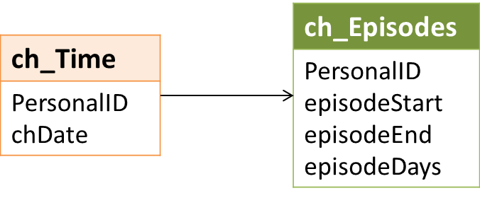

### Logic

For purposes of the LSA, an ‘episode’ is an uninterrupted series of ES/SH/Street dates.

* **episodeStart**is any **ch_Date** where there is no (**ch_Date** – 1 day) for the same PersonalID – i.e., any ES/SH/Street date where there is no information to indicate that the client was in ES/SH or on the street on the day before.
* **episodeEnd**is the first **ch_Date** after **episodeStart** where (**ch_Date** + 1 day) does not exist
* **episodeDays**is the total number of days between **episodeStart** and (**episodeEnd** – 1 day)

## Set Initial LSAPerson CHTime and CHTimeStatus

### Relevant Data

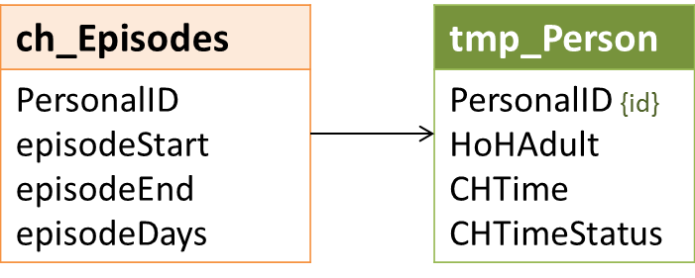

### Logic

For all records in tmp_Person where **HoHAdult**=-0 (the client was not served as a head of household and was under 18), **CHTime**and **CHTimeStatus**will always be equal to -1.

Values for **CHTime** are initially set based on the episodes identified in the previous step:

| Sum of episodeDays | CHTime Value |
| --- | --- |
| < 270 | 0 |
| Between 270 and 364 | 270 |
| >=365 | 365 |

Set tmp_Person.**CHTimeStatus**= -1 (not applicable) where **CHTime** in (0,270).

Where **CHTime** = 365, set **CHTimeStatus** to the first value below for which criteria are met:

| CHTimeStatus | Criteria | Category |
| --- | --- | --- |
| 1 | **episodeEnd** between (**LastActive**– 364 days) and **LastActive** | At least one continuous 365+ day period |
| 2 | Count of episodes >= 4 | Four or more times in ES/SH/Street |
| 3 | Count of episodes < 4 | Less than four episodes in ES/SH/Street |

After applying the above logic:

* Every record in tmp_Person where **HoHAdult** > 0 has a final **CHTime** value > -1
* Every record in tmp_Person where **CHTime** = 365 has a final **CHTimeStatus** value > -1
* For records where **CHTime** = 365 and **CHTimeStatus** is in (1,2), values are final.
* Records where **CHTime** < 365 or **CHTimeStatus** = 3 may be updated in the next step.

## Update LSAPerson CHTime and CHTimeStatus

### Relevant Data

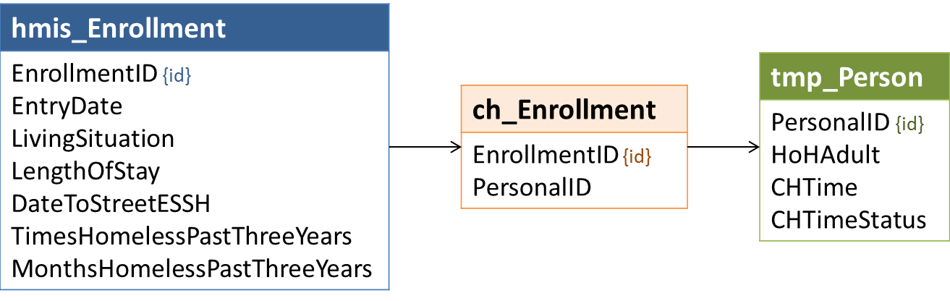

### Logic

For any record in tmp_Person where **CHTime** = 365 and **CHTimeStatus** is in (1,2), the client meets the time criteria for chronic homelessness and no further information is needed.

Clients that do not meet the time criteria based on episodes constructed in the previous steps, however, may meet them based on other *3.917 Living Situation* data.

Set **CHTime** *=* 400 (12 or more months in three years) and **CHTimeStatus** = 2 (4 or more times in ES/SH/Street) where:

* **CHTimeStatus** not in (1,2)
* *EntryDate* for ch_Enrollment >= (**LastActive** – 364 days)
* *TimesHomelessPastThreeYears* = 4 (Four or more times)
* *MonthsHomelessPastThreeYears* in (112, 113) (12 or more than 12 months)

For clients who do not meet CH time criteria, the LSA distinguishes between clients whose data appear to be complete and those that do not.

* Set **CHTimeStatus** = 99 where (**CHTime** in (0,270) or **CHTimeStatus** = 3) and for any ch_Enrollment where*DateToStreetESSH > EntryDate*
* *LivingSituation* in (8,9,99) or is null
* *LengthOfStay* in (8,9,99) or is null
* *ProjectType* in (1,8) and *DateToStreetESSH* is null
* *LivingSituation* in (1,16,18) and *DateToStreetESSH* is null
* *LengthOfStay* in (10,11) and (*PreviousStreetESSH* is null or (*PreviousStreetESSH* = 1 and *DateToStreetESSH* is null))
* *LivingSituation* in (4,5,6,7,15,24) and *LengthOfStay* in (2,3) and (*PreviousStreetESSH* is null or (*PreviousStreetESSH* = 1 and *DateToStreetESSH* is null))
* *TimesHomelessPastThreeYears* in (8,9,99) or is null
* *MonthsHomelessPastThreeYears* in (8,9,99) or is null

## Set LSAPerson Project Group and Household Type Identifiers

### Relevant Data

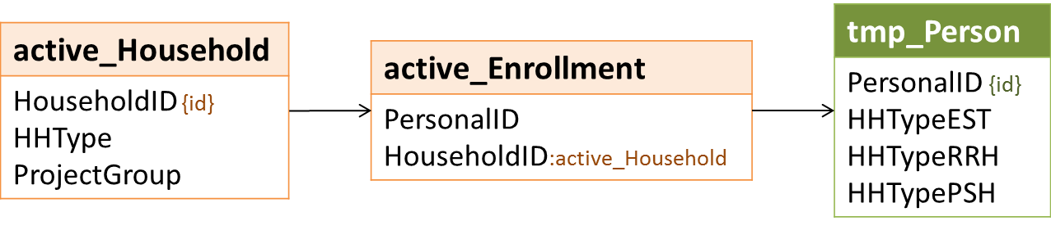

### Logic

LSAPerson includes a household type column for each project group – EST, RRH, and PSH. These columns indicate:

* Whether or not the client was served in the project group; and
* If served in the project group, the household type(s) in which the client was served.

Apart from identifying project groups, the logic for the **HHTypeEST**, **HHTypeRRH**, and **HHTypePSH** columns is identical. The UN household type is only included for people who were not served in any identified household type (AO, AC, or CO) in the project group.

| Household Type(s) for Project Group | HHTypeEST | HHTypeRRH | HHTypePSH |
| --- | --- | --- | --- |
| None - not served in project group | -1 | -1 | -1 |
| AO | 1 | 1 | 1 |
| AC | 2 | 2 | 2 |
| CO | 3 | 3 | 3 |
| AO and AC | 12 | 12 | 12 |
| AO and CO | 13 | 13 | 13 |
| AC and CO | 23 | 23 | 23 |
| UN only | 99 | 99 | 99 |
| AO, AC, and CO | 123 | 123 | 123 |

## Set LSAPerson Head of Household Identifiers

### Relevant Data

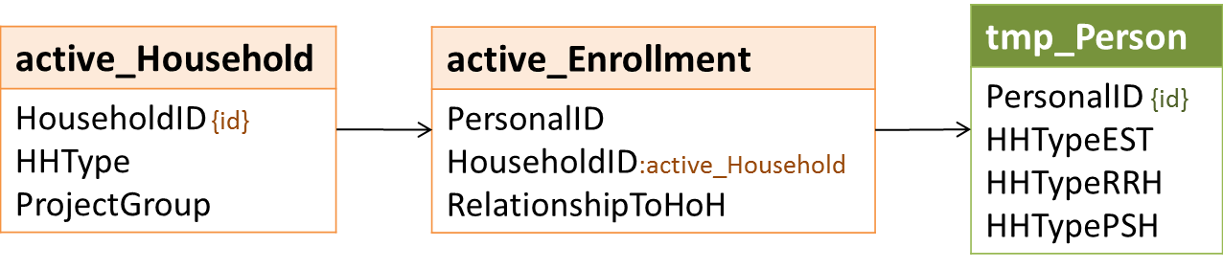

### Logic

LSAPerson includes a head of household column for each project group – EST, RRH, and PSH. These columns indicate:

* Whether or not the client was served in the project group as a head of household; and
* If so, the household type(s) in which the client was served as a head of household.

Apart from being limited to household types in which clients were designated (or reported) head of household, the logic for the **HoHEST**, **HoHRRH**, and **HoHPSH** columns is identical to the **HHType** columns.

| Head of Household Type(s) for Project Group | HoHEST | HoHRRH | HoHPSH |
| --- | --- | --- | --- |
| None - not served in project group | -1 | -1 | -1 |
| AO | 1 | 1 | 1 |
| AC | 2 | 2 | 2 |
| CO | 3 | 3 | 3 |
| AO and AC | 12 | 12 | 12 |
| AO and CO | 13 | 13 | 13 |
| AC and CO | 23 | 23 | 23 |
| UN only | 99 | 99 | 99 |
| AO, AC, and CO | 123 | 123 | 123 |

## Set Population Identifiers for Active HMIS Households

### Relevant Data

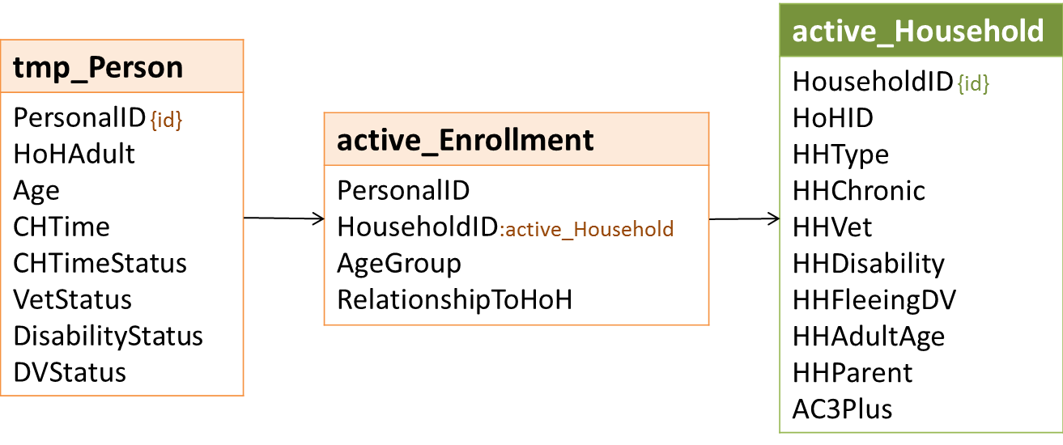

Several populations require that an adult or head of household must meet certain criteria. For example, *Households Currently Fleeing Domestic Violence* population is based on the DV status of adults and/or heads of household.

Information related to DV status comes from tmp_Person – or as it is reported in LSAPerson. Although DV status is only reported for an individual if s/he was served as an adult or head of household on at least one enrollment, it is only relevant to the HMIS household – i.e., a specific enrollment – if the individual was the designated head of household for that *HouseholdID* or an adult during the relevant enrollment (**AgeGroup** for the *EnrollmentID* associated with the *HouseholdID* between 18 and 65).

**Example:**

* Violet, age 17, was enrolled by herself in an ES project and reported that she was fleeing domestic violence at the time.
* Later in the year, Harold and Violet – both 17 – enrolled together in another ES project. Neither reported that they were fleeing DV.

For LSAPerson, Violet’s **DVStatus** is counted as ‘Currently fleeing domestic violence’ – she was the head of household for her first enrollment – and she will be included in counts of people in *Households Currently Fleeing Domestic Violence* in the ES/SH/TH project group.

Whether or not Harold is included in counts of people in *Households Currently Fleeing Domestic Violence* in the ES/SH/TH project group depends on which of them was designated as head of household when they were served together.

* If Harold was the designated HoH, there is no adult or head of household in the Harold+Violet household whose LSAPerson **DVStatus** = ‘Currently fleeing domestic violence’ – Violet is under 18 – and Harold is not counted in the population.
* If Violet was the designated HoH, the Harold+Violet HMIS household is included in the population and Harold is also included in counts of people in *Households Currently Fleeing Domestic Violence* in the ES/SH/TH project group.

### Logic

#### HHChronic

**HHChronic** = 1 if **HHType** is in (1,2,3) and the head of household or any adult in the household is reported in LSAPerson with:

* **DisabilityStatus** = 1; and
* **CHTime** = 365; and
* **CHTimeStatus** in (1,2)

Otherwise, **HHChronic** = -1.

#### HHVet

**HHVet** = 1 if **HHType** is in (1,2) and any adult household member has **VetStatus** = 1. Otherwise, **HHVet** = -1.

#### HHDisability

**HHDisability** = 1 if **HHType** is in (1,2,3) and the head of household or any adult in the household has **DisabilityStatus** = 1. Otherwise, **HHDisability** = -1.

#### HHFleeingDV

**HHFleeingDV** = if **HHType** is in (1,2,3) and the head of household or any adult in the household has **DVStatus** = 1. Otherwise, **HHFleeingDV** = -1.

#### HHAdultAge

**HHAdultAge** is only relevant in AO and AC households (HHType in (1,2)) where all of the adults in the household meet specific age criteria.

Set **HHAdultAge** for each active household to the upload value shown below based on **HHType** and the *first* of the criteria below met by the AgeGroup values in active_Enrollment for all household members.

| Upload Value | Criteria |
| --- | --- |
| -1 | The maximum of all AgeGroup values is >= 98 (one or more unknown ages) |
| -1 | The maximum of all AgeGroup values is <= 17 (no adults in household) |
| 18 | The maximum of all AgeGroup values is 21 (all adults are between 18 and 21) |
| 24 | The maximum of all AgeGroup values is 24 (all adults are under 25) |
| 55 | The minimum of all AgeGroup values is between 55 and 65 (all members are 55+) |
| 25 | (all other households) |

#### HHParent

***HHParent*** = 1 ifone or more active enrollments associated with the *HouseholdID* has *RelationshipToHoH* = 2 where **AgeGroup**< 18; and:

* **HHType**= 2 and **HHAdultAge** <= 24; OR
* **HHType** = 3.

Otherwise, ***HHParent***= -1.

#### AC3Plus

**AC3Plus** = 1 if:

* **HHType** for the active household = 2; and
* The count of distinct *PersonalIDs* from active enrollments associated with the *HouseholdID* where enrollment **AgeGroup**< 18 is >= 3.

Otherwise, **AC3Plus** = 0.

## Set Population Identifiers for LSAPerson from Active Households

### Relevant Data

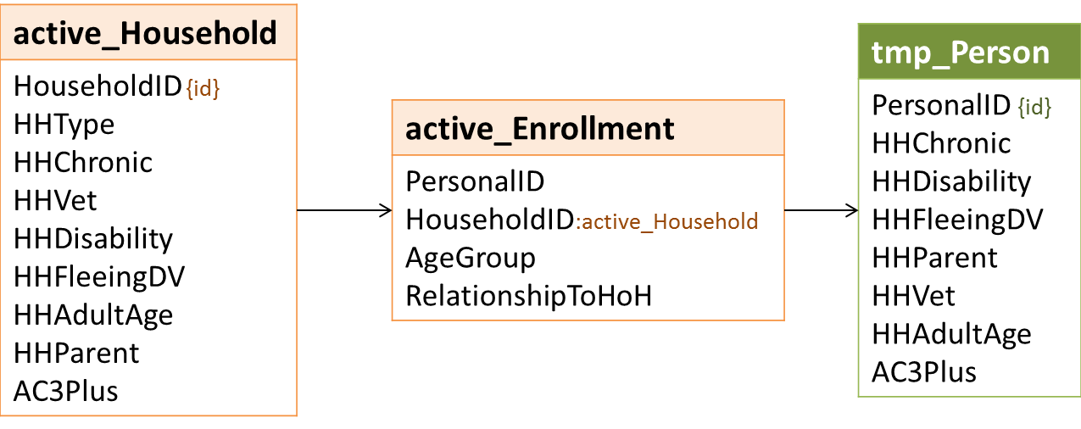

### Logic

#### AC3Plus

Set the value to 1 for any client with an active enrollment associated with an active household where **AC3Plus** = 1.

#### HHAdultAge

Set tmp_Person.**HHAdultAge** based on the first of the criteria below met by any associated active household:

| active_Household | tmp_Person.HHAdultAge |
| --- | --- |
| **HHType** in (1,2) and **HHAdultAge** = 18 | 18 |
| **HHType** in (1,2) and **HHAdultAge** = 24 | 24 |
| **HHType** in (1,2) and **HHAdultAge** = 55 | 55 |
| **HHType** in (1,2) and **HHAdultAge** = 25 | 25 |
| (any other) | -1 |

#### Other Population Identifiers

The process of assigning other population identifiers to tmp_Person from active_Household is similar to the process of assigning project group and head of household identifiers; each column indicates whether or not the client is included in the population and, if so, the associated household types. This step will assign the following population identifiers:

* **HHChronic**
* **HHVet**
* **HHDisability**
* **HHFleeingDV**
* **HHParent**

For clients with no active enrollments associated with an active household where [Population Identifier] = 1 and **HHType** in (1,2,3), set the value in tmp_Person to -1.

For clients with one or more active enrollments associated with an active household where [Population Identifier] = 1 and **HHType** in (1,2,3), set the value in tmp_Person to the appropriate value from the table below.

| Household Type(s) for Population Identifiers | Upload Values |
| --- | --- |
| None - not served in population | -1 |
| AO | 1 |
| AC | 2 |
| CO | 3 |
| AO and AC | 12 |
| AO and CO | 13 |
| AC and CO | 23 |
| AO, AC, and CO | 123 |

## Get Distinct Households for LSAHousehold

### Data Construct: tmp_Household

A household-level construct that serves as the basis for the aggregate LSAHousehold.csv file. Uses distinct combinations of **HoHID** and **HHType** from active_Household as a primary key; includes all columns from LSAHousehold.csv other than **RowTotal** and **ReportID**.

LSAHousehold contains counts of households grouped by 40 different factors. Each household is counted in only one row; the sum of **RowTotal** values is the total number of households.

| Name | Values |
| --- | --- |
| HoHID | *PersonalID* for heads of active households; distinct combinations of **HoHID** and **HHType** serve as a primary key. |
| HHType | The household type, based on the ages of household members – i.e., for every active enrollment associated with the *HouseholdID*  (1 = AO, 2 = AC, 3 = CO, 99 = UN). |
| LastInactive | Where Stat = 5, the most recent date prior to the start of the report period where the household was not engaged with the system. |
| Stat | See LSA Data Dictionary for column descriptions. Logic associated with setting values for this and following columns is defined in the following sections. |
| ReturnTime | See LSA Data Dictionary for column descriptions. |
| HHChronic | See LSA Data Dictionary for column descriptions. |
| HHVet | See LSA Data Dictionary for column descriptions. |
| HHDisability | See LSA Data Dictionary for column descriptions. |
| HHFleeingDV | See LSA Data Dictionary for column descriptions. |
| HoHRace | See LSA Data Dictionary for column descriptions. |
| HoHEthnicity | See LSA Data Dictionary for column descriptions. |
| HHAdult | See LSA Data Dictionary for column descriptions. |
| HHChild | See LSA Data Dictionary for column descriptions. |
| HHNoDOB | See LSA Data Dictionary for column descriptions. |
| HHAdultAge | See LSA Data Dictionary for column descriptions. |
| HHParent | See LSA Data Dictionary for column descriptions. |
| ESTStatus | See LSA Data Dictionary for column descriptions. |
| RRHStatus | See LSA Data Dictionary for column descriptions. |
| RRHMoveIn | See LSA Data Dictionary for column descriptions. |
| PSHStatus | See LSA Data Dictionary for column descriptions. |
| PSHMoveIn | See LSA Data Dictionary for column descriptions. |
| ESDays | See LSA Data Dictionary for column descriptions. |
| THDays | See LSA Data Dictionary for column descriptions. |
| ESTDays | See LSA Data Dictionary for column descriptions. |
| ESTGeography | See LSA Data Dictionary for column descriptions. |
| ESTLivingSit | See LSA Data Dictionary for column descriptions. |
| ESTDestination | See LSA Data Dictionary for column descriptions. |
| RRHPreMoveInDays | See LSA Data Dictionary for column descriptions. |
| RRHPSHPreMoveInDays | See LSA Data Dictionary for column descriptions. |
| RRHHousedDays | See LSA Data Dictionary for column descriptions. |
| SystemDaysNotPSHHoused | See LSA Data Dictionary for column descriptions. |
| RRHGeography | See LSA Data Dictionary for column descriptions. |
| RRHLivingSit | See LSA Data Dictionary for column descriptions. |
| RRHDestination | See LSA Data Dictionary for column descriptions. |
| SystemHomelessDays | See LSA Data Dictionary for column descriptions. |
| Other3917Days | See LSA Data Dictionary for column descriptions. |
| TotalHomelessDays | See LSA Data Dictionary for column descriptions. |
| PSHGeography | See LSA Data Dictionary for column descriptions. |
| PSHLivingSit | See LSA Data Dictionary for column descriptions. |
| PSHDestination | See LSA Data Dictionary for column descriptions. |
| PSHHousedDays | See LSA Data Dictionary for column descriptions. |
| SystemPath | See LSA Data Dictionary for column descriptions. |

### Relevant Data

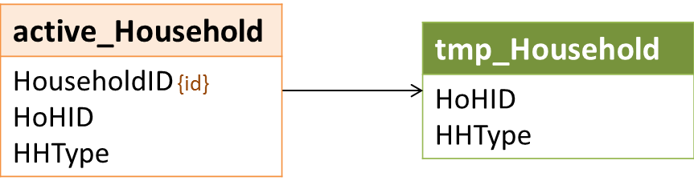

### Logic

For the LSA, each distinct combination of a head of household’s **PersonalID** and **HHType** from all **HouseholdID**s active in the report period is counted as a single household.

Records in the intermediate household-level tmp_Household are created based on distinct combinations of **HHType** and **HoHID** in active_Household.

## Set Population Identifiers for LSAHousehold

### Relevant Data

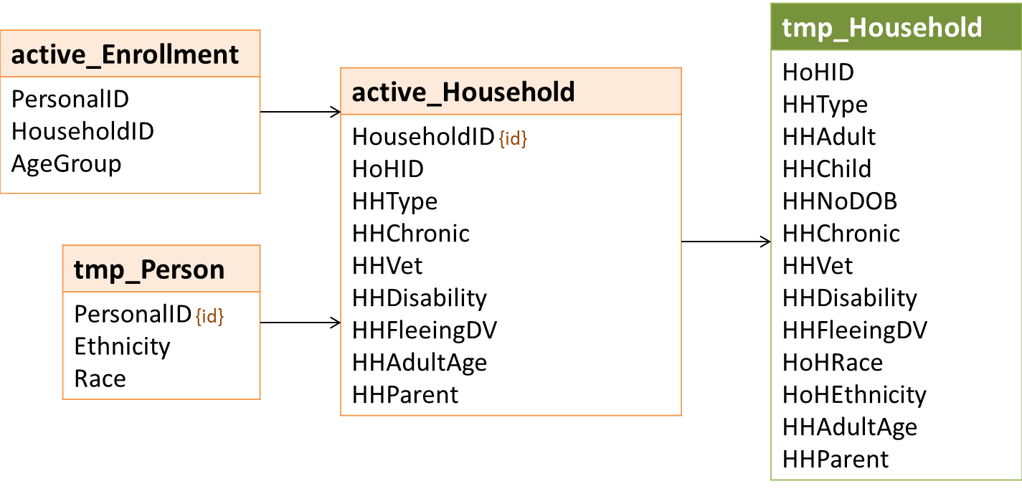

### Logic

#### HHAdult

Count (up to 3) of household members whose **AgeGroup** for *every* associated enrollment is between 18 and 65. Anyone served as both an adult and a child with the same **HoHID**/**HHType** should be counted as a child. (This is only possible in AC households when a household member turns 18 between enrollments and there is another household member still under 18.)

| Value | Category |
| --- | --- |
| 0 | No adult in household |
| 1 | 1 adult in household |
| 2 | 2 adults in household |
| 3 | 3 or more adults in household |

#### HHChild

Count of all household members (up to 3) whose **AgeGroup** for *any* associated enrollment is under 18.

| Value | Category |
| --- | --- |
| 0 | No child in household |
| 1 | 1 child in household |
| 2 | 2 children in household |
| 3 | 3 or more children in household |

#### HHNoDOB

Count of all household members (up to 3) whose **AgeGroup** is in (98,99).

| Value | Category |
| --- | --- |
| 0 | No person with no DOB in household |
| 1 | 1 person with no DOB in household |
| 2 | 2 people with no DOB in household |
| 3 | 3 or more people with no DOB in household |

#### HoHRace and HoHEthnicity

Values for **HoHRace** and **HoHEthnicity** in tmp_Household should be identical to **Race** and **Ethnicity** values for the head of household in tmp_Person.

#### HHVet, HHChronic, HHDisability, HHFleeingDV, and HHParent

Set the value in tmp_Household to the maximum value for the corresponding column in active_Household – i.e., if the value is 1 for any *HouseholdID* for the same **HoHID** and **HHType**, set the value in tmp_Household to 1. Otherwise, set the value to -1.

#### HHAdultAge

Set **HHAdultAge** based on the *first* of the criteria below met by any active_Household record with the same **HHType** and **HoHID**:

| active_Household | tmp_Person.HHAdultAge |
| --- | --- |
| **HHAdultAge** = 18 | 18 |
| **HHAdultAge** = 24 | 24 |
| **HHAdultAge** = 55 | 55 |
| **HHAdultAge** = 25 | 25 |
| (any other) | -1 |

The populations for which **HHAdultAge** are relevant are:

* AO Unaccompanied Youth 18-21 (HHType = 1 and HHAdultAge = 18) – all household members are between the ages of 18 and 21
* AO Unaccompanied Youth 22-24 – (HHType = 1 and HHAdultAge = 18) at least one household member is between 22 and 24; all are between 18 and 24
* AO Non-Veteran Households 25+ - at least one household member is over 24
* AO Senior Households 55+ - all household members are 55 or older
* AC Parenting Youth 18-24 – all adults in the household are between 18 and 24; there are no household members of unknown age

In general, each distinct combination of **HoHID**/**HHType** from active_Household is counted in all populations identified for associated *HouseholdIDs*. Technically, a non-veteran served alone – once once at age 24 and again at 25 – is a member of two populations:

* Unaccompanied Young Adults 18-24; and
* Non-Veteran Households 25+.

With a single upload value for **HHAdultAge** in both LSAHousehold and LSAPerson, it isn’t possible to identify both;. Inclusion in youth and senior populations is prioritized over the Non-Veteran Households 25+ population.

## Set LSAHousehold Project Group Status Indicators

### Relevant Data

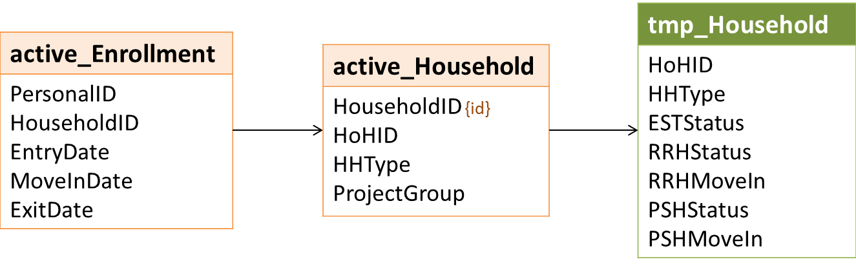

### Logic

Like tmp_Person, tmp_Household includes columns to indicate the project groups in which each household was served.

The logic and upload values associated with **ESTStatus**, **RRHStatus**, and **PSHStatus** are identical, aside from the project group. Rather than repeating the same text for EST, RRH, and PSH columns, the following sections use ‘x’ in place of the project group identifier – e.g., **xStatus** instead of **ESTStatus**.

**xStatus** values are based on:

* Earliest *EntryDate* for an active enrollment in ProjectGroup x; and
* A null value for *ExitDate* on any active enrollment in the project group OR the latest *ExitDate.*

For every record in tmp_Household:

| Earliest x *EntryDate* | Latest x *ExitDate* | xStatus Value |
| --- | --- | --- |
| NULL | n/a | 0 |
| < ReportStart | NULL / there is an active enrollment for x with no *ExitDate* | 11 |
| < ReportStart | Between ReportStart and ReportEnd | 12 |
| >= ReportStart | NULL / there is an active enrollment for x with no *ExitDate* | 21 |
| >= ReportStart | Between ReportStart and ReportEnd | 22 |

**Note**: 2 is also a valid value for **xStatus** but is not assigned until a later step.

## Set RRH and PSH Move-In Status Indicators

### Relevant Data

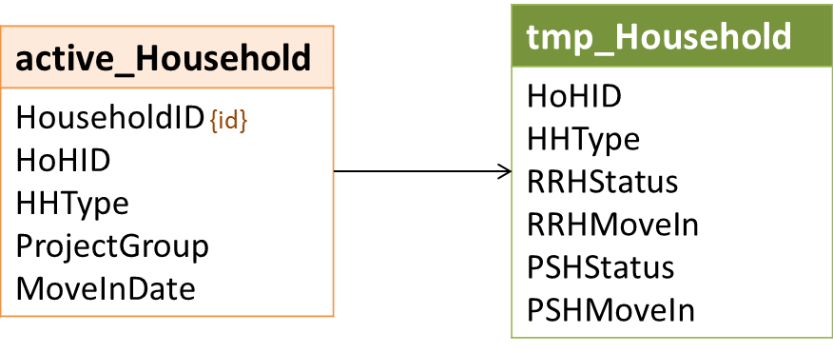

### Logic

Aside from the project type, the logic and upload values associated with *RRHMoveIn* and *PSHMoveIn* are identical. They are based on **RRHStatus** and **PSHStatus**, respectively, and move-in dates for relevant enrollments.

For all records in tmp_Household:

| xStatus Value | MoveInDate | xMoveIn Value |
| --- | --- | --- |
| <= 2 | Any | -1 |
| > 2 | There is no *MoveInDate* | 0 |
| > 2 | Most recent *MoveInDate* >= ReportStart | 1 |
| > 2 | Most recent *MoveInDate* < ReportStart | 2 |

## Set LSAHousehold Demographics

### Relevant Data

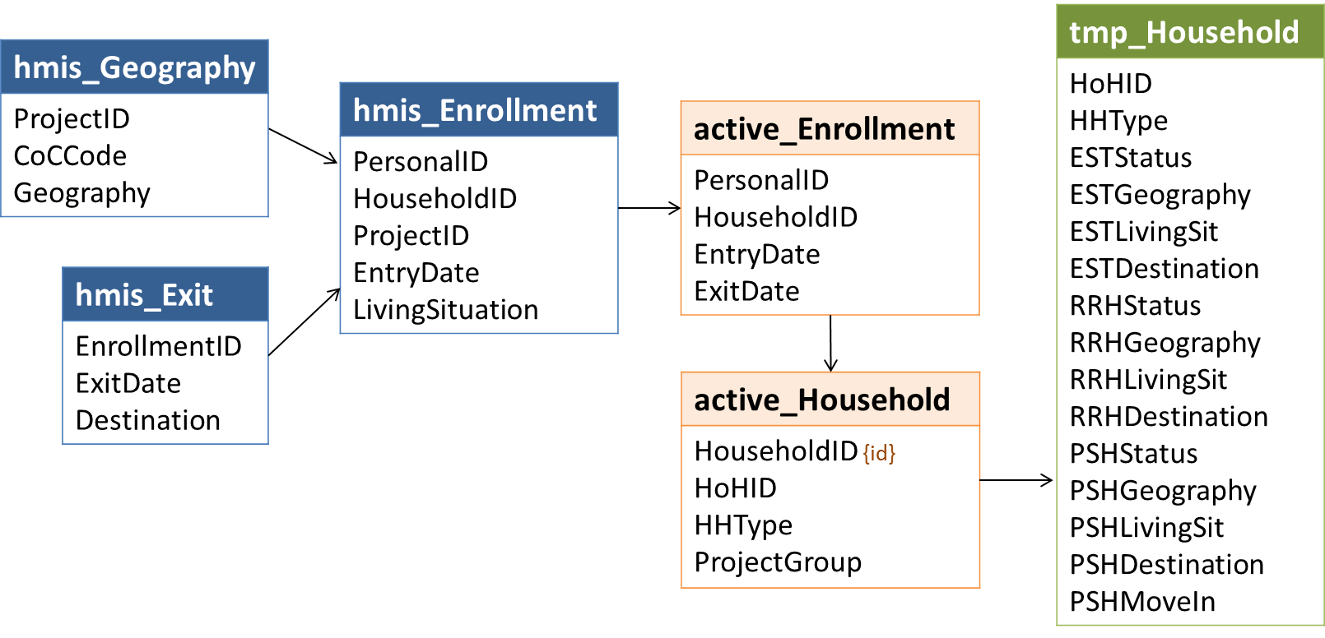

The logic and upload values associated with project geography, living situation, and destinations for each project group are identical. Rather than repeating the same text for EST, RRH, and PSH columns, the following sections use ‘x’ in place of the project group identifier – e.g., **xStatus** instead of **ESTStatus**.

### Logic

#### Geography

For all records in tmp_Household, if:

* **xStatus** <= 2, set **xGeography** = -1.
* **xStatus** > 2, set **xGeography** based on:
  + The active_Enrollment with the latest active date in the report period where *ProjectGroup* = ‘x’ ; and
  + The record of *Geography* for the associated *ProjectID* with the latest *InformationDate* that is on or before the last active date:
    - If *Geography* associated with enrollment *ProjectID* is in (1,2,3), set **xGeography** = *Geography.*
    - Otherwise, set **xGeography** = 99.

| HMIS Value | HMIS Response Category | LSA Value |
| --- | --- | --- |
| 1 | Urban | 1 |
| 2 | Suburban | 2 |
| 3 | Rural | 3 |

#### Living Situation

For all records in tmp_Household, if:

* **xStatus** <= 2, set **xLivingSit** = -1.
* **xStatus** >2, for the active_Enrollment where **ProjectGroup** = ‘x’ with the earliest *EntryDate* date, crosswalk HMIS/LSA values as shown in the table below and set **xLivingSit** = LSA Value

| HMIS Value | HMIS Response Category | LSA Value |
| --- | --- | --- |
| 16 | Place not meant for habitation | 1 |
| 1 | Emergency shelter | 2 |
| 18 | Safe Haven | 2 |
| 27 | Interim Housing | 3 |
| 2 | Transitional housing for homeless persons | 4 |
| 14 | Hotel or motel paid for without ES voucher | 5 |
| 26 | Residential project with no homeless criteria | 6 |
| 12 | Staying or living with family | 7 |
| 13 | Staying or living with friends | 8 |
| 3 | Permanent housing for formerly homeless persons | 9 |
| 21 | Owned by client, with ongoing housing subsidy | 10 |
| 23 | Owned by client, no ongoing housing subsidy | 10 |
| 22 | Rental by client, no ongoing housing subsidy | 11 |
| 19 | Rental by client, with VASH subsidy | 12 |
| 25 | Rental by client, with GPD TIP subsidy | 12 |
| 20 | Rental by client, with other housing subsidy (including RRH) | 12 |
| 15 | Foster care home or foster care group home | 13 |
| 24 | Long-term care facility or nursing home | 14 |
| 7 | Jail, prison or juvenile detention facility | 15 |
| 6 | Hospital or other residential non-psychiatric medical facility | 16 |
| 4 | Psychiatric hospital or other psychiatric facility | 16 |
| 5 | Substance abuse treatment facility or detox center | 16 |
|  | (any other) | 99 |

#### Destination

For all records in tmp_Household, if:

* **xStatus** not in (12,22), set **xDestination** = -1.
* **xStatus** in (12,22), for the most recent active_Enrollment.*ExitDate* where *ProjectGroup* = ‘x’, crosswalk HMIS/LSA values as shown in the table below and set **xDestination** = LSA Value

| HMIS Value | HMIS Response Category | LSA Value |
| --- | --- | --- |
| 3 | Permanent housing (other than RRH) for formerly homeless persons | 1 |
| 31 | Rental by client, with RRH or equivalent subsidy | 2 |
| 19 | Rental by client, with VASH housing subsidy | 3 |
| 20 | Rental by client, with other ongoing housing subsidy | 3 |
| 21 | Owned by client, with ongoing housing subsidy | 3 |
| 26 | Moved from one HOPWA funded project to HOPWA PH | 3 |
| 28 | Rental by client, with GPD TIP housing subsidy | 3 |
| 10 | Rental by client, no ongoing housing subsidy | 4 |
| 11 | Owned by client, no ongoing housing subsidy | 4 |
| 22 | Staying or living with family, permanent tenure | 5 |
| 23 | Staying or living with friends, permanent tenure | 6 |
| 15 | Foster care home or foster care group home | 7 |
| 25 | Long-term care facility or nursing home | 7 |
| 4 | Psychiatric hospital or other psychiatric facility | 8 |
| 5 | Substance abuse treatment facility or detox center | 8 |
| 6 | Hospital or other residential non-psychiatric medical facility | 8 |
| 7 | Jail, prison or juvenile detention facility | 9 |
| 14 | Hotel or motel paid for without emergency shelter voucher | 10 |
| 29 | Residential project or halfway house with no homeless criteria | 10 |
| 1 | Emergency shelter, including hotel or motel paid for with ES voucher | 11 |
| 2 | Transitional housing for homeless persons | 11 |
| 18 | Safe Haven | 11 |
| 27 | Moved from one HOPWA funded project to HOPWA TH | 11 |
| 16 | Place not meant for habitation | 12 |
| 12 | Staying or living with family, temporary tenure | 13 |
| 13 | Staying or living with friends, temporary tenure | 14 |
| 24 | Deceased | 15 |
|  | (any other) | 99 |

## System Engagement Status and Return Time

### Relevant Data

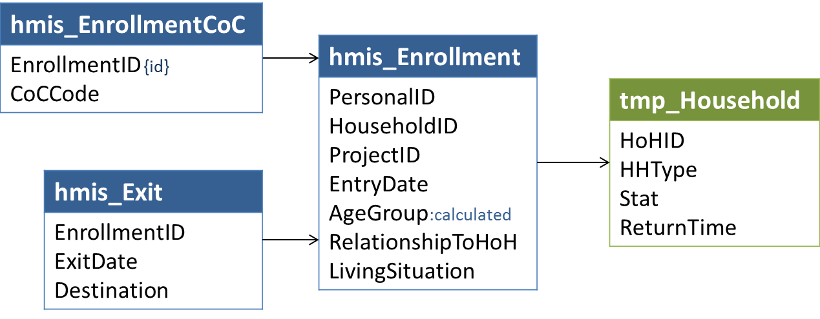

### Logic

**Stat** refers to the household status related to continuum engagement on the first day of the earliest enrollment active during the report period in the following categories:

| Value | Category |
| --- | --- |
| 1 | First-time homeless |
| 2 | Return to continuum 15-730 days after exit to permanent destination |
| 3 | Re-engage with continuum 15-730 days after exit to temporary destination |
| 4 | Re-engage with continuum 15-730 days after exit to unknown destination |
| 5 | Continuous engagement with continuum |

When **Stat** = (2,3,4), **ReturnTime** refers to the length of time in days between exit and the earliest active enrollment.

For households already enrolled on ReportStart (**PSHStatus** in (11,12) or **RRHStatus** in (11,12) or **ESTStatus** in (11,12)), set **Stat** = 5 (household has been continuously engaged) and **ReturnTime** = -1.

Using the head of household’s earliest *EntryDate* for an active_Enrollment, search for the most recent exit where:

* *ProjectType* in (1,2,3,8,13)
* *ExitDate* >= (active_Enrollment.**EntryDate** *-* 730 days)
* PersonalID = active_Enrollment.**HoHID** and RelationshipToHoH = 1
* *HHType* (as calculated for the enrollment) = active_Enrollment.**HHType**
* Most recent *EnrollmentCoC* = ReportCoC

If there is no exit for the head of household in the 2 years prior to enrollment, **set Stat = 1** (first time homeless) and **ReturnTime = -1.**

If there are one or more exits, calculate the number of days between the most recent *ExitDate* and the earliest active_Enrollment *EntryDate*.

* If the number of days is < 15, set **Stat** = 5and **ReturnTime** = -1 (household has been continuously engaged).
* If the number of days is >= 15, set **ReturnTime** to the appropriate value below.

| Value | Category |
| --- | --- |
| -1 | n/a |
| 30 | 30 days |
| 60 | 31-60 days |
| 90 | 61-90 days |
| 180 | 91-180 days |
| 365 | 181-365 days |
| 547 | 366-547 days |
| 730 | 548-730 days |

* **Set Stat** based on the *Destination* of the exit and the appropriate upload value below.

| LSA Value | Category | HMIS Destination Values |
| --- | --- | --- |
| 1 | First-time homeless | (n/a) |
| 2 | Return 15-730 days after exit to permanent destination | 3,31,19,20,21,26,28,10,11,22,23 |
| 3 | Re-engage 15-730 days after exit to temporary destination | 15,25,4,5,6,7,14,29,1,2,18,27,16,12,13 |
| 4 | Re-engage 15-730 days after exit to unknown destination | (any other) |
| 5 | Continuous engagement with continuum | (n/a) |

## Get Dates In RRH Pre-Move-In

### Relevant Data

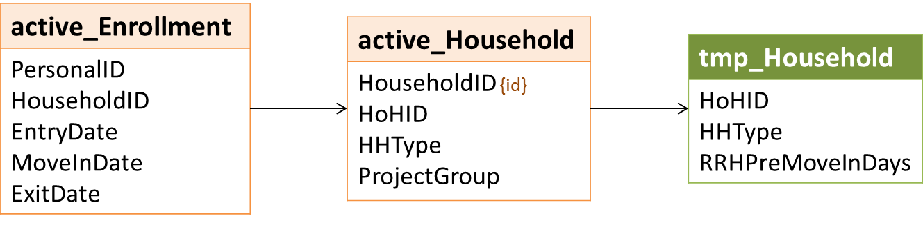

### Logic

The logic associated with the LSAHousehold.**RRHPreMoveInDays** column differs from others that count days engaged in various parts of the system, referred to collectively as ‘system use days.’ The other counts resolve potential data conflicts so that each day has a single status and is counted only once. For example, days spent in RRH prior to move-in that overlap with days in emergency shelter are counted as ES days.

The **RRHPreMoveInDays** column is a count of these days regardless of other system use data.

For each record in active_Household where **HoHID**/**HHType** = tmp_Household. **HoHID**/**HHType** and **ProjectGroup** = ‘RRH’ set **RRHPreMoveInDays** = a count of the distinct dates between any active_Enrollment.**EntryDate** and the earliest associated non-null value for:

* **MoveInDate** – 1 day
* **ExitDate** – 1 day
* ReportEnd

## Get Dates Housed in PSH or RRH

### Data Construct: sys_Time

The primary key for sys_Time is the unique combination of **HoHID**, **HHType**, and **sysDate** – i.e., no date can be counted with more than one status for any given LSA household.

| Name | Values |
| --- | --- |
| HoHID | HoHID – tmp_Household |
| HHType | HHType – tmp_Household |
| sysDate | Distinct dates enrolled in a continuum project and/or Street/ES/SH dates from *3.917 Living Situation* |
| sysStatus | 1 = Housed in PSH  2 = Housed in RRH  3 = In TH  4 = In ES/SH  5 = In PSH pre-move-in  6 = In RRH pre-move-in  7 = Street/ES/SH (3.917) |

### Relevant Data

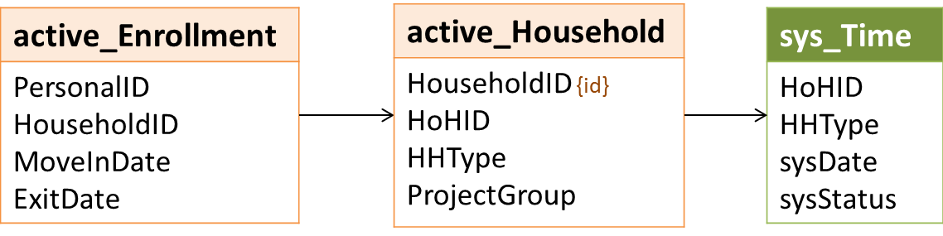

### Logic

LSAHousehold includes counts of the total number of days that a head of household was either homeless and/or engaged in various parts of the system, referred to collectively as ‘system use days.’ The counts are grouped by the client’s system status – i.e., ‘Days in TH’ or ‘Days housed in PSH’ – on each relevant date.

Similar to the process of counting days for chronic homelessness, a head of household’s system use status for any given date is assigned in priority order, using the *first* status from the list below, in priority order, for which the HoH meets the identified criteria.

| Priority | Status | [Date] |
| --- | --- | --- |
| 1 | Housed in PSH | *MoveInDate* to (*ExitDate* – 1 day)/ReportEnd |
| 2 | Housed in RRH | *MoveInDate* to (*ExitDate* – 1 day)/ReportEnd |
| 3 | In TH | *EntryDate* to (*ExitDate* – 1 day)/ReportEnd |
| 4 | In entry-exit ES/SH | *EntryDate* to (*ExitDate* – 1 day)/ReportEnd |
| 4 | In night-by-night ES | = *BedNightDate* |
| 5 | Enrolled but not housed in PSH | *EntryDate* to (*MoveInDate*/*ExitDate* – 1 day)/ReportEnd |
| 6 | Enrolled but not housed in RRH | *EntryDate* to (*MoveInDate*/*ExitDate* – 1 day)/ReportEnd |
| 7 | Street/ES/SH (3.917) | *DateToStreetESSH* to (*EntryDate* – 1 day) |

In the CH process, dates associated with any *EnrollmentID* for a given client may be relevant, regardless of household type or head of household status for the enrollment. However, counting system use days based on HMIS enrollments requires both that:

* The [HHType], as calculated for the *HouseholdID,* is equal to tmp_Household.**HHType**; and
* hmis_Enrollment.*PersonalID* = tmp_Household.**HoHID** and hmis_Enrollment.*RelationshipToHoH* = 1.

#### Dates Housed in PSH

For each **HoHID**/**HHType** in tmp_Household, create a record with a **sysStatus** = 1 in sys_Time for any [Date] <= ReportEnd where:

* **ProjectGroup** in active_Household is ‘PSH’; and
* **RelationshipToHoH** = 1; and
* **MoveInDate** <= [Date]; and
* **ExitDate** > [Date] or is null

#### Dates Housed in RRH

For each **HoHID**/**HHType** in tmp_Household, create a record with a **sysStatus** = 2 in sys_Time for any [Date] <= ReportEnd where:

* **sysDate** in sys_Time<> [Date] (There is no record for the date in sys_Time)
* **ProjectGroup** in active_Household is ‘RRH’; and
* **RelationshipToHoH** = 1; and
* **MoveInDate** <= [Date]; and
* **ExitDate** > [Date] or is null

## Get Enrollments Relevant to Last Inactive Date and Other System Use Days

### Data Construct: sys_Enrollment

|  |  |
| --- | --- |
| **Name** | **Values** |
| **HoHID** | tmp_Household |
| **HHType** | tmp_Household |
| **EnrollmentID** | hmis_Enrollment |
| **ProjectType** | hmis_Project |
| **EntryDate** | hmis_Enrollment |
| **ExitDate** | hmis_Exit (< ReportStart) |

### Relevant Data

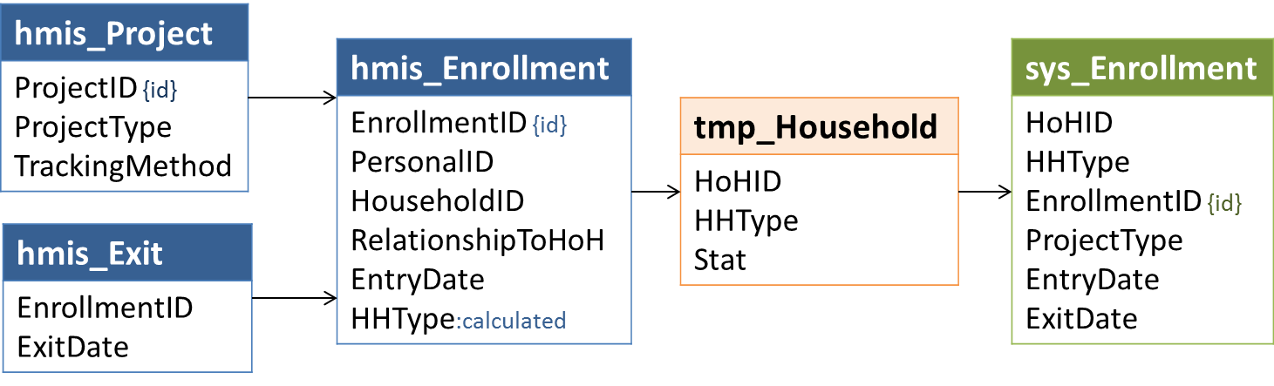

### Logic

Both active enrollments and inactive enrollments (i.e, *ExitDate* < ReportStart) for each distinct **HoHID**/**HHType** in tmp_Household are represented here in the data construct sys_Enrollment.

All active enrollments are relevant to counting system use days and are included in sys_Enrollment.

Inactive enrollments are *potentially* relevant. They are included in sys_Enrollment; the logic associated with determining which, if any, are part of a period of continuous system engagement and actually relevant to counts of system use days is described in the next section.

For records in tmp_Household where:

* tmp_Household.**Stat** = 5
* tmp_Household.**PSHStatus** <> 2

The *potentially* relevant inactive enrollments include those where:

* *ExitDate* > 10/1/2012 and *ExitDate <* ReportStart
* *PersonalID* = tmp_Household.**HoHID**
* [HHType] (as calculated for the *HouseholdID)* = tmp_Household.**HHType**
* *RelationshipToHoH* = 1
* hmis_Project.*ContinuumProject* = 1
* hmis_Project.*ProjectType* in (1,2,3,8,13)
* If *ProjectType* in (3,13), *MoveInDate* is null
* There is at least one *EnrollmentCoC* record for the *EnrollmentID* where *CoCCode* = ReportCoC

For night-by-night shelters (*ProjectType*= 1and *TrackingMethod* = 3), only bed nights are actually counted. Creating a record in the sys_Enrollment construct for these enrollments where *EntryDate* and *ExitDate* are null – regardless of bed nights – simplifies later steps.

## Get Last Inactive Date

### RelevantData

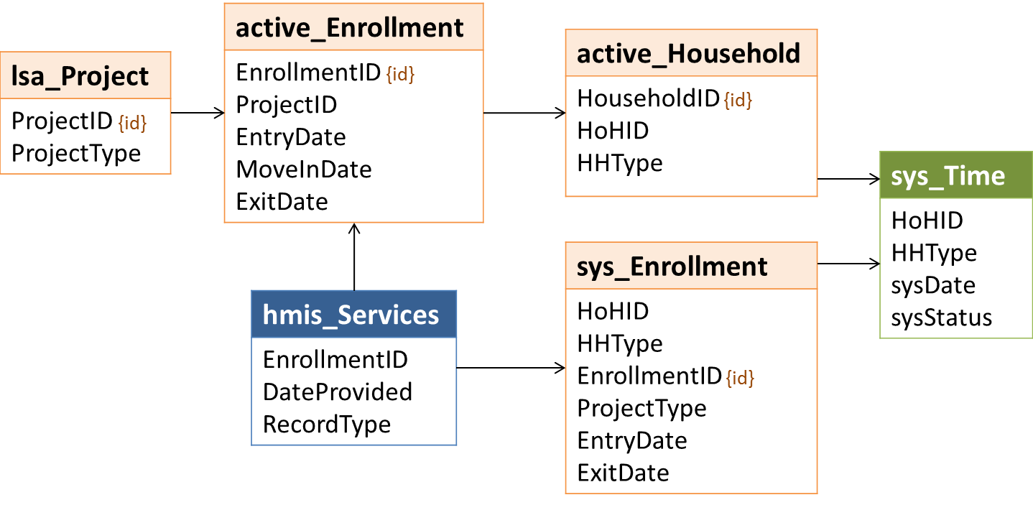

### Logic

This step identifies, based on active enrollments and the potentially relevant inactive enrollments from the previous step, the date immediately prior to the first day of continuous system engagement for which all system use days are counted – or the household’s last inactive date.

Specifically, this is the latest date in the most recent period of at least seven nights during which a household was not enrolled in a continuum ES, SH, TH, RRH, or PSH project AND was not housed in RRH or PSH. This is the date after which all system use days are reportable. Enrollments prior to the last inactive date are excluded from counts of system use days in the next section.

**LastInactive** is the later of 9/30/2012 and the most recent date where:

* [Date] < tmp_Household.**FirstEntry**
* [Date] is not between a sys_Enrollment.*BedNightDate* and (*BedNightDate* + 6 days); and
* [Date] is not between a sys_Enrollment.**EntryDate** and the associated (**ExitDate** + 6 days)

## Get Dates of Other System Use

### Relevant Data

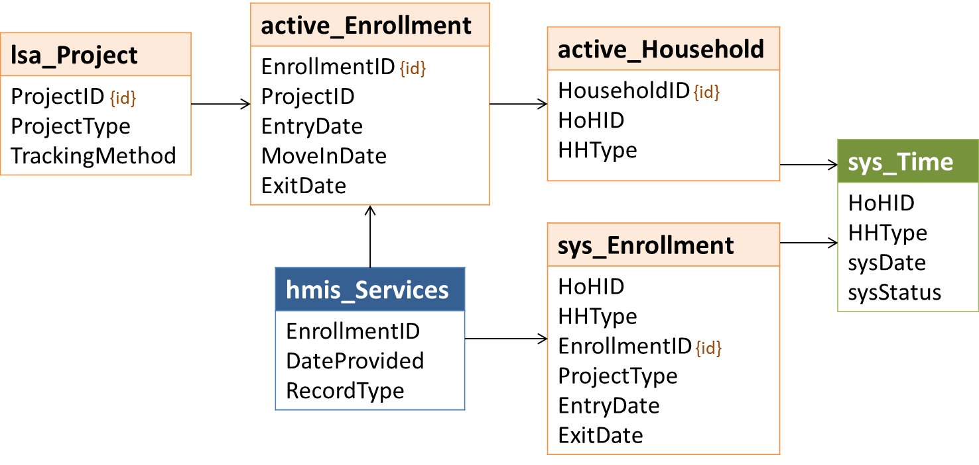

### Logic

The sys_Time data construct is populated with dates housed in RRH (sysStatus = 2) or PSH (sysStatus = 1) in step 4.31. Other system use days which do not conflict with dates housed on RRH/PSH are added in this step.

For each **HoHID**/**HHType** in sys_Enrollment, create a record in sys_Time for any [Date] where:

* **EnrollmentID** in sys_Enrollment; and
* [Date] is not in sys_Time for the same **HoHID**/**HHType;** and
* **EntryDate** > tmp_Household.**LastInactive**
* [Date] is between **EntryDate** and **ExitDate**
* If a night-by-night shelter (sys_Enrollment.**EntryDate** is null), [Date] = a bed night date

The **sysStatus** values referenced in the next sections are based on project type:

| Value | Category |
| --- | --- |
| 3 | In transitional housing |
| 4 | In emergency shelter/Safe Haven |
| 5 | Enrolled but not housed in PSH |
| 6 | Enrolled but not housed in RRH |

If a [Date] meets the criteria for more than one **sysStatus** based on the list below, use the **sysStatus** with the lowest value. For example, if a client has overlapping enrollments in both an emergency shelter (**sysStatus** = 4) and a transitional housing project (**sysStatus** = 3) on a single date, the **sysStatus** for that date should be the lower of the two values (3).

| Value | Criteria |
| --- | --- |
| 3 | between **EntryDate** and **ExitDate** and lsa_Project.**ProjectType** = 2 |
| 3 | between **EntryDate** and **ExitDate** and sys_Enrollment***.*ProjectType** = 2 |
| 4 | between **EntryDate** and **ExitDate** and sys_Enrollment***.*ProjectType** in (1,8) |
| 4 | between **EntryDate** and **ExitDate** and lsa_ Project.**ProjectType** in (1,8) and **TrackingMethod** <> 3 |
| 4 | = *BedNightDate* |
| 5 | between **EntryDate** and **ExitDate** and sys_Enrollment***.*ProjectType** = 3 |
| 5 | between **EntryDate** and the earliest non-null of **MoveInDate**/**ExitDate/**ReportEndand lsa_Project***.*ProjectType** = 3 |
| 6 | between **EntryDate** and **ExitDate** and sys_Enrollment***.*ProjectType** = 13 |
| 6 | between **EntryDate** and the earliest non-null of **MoveInDate**/**ExitDate/**ReportEndand lsa_Project***.*ProjectType** = 13 |

## Get Other Dates Homeless from 3.917 Living Situation

### Relevant Data

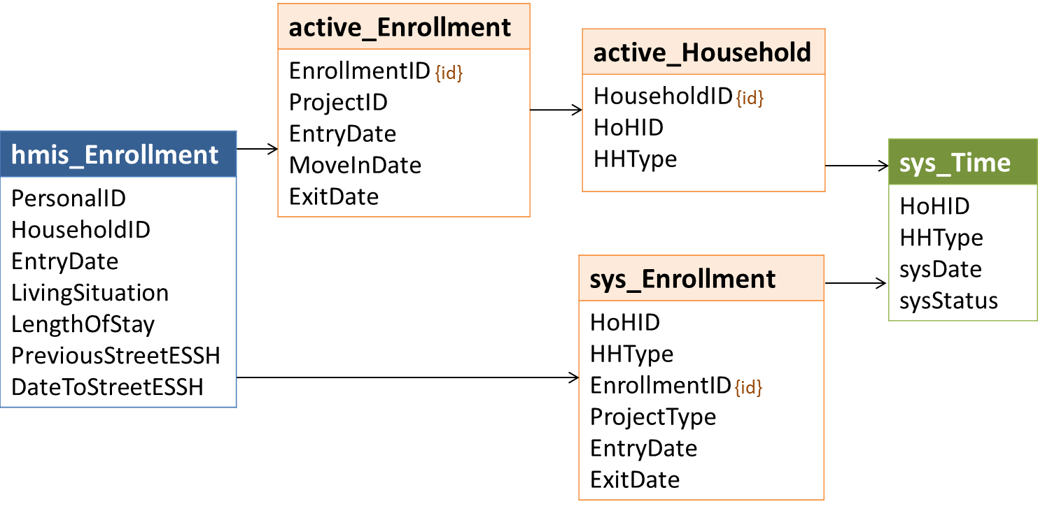

### Logic

Dates that are documented as Street/ES/SH dates in *3.917 Living Situation*, do not have a status based on system use, and are contiguous to the period of continuous engagement should be counted as such for LOTH reporting. Unlike system use, this may include both dates prior to **LastInactive** and dates prior to 10/1/2012**.**

For any **EnrollmentID** from sys_Enrollment where:

* *EntryDate >* **LastInactive**; and
* **HoHID**/**HHType** = tmpHousehold **HoHID**/**HHType**; and
  + *LivingSituation* in (1,18,16) or *ProjectType* in (1,8); or
  + *LengthOfStay* in (10, 11) and *PreviousStreetESSH* = 1; or
  + *LivingSituation* in (4,5,6,7,15,24) and *LengthOfStay* in (2,3) and *PreviousStreetESSH* = 1

The value of **Other3917Days** is equal to the count of all dates:

* Between the later of *DateToStreetESSH* or **LastInactive** and the day prior to the associated *EntryDate* where the date does not already have a status based on system use..
* Between any *DateToStreetESSH* and the day prior to **LastInactive** where the associated *EntryDate* is >= LastInactive.

In the sample code:

* **Other3917Days** in tmp_Household is populated with the difference in days between the earliest of any *DateToStreetESSH* prior to **LastInactive** and **LastInactive**.
* Records for dates after **LastInactive** are created in sys_Time with **sysStatus** = 7;
* A count of dates in sys_Time where **sysStatus** = 7 is added in the next step to the value in **Other3917Days.**

## Set System Use Days for LSAHousehold

### Relevant Data

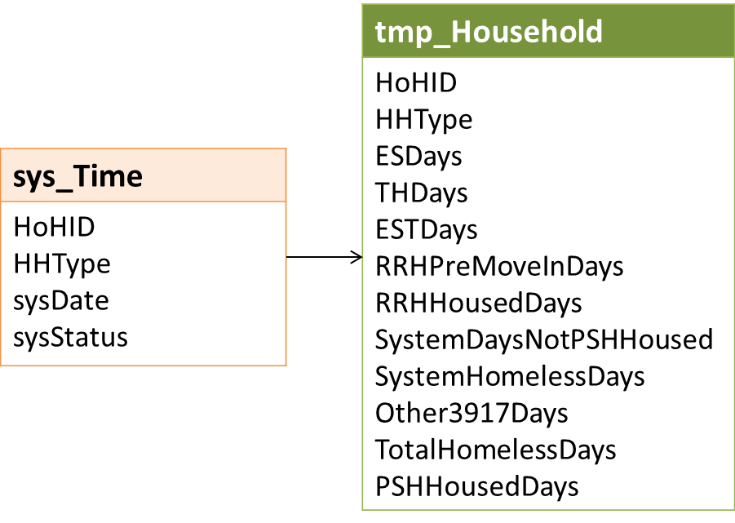

### Logic

Thevalues for system use days columns in tmp_Household should be set to the actual number of days counted and NOT the associated upload value; the actual number of days are needed to generate averages for LSACalculated.

#### ESDays

1. Set **ESDays** = count of distinct **sysDate**s in sys_Time where **sysStatus** = 4 and **HoHID/HHType** = tmp_Household **HoHID/HHType.**
2. If the value = 0 and **ESTStatus** = 0, set **ESDays** = -1.

#### THDays

1. Set **THDays** = count of distinct **sysDate**s in sys_Time where **sysStatus** = 3 and **HoHID/HHType** = tmp_Household **HoHID/HHType.**
2. If the value = 0 and **ESTStatus** = 0, set **THDays** = -1.

#### ESTDays

1. Set **ESTDays** = count of distinct **sysDate**s in sys_Time where **sysStatus** in (3,4) and **HoHID/HHType** = tmp_Household **HoHID/HHType.**
2. If the value = 0 and **ESTStatus** = 0, set **ESTDays** = -1.

#### RRHPSHPreMoveInDays

1. Set **RRHPSHPreMoveInDays** = count of distinct **sysDate**s in sys_Time where **sysStatus** in (5,6) and **HoHID/HHType** = tmp_Household **HoHID/HHType.**
2. If the value = 0 and **RRHStatus** = 0 and **PSHStatus** = 0, set **RRHPSHPreMoveInDays** = -1.

#### SystemHomelessDays

Set **SystemHomelessDays** = count of distinct **sysDate**s in sys_Time where **sysStatus** in (3,4,5,6) and **HoHID/HHType** = tmp_Household **HoHID/HHType.**

#### RRHHousedDays

1. Set **RRHHousedDays** = count of distinct **sysDate**s in sys_Time where **sysStatus** = 2 and **HoHID/HHType** = tmp_Household **HoHID/HHType.**
2. If the value = 0 and **RRHStatus** = 0, set **RRHHousedDays** = -1.

#### SystemDaysNotPSHHoused

Set **SystemDaysNotPSHHoused**= count of distinct **sysDate**s in sys_Time where **sysStatus** in (2,3,4,5,6) and **HoHID/HHType** = tmp_Household **HoHID/HHType.**

#### PSHHousedDays

1. Set **PSHHHousedDays** = count of distinct **sysDate**s in sys_Time where **sysStatus** = 1 and **HoHID/HHType** = tmp_Household **HoHID/HHType.**
2. If the value = 0 and **PSHStatus** = 0, set **PSHHousedDays** = -1.

#### Other3917Days

Set **Other3917Days** = the sum of:

* The count of distinct **sysDate**s in sys_Time where **sysStatus** = 7 and **HoHID/HHType** = tmp_Household **HoHID/HHType;** and
* The count of distinct dates between the earliest relevant *DateToStreetESSH* and **LastInactive** – or the difference in days between the earliest *DateToStreetESSH* and **LastInactive**, as described in section 4.35.

## Update ESTStatus and RRHStatus

### Relevant Data

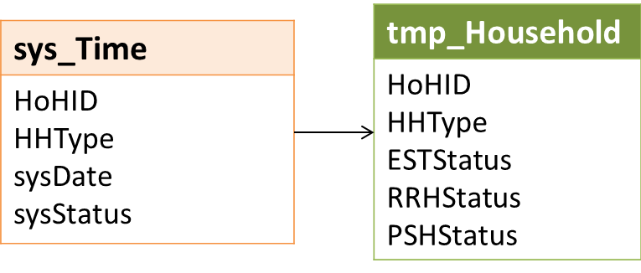

### Logic

For any **HoHID**/**HHType** in tmp_Household where **Stat** = 5 (continuous engagement), the household may have system use days from prior to the report period for project types other than those from the report period.

Set **ESTStatus** = 2 (Served in contiguous period prior to report start only) where

* **ESTStatus** = 0 and
* Any record in sys_Time for the **HoHID**/**HHType** has a **sysStatus** in (3,4)

Set **RRHStatus** = 2 (Served in contiguous period prior to report start only) where:

* **RRHStatus** = 0 and
* Any record in sys_Time for the **HoHID**/**HHType** has a **sysStatus** = 6

## Set SystemPath for LSAHousehold

### Relevant Data

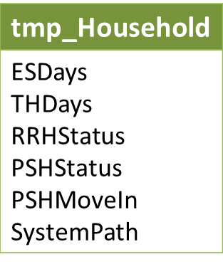

### Logic

The **SystemPath** column is technically redundant – it is based entirely on values in other LSAHousehold columns – but having the value in a single column simplifies the processes of populating LSACalculated and, in the HDX 2.0, generating report tables.

As noted previously, heads of household housed in PSH at ReportStart who did not enroll in any other project types during the report period are excluded from all reporting on LOTH and system path. For those households, **SystemPath** is always set to -1. The critiera for all values are listed below.

| Name | SystemPath | ESTStatus | ESDays | THDays | RRHStatus | PSHStatus | PSHMoveIn |
| --- | --- | --- | --- | --- | --- | --- | --- |
| Not applicable | -1 | Not in (21,22) | -- | -- | Not in (21,22) | -- | 2 |
| ES/SH only | 1 | -- | >= 1 | = 0 | = 0 | = 0 | -- |
| TH only | 2 | -- | = 0 | >= 1 | = 0 | = 0 | -- |
| ES/SH + TH | 3 | -- | >= 1 | >= 1 | = 0 | = 0 | -- |
| RRH only | 4 | = 0 | -- | -- | >= 2 | = 0 | -- |
| ES/SH + RRH | 5 | -- | >= 1 | = 0 | >= 2 | = 0 | -- |
| TH + RRH | 6 | -- | = 0 | >= 1 | >= 2 | = 0 | -- |
| ES/SH + TH + RRH | 7 | -- | >= 1 | >= 1 | >= 2 | = 0 | -- |
| PSH only | 8 | = 0 | -- | -- | = 0 | >= 11 | <> 2 |
| ES/SH + PSH | 9 | -- | >= 1 | = 0 | = 0 | >= 11 | <> 2 |
| ES/SH + RRH + PSH | 10 | -- | >= 1 | = 0 | >= 2 | >= 11 | <> 2 |
| RRH + PSH | 11 | = 0 | -- | -- | >= 2 | >= 11 | <> 2 |
| All other | 12 | (any not specified above) | | | | | |

## Get Exit Cohort Dates

### Data Construct: tmp_CohortDates

|  |  |
| --- | --- |
| Name | **Values** |
| Cohort | -2, -1, 0 |
| CohortStart | The first day of the cohort period, based on ReportStart. |
| CohortEnd | The last day of the cohort period, based on ReportEnd. |

### Relevant Data

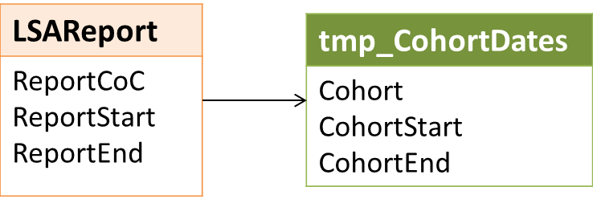

### Logic

**Cohort** identifies which exit cohort the household is in. These categories are not mutually exclusive; a household may be included in one or all exit cohorts.

Identify the relevant date ranges for each of the three exit cohorts based on ReportStart and ReportEnd.

| Cohort | CohortStart | CohortEnd |
| --- | --- | --- |
| 0 | ReportStart | ReportEnd – 6 months  If ReportEnd – 6 months < ReportStart, use ReportEnd |
| -1 | ReportStart – 1 year | ReportEnd – 1 year |
| -2 | ReportStart – 2 year | ReportEnd – 2 year |

## Get Exit Cohort Members

The objective of this step is to identify the members of each exit cohort. Each household with a qualifying exit in the cohort period is represented by the distinct combination of the **Cohort**, the *PersonalID* for the head of household (**HoHID**), and household type (**HHType**).

### Data Construct: tmp_Exit

|  |  |
| --- | --- |
| **HoHID** | *PersonalID* for heads of active households; distinct combinations of **HoHID**, **HHType**, and **Cohort** serve as a primary key. |
| **EnrollmentID** | The *EnrollmentID* for the head of household’s first qualifying exit to permanent housing in the cohort period, or, if the client did not exit to permanent housing, the first qualifying exit to any destination type. |
| **HouseholdID** | The *HouseholdID* associated with the enrollment. |
| **EntryDate** | The *EntryDate* for the enrollment. |
| **ExitDate** | The *ExitDate* for the enrollment. |
| **Cohort** | See LSA Data Dictionary for column descriptions. Logic associated with setting values for this and the following columns is defined in the following sections. |
| **Stat** | See LSA Data Dictionary for column descriptions. |
| **ExitFrom** | See LSA Data Dictionary for column descriptions. |
| **ExitTo** | See LSA Data Dictionary for column descriptions. |
| **ReturnTime** | See LSA Data Dictionary for column descriptions. |
| **HHType** | See LSA Data Dictionary for column descriptions. |
| **HHVet** | See LSA Data Dictionary for column descriptions. |
| **HHDisability** | See LSA Data Dictionary for column descriptions. |
| **HHFleeingDV** | See LSA Data Dictionary for column descriptions. |
| **HoHRace** | See LSA Data Dictionary for column descriptions. |
| **HoHEthnicity** | See LSA Data Dictionary for column descriptions. |
| **HHAdultAge** | See LSA Data Dictionary for column descriptions. |
| **HHParent** | See LSA Data Dictionary for column descriptions. |
| **AC3Plus** | See LSA Data Dictionary for column descriptions. |
| **SystemPath** | See LSA Data Dictionary for column descriptions. |

### Relevant Data

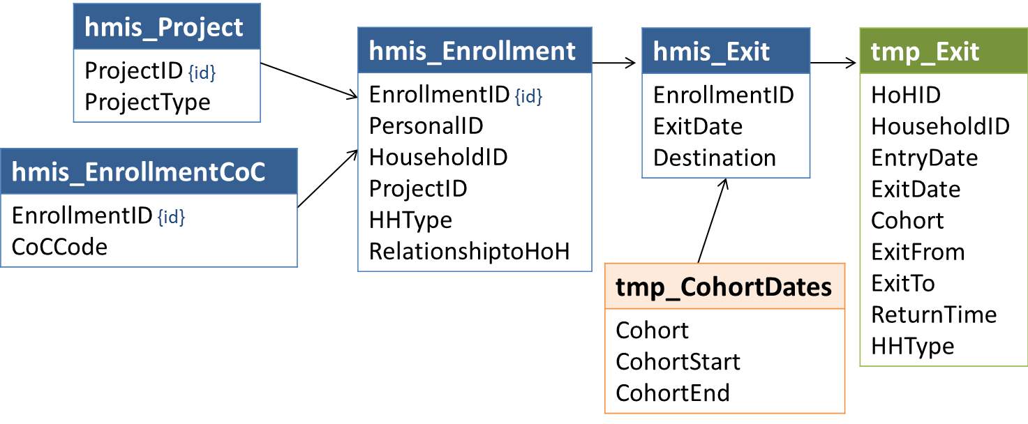

Note that identification of exit cohort members requires exit data from Street Outreach projects and may include exits from ES, SH, TH, RRH, and/or PSH projects no longer active during the report period. For both of these reasons, reporting procedures should join to HMIS project descriptor data and not to the lsa_Project data construct in this step.

Core logic for identification of exit cohort members is defined in the next section. As in 4.7 Get Active HouseholdIDs, in any HMIS application that does not enforce the data standards requirement for one and only one designated head of household per enrollment, LSA reporting procedures must also incorporate the modified logic in the following section.

### Logic: All Applications

Each distinct combination of **Cohort**, the *PersonalID* for the head of household (**HoHID**), and household type (**HHType**) associated with one or more qualifying exits in the cohort period represents a single household/cohort member for LSAExit.

As with the active cohort, a household is identified based on each unique combination of HoHID/HHType. Aside from the dates, there are no differences in logic among the three exit cohorts.

#### Exit Cohort Household Types

The logic associated with identifying household type based on the number of adults, children, and people of unknown age is identical to the exit cohort. Household type (**HHType**) for each HMIS *HouseholdID* is based on the presence or absence of household members by age status – adult, child, or unknown.

| # Adults | # Children | # Unknown Age | HHType | Upload Value |
| --- | --- | --- | --- | --- |
| >= 1 | 0 | 0 | AO (Adult-only) | 1 |
| >= 1 | >= 1 | (any) | AC (Adult-child) | 2 |
| 0 | >= 1 | 0 | CO (Child-only) | 3 |
| (any) | 0 | >= 1 | UN (Unknown) | 99 |
| 0 | (any) | >= 1 | UN (Unknown) | 99 |

The process of determining age status has some differences, however.

For enrollments with a qualifying exit in the cohort period, **AgeDate** = *EntryDate* or CohortStart (instead of ReportStart), whichever is later.

An exit is only ‘qualifying’ if there are no active enrollments for the same head of household (**HoHID**) and household type (**HHType**) in any continuum ES, SH, TH, RRH, or PSH project during the 14 days after the exit date. Household type for this ‘other activity’ is based on age status for all household members as of the *EntryDate* for their respective enrollments, regardless of CohortStart.

Because there is no demographic reporting on age for exit cohorts, there is no need for the granular age groups used in setting household type for active cohort *HouseholdID*s; they can be collapsed into the three broad age status categories: Adult, Child, and Unknown.

| Priority | Condition | Age |
| --- | --- | --- |
| 1 | *DOBDataQuality* in (8,9) | Unknown |
| 2 | *DOBDataQuality* not in (1,2) | Unknown |
| 3 | *DOB* is missing or set to a system default | Unknown |
| 4 | *DOB* *> EntryDate* | Unknown |
| 5 | *RelationshipToHoH* = 1 and *DOB* *= EntryDate* | Unknown |
| 5 | [*DOB* *+* 105 years] *<=* AgeDate | Unknown |
| 12 | [*DOB* *+* 18 years] *<=* AgeDate | Adult |
| 16 | (other) | Child |

#### Systemwide LSA

When the LSA is being generated for all relevant projects systemwide, a qualifying exit (and its associated enrollment data) meets the following criteria:

* *ExitDate* between CohortStart and CohortEnd
* *ProjectType* in (1,2,3,4,8,13) and *ContinuumProject* = 1
* *RelationshipToHoH* = 1
* Last record of *EnrollmentCoC* = ReportCoC
* There is no record of enrollment activity for the distinct **HoHID**/**HHType** for at least 14 days after the *ExitDate* where:
  + [OtherActivity] *ProjectType* in (1,2,3,8,13)
  + [OtherActivity] *EnrollmentCoC* = ReportCoC

The identification of exit cohorts for a systemwide LSA is the only time Street Outreach data (*ProjectType* = 4) is relevant. It is not relevant in identifying the [OtherActivity] referenced above.

**Example 1:** Annabelle has a total of two enrollments in HMIS.

* June 1 – Annabelle exited from an Outreach project.
* June 2 – Annabelle is re-enrolled in the same Outreach project
* At CohortEnd, Annabelle is still enrolled in the Outreach project

Because Annabelle exits from an Outreach project (a qualifying exit) and there is no record of other activity in ES, SH, TH, RRH, or PSH projects in the 14 days following the exit, Annabelle is included in the exit cohort.

**Example 2:** Henry has a total of two enrollments in HMIS.

* June 1 – Henry exited from an Outreach project.
* June 2 – Henry entered an RRH project
* At CohortEnd, Henry is still enrolled in the RRH project

Even though Henry exits from an Outreach project in the cohort period, his ‘other activity’ less than 15 days after the exit – the enrollment in RRH on the following day – is disqualifying. Henry is not included in the exit cohort.

**Example 3:** Caroline has a total of three enrollments in HMIS.

* March 1 – Caroline entered ES1 (HHType CO)
* March 31 – She exited ES1 on her 18th birthday
* April 1 – Caroline entered ES2 (HHType AO)
* April 27 – She exited ES2
* May 1 – Caroline and her infant daughter entered ES3 (HHType AC)
* May 31 – They exited ES3
* June 1 – Caroline and her daughter entered ES4 with Riley, who is 19 and the designated HoH (HHType AC).
* At CohortEnd, they are still enrolled in ES4.

Three separate households are included in the exit cohort: Caroline/CO, Caroline/AO, and Caroline/AC. Even though Caroline – as a person -- was enrolled almost continuously, each of her three exits are qualifying because there is no other activity for the unique combination of HoHID/HHType in the 14 days (or at any time) following each exit date.

#### Project-Focused LSA

If the LSA is being generated for a subset of projects, a qualifying exit (and its associated enrollment data) meets the following criteria:

* *ExitDate* between CohortStart and CohortEnd
* *ProjectID* in lsa_Project
  + Section 2.1 requires that the projects available to a user for selection must be limited to ProjectTypes ES (1), SH (8), TH (2), RRH (13), and PSH (3), so records for other project types are never included in lsa_Project when LSAScope = 2
* RelationshipToHoH = 1
* Last record of *EnrollmentCoC* = ReportCoC
* There is no record of enrollment activity for the distinct **HoHID**/**HHType** for at least 14 days after the *ExitDate* where:
  + [OtherActivity] *ProjectType* in (1,2,3,8,13)
  + [OtherActivity] *EnrollmentCoC* = ReportCoC

Note that for a project-focused LSA, exit cohorts are limited to people who exited from the selected projects, but activity in **any** ES/SH/TH/RRH/PSH project systemwide in the 14 days following the exit would exclude the household from the exit cohort.

### Modified Logic: HMIS Application Does Not Enforce Head of Household Requirements

* For any *HouseholdID* where **more than one** enrollment has a *RelationshipToHoH = 1,* use the lowest *PersonalID* (when sorted alphabetically or numerically, depending on system data type for *PersonalID)* for the *HouseholdID* where *RelationshipToHoH = 1* as the designated head of household.
* For any *HouseholdID* where **no** enrollment has a *RelationshipToHoH = 1,* use the lowest *PersonalID* (when sorted alphabetically or numerically, depending on system data type for *PersonalID)* as the designated head of household.
* For any *HouseholdID* where 0 or more than 1 enrollments have a *RelationshipToHoH = 1,* use the most recent record of *3.16 Client Location* associated with any active household member where *InformationDate* is on or before ReportEnd to determine whether or not the household meets the criteria for inclusion in the LSA (*EnrollmentCoC.CoCCode* = ReportCoC).

Aside from identification of heads of household, business logic is identical to that defined for applications that do enforce requirements.

## Get EnrollmentIDs for Exit Cohort Households

### Relevant Data

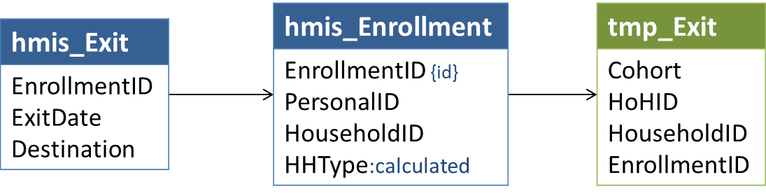

### Logic

If a household (the distinct combination of **Cohort***,* **HoHID** and **HHType**) has more than one qualifying exit in a single cohort period that meets the criteria for inclusion, calculation of return time (if any) and other exit cohort reporting should be based on:

* The *EnrollmentID* of the first exit in the cohort period to permanent housing; or
* If the household does not have a qualifying exit to permanent housing, the *EnrollmentID* of the first qualifying exit to any destination in the cohort period.

Permanent housing destinations are:

| HMIS Value | Permanent Housing Destination |
| --- | --- |
| 3 | Permanent housing (other than RRH) for formerly homeless persons |
| 31 | Rental by client, with RRH or equivalent subsidy |
| 19 | Rental by client, with VASH housing subsidy |
| 20 | Rental by client, with other ongoing housing subsidy |
| 21 | Owned by client, with ongoing housing subsidy |
| 26 | Moved from one HOPWA funded project to HOPWA PH |
| 28 | Rental by client, with GPD TIP housing subsidy |
| 10 | Rental by client, no ongoing housing subsidy |
| 11 | Owned by client, no ongoing housing subsidy |
| 22 | Staying or living with family, permanent tenure |
| 23 | Staying or living with friends, permanent tenure |

## Set *ExitFrom* and *ExitTo* for Exit Cohort Households

### Relevant Data

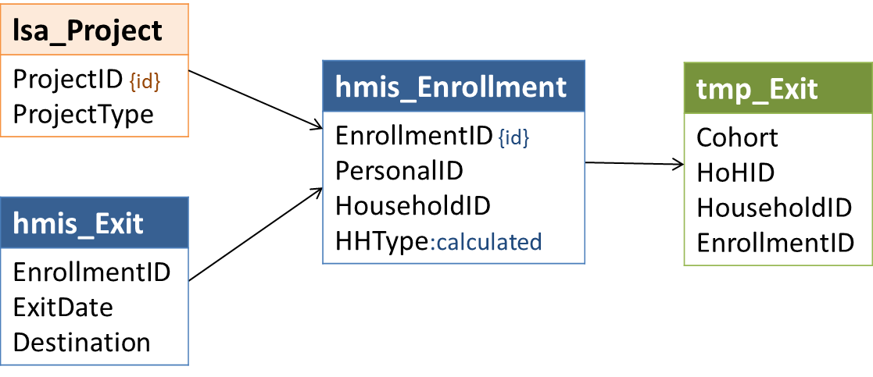

### Logic

#### ExitFrom

Crosswalk the *ProjectType* for the *ProjectID* associated with tmp_Exit.**EnrollmentID** to the appropriate **ExitFrom** value below.

| HMIS ProjectType | *ExitFrom* Value | Category |
| --- | --- | --- |
| 4 | 1 | SO |
| 1 | 2 | ES |
| 2 | 3 | TH |
| 8 | 4 | SH |
| 13 | 5 | RRH |
| 3 | 6 | PSH |

#### ExitTo

Crosswalk the *Destination* value associated with the most recent exit in the cohort period to the appropriate **ExitTo** value below.

| HMIS Value | HMIS Response Category | LSA Value |
| --- | --- | --- |
| 3 | Permanent housing (other than RRH) for formerly homeless persons | 1 |
| 31 | Rental by client, with RRH or equivalent subsidy | 2 |
| 19 | Rental by client, with VASH housing subsidy | 3 |
| 20 | Rental by client, with other ongoing housing subsidy | 3 |
| 21 | Owned by client, with ongoing housing subsidy | 3 |
| 26 | Moved from one HOPWA funded project to HOPWA PH | 3 |
| 28 | Rental by client, with GPD TIP housing subsidy | 3 |
| 10 | Rental by client, no ongoing housing subsidy | 4 |
| 11 | Owned by client, no ongoing housing subsidy | 4 |
| 22 | Staying or living with family, permanent tenure | 5 |
| 23 | Staying or living with friends, permanent tenure | 6 |
| 15 | Foster care home or foster care group home | 7 |
| 25 | Long-term care facility or nursing home | 7 |
| 4 | Psychiatric hospital or other psychiatric facility | 8 |
| 5 | Substance abuse treatment facility or detox center | 8 |
| 6 | Hospital or other residential non-psychiatric medical facility | 8 |
| 7 | Jail, prison or juvenile detention facility | 9 |
| 14 | Hotel or motel paid for without emergency shelter voucher | 10 |
| 29 | Residential project or halfway house with no homeless criteria | 10 |
| 1 | Emergency shelter, including hotel or motel paid for with ES voucher | 11 |
| 2 | Transitional housing for homeless persons | 11 |
| 18 | Safe Haven | 11 |
| 27 | Moved from one HOPWA funded project to HOPWA TH | 11 |
| 16 | Place not meant for habitation | 12 |
| 12 | Staying or living with family, temporary tenure | 13 |
| 13 | Staying or living with friends, temporary tenure | 14 |
| 24 | Deceased | 15 |
|  | (any other) | 99 |

## Set ReturnTime for Exit Cohort Households

### Relevant Data

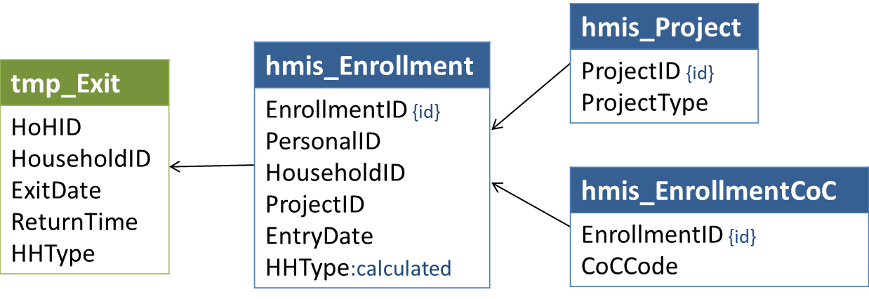

### Logic

The **ReturnTime**value in tmp_Exit should be set to the actual number of days to return and NOT the associated upload value; the actual number of days are needed to generate averages for LSACalculated.

**ReturnTime**is the number of days between tmp_Exit.**ExitDate** and the earliest later enrollment where:

* *EntryDate* >= (tmp_Exit.**ExitDate** *+* 15 days)
* *EntryDate* <= (tmp_Exit.**ExitDate** *+* 730 days)
* PersonalID = tmp_Exit.**HoHID** and RelationshipToHoH = 1
* *ProjectType* in (1,2,3,8,13)[2]
* *HHType* (as calculated for the later enrollment as of the *EntryDate* for that enrollment) = tmp_Exit.**HHType**
* *EnrollmentCoC* at entry = ReportCoC

If there is no later enrollment that meets those criteria, set **ReturnTime**= -1.

**Note**: In both tmp_Household and tmp_Exit, **Stat**is determined based on a household’s system use **before** active enrollments (tmp_Household) or a qualifying exit (tmp_Exit) – i.e., their system engagement status in on their first active date in the period.

Both files have a **ReturnTime** column, but the logic is different:

* In tmp_Household, **ReturnTime** is associated with **Stat**and events that occurred *prior to active enrollments.*
* In tmp_Exit, **ReturnTime** is associated with enrollments that occurred *after the qualifying exit*; it is not associated with **Stat.**

## Set Population Identifiers for Exit Cohort Households

### Relevant Data

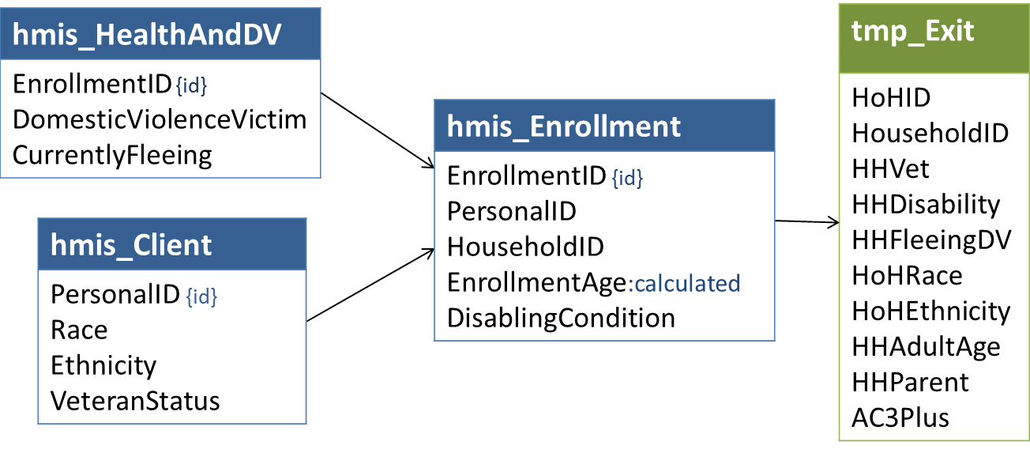

### Logic

As with the active cohort, population identifiers for exit cohort households are based on the characteristics of all household members.

The underlying logic associated with setting population identifiers for exit cohort households is the same as that for active cohort households with the following exceptions:

* Only data from the enrollment associated with the *HouseholdID* of the qualifying exit is used (as opposed to all enrollments active in the report period).
* There is no exit cohort reporting for the Chronically Homeless Households population, so it is not necessary to determine CH status.

In practice, because there is no person-level reporting for exit cohorts, the population identifiers can be set for the household without the intermediate step of setting detailed values for each person.

#### HHVet

Set **HHVet** = 1 if any adult household member has a *VeteranStatus* of 1. Otherwise, **HHVet** = 0.

#### HHDisability

Set **HHDisability**= 1 if the HoH or any adult household member has a *DisablingCondition* = 1. Otherwise, **HHDisability**= 0.

#### HHFleeingDV

Set **HHFleeingDV** = 1 if the HoH or any adult household member has a record where *DomesticViolenceVictim* = 1 and *CurrentlyFleeing* = 1. Otherwise, set **HHFleeingDV** = 0

#### HoHRace

Crosswalk HMIS *Race* values for the head of household and set **HoHRace** to the first LSA value in the table below:

| Priority | HMIS Race Values | LSA Value | LSA Category |
| --- | --- | --- | --- |
| 1 | *Client doesn’t know* (8) or *Client refused* (9) | 98 | Client doesn't know/refused |
| 2 | *Data not collected* (99) or no race selected | 99 | Missing/invalid |
| 3 | Two or more *Race* values selected | 6 | Multiple Races |
| 4 | *White* (5) is the only race selected and Ethnicity <> 1 | 0 | White, non-Hispanic/Latino |
| 4 | *White* (5) is the only race selected and Ethnicity = 1 (Hispanic/Latino) | 1 | White, Hispanic/Latino |
| 4 | *Black or African American* (3) is the only race selected | 2 | Black or African American |
| 4 | *Asian* (2) is the only race selected | 3 | Asian |
| 4 | *American Indian or Alaska Native* (1) is the only race selected | 4 | American Indian or Alaska Native |
| 4 | *Native Hawaiian or Other Pacific Islander* (4) is the only race selected | 5 | Native Hawaiian / Other Pacific Islander |

#### HoHEthnicity

Crosswalk HMIS *Ethnicity* values for the head of household as follows:

| HMIS Value | HMIS Category | LSA Value | LSA Category |
| --- | --- | --- | --- |
| 0 | Non-Hispanic/Latino | 0 | Non-Hispanic/Latino |
| 1 | Hispanic/Latino | 1 | Hispanic/Latino |
| 8 | Client doesn’t know | 98 | Client doesn’t know/refused |
| 9 | Client refused | 98 | Client doesn’t know/refused |
| (any other) | Any other, including NULL | 99 | Unknown |

#### HHAdultAge

Set **HHAdultAge** based on the ages of all household members as of the later of *EntryDate* and CohortStart using the first / topmost of the criteria below appropriate to the household:

| Upload Value | Criteria |
| --- | --- |
| -1 | The maximum of all ages is >= 98 (one or more unknown ages) |
| -1 | The maximum of all ages values is <= 17 (no adults in household) |
| 18 | The maximum of all ages is 21 (all adults are between 18 and 21) |
| 24 | The maximum of all ages is 24 (all adults are under 25) |
| 55 | The minimum of all ages is between 55 and 65 (all members are 55+) |
| 25 | (all other households) |

#### HHParent

Set **HHParent** = 1 if **HHType** is AC or CO (in (2,3)) and at least one household member under the age of 18 has a *RelationshipToHoH* = 2 (Child of HoH).

#### AC3Plus

Set **AC3Plus** = 1 if **HHType** = 2 (AC) and there are three or more household members under the age of 18. Otherwise, **AC3Plus** = 0.

## Set Stat for Exit Cohort Households

### Relevant Data

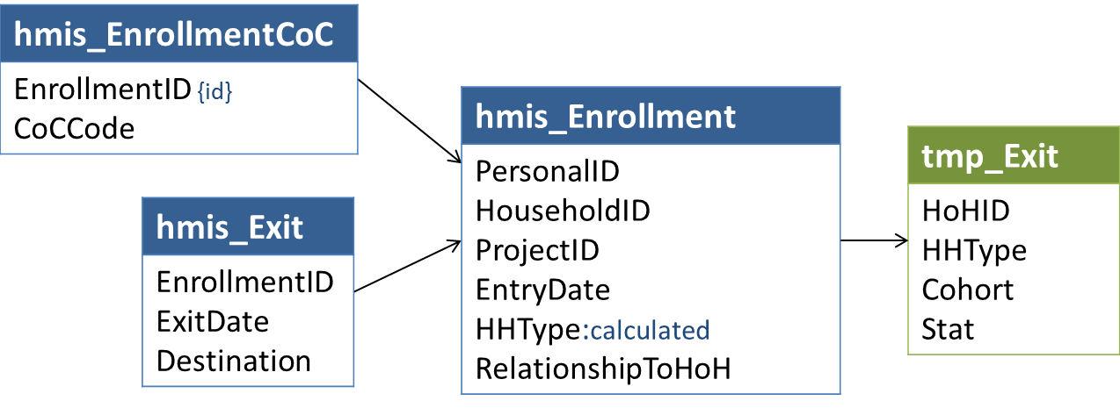

### Logic

For each *EnrollmentID* in tmp_Exit, search for the most recent previous enrollment where:

* (*ExitDate* + 730 days) is >=-tmp_Exit.*EntryDate*
* *RelationshipToHoH* = 1 and *PersonalID* = tmp_Exit.**HoHID**
* *ProjectType* in (1,2,3,8,13)
* **HHType** for the previous exit’s household = tmp_Exit.**HHType**

If there is no exit for the head of household in the same household type in the 2 years prior to enrollment, set **Stat** = 1 (first time homeless)

If the number of days between the previous *ExitDate* and *EntryDate* for exit_Enrollment is < 15, set **Stat** = 5 (household has been continuously engaged).

If the number of days is >= 15, set **Stat**based on the *Destination* of the previous enrollment.

| Stat | Category | HMIS Destination Values |
| --- | --- | --- |
| 2 | Return 15-730 days after exit to permanent destination | 3,31,19,20,21,26,28,10,11,22,23 |
| 3 | Re-engage 15-730 days after exit to temporary destination | 15,25,4,5,6,7,14,29,1,2,18,27,16,12,13 |
| 4 | Re-engage 15-730 days after exit to unknown destination | (any other) |

## Set SystemPath for Exit Cohort Households

### Relevant Data

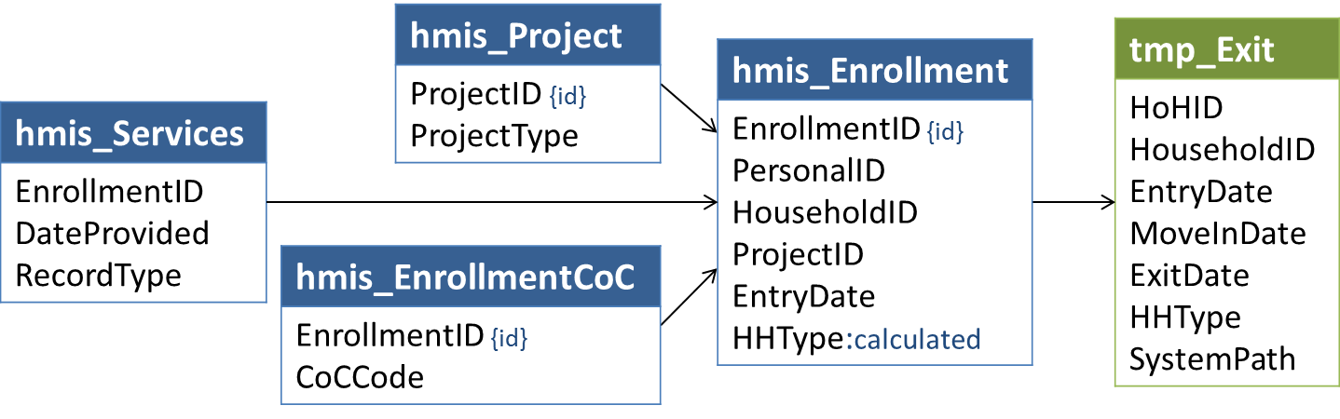

### Logic

The **SystemPath** value represents the combination of project types in which a head of household was served during a continuous period of system use ending on tmp_Exit.*ExitDate*. The logic associated with **SystemPath** for tmp_Exit is similar to that for tmp_Household, but there are some differences:

* For households exiting from PSH (**ExitFrom**= 6), if *MoveInDate* <= **CohortStart** – i.e., if the household was housed in PSH at the start of the cohort period – set **SystemPath** = -1.
* For households exiting from RRH or PSH (**ExitFrom**in (5,6)) after at least 365 days in permanent housing (*MoveInDate* + 365 days <= *ExitDate*), set **SystemPath** = -1.
* For all households exiting from SO (**ExitFrom**= 1), set **SystemPath** = 12 (all other combinations)
* (Optional) For first-time homeless households (**Stat** = 1) and households returning or re-engaging with the continuum after 15-730 days (**Stat** in (2,3,4)), we already know that their continuous system use is limited to the project type associated with the qualifying exit. As such, it isn’t necessary to build a full history (as described in the next step) to determine their **SystemPath** – it may be set directly based on **ExitFrom** values using thevalues shown in the table below.

| ExitFrom | | SystemPath | |
| --- | --- | --- | --- |
| 1 | SO | 12 | All other combinations |
| 2 | ES | 1 | ES/SH |
| 3 | TH | 2 | TH |
| 4 | SH | 1 | ES/SH |
| 5 | RRH | 4 | RRH |
| 6 | PSH | 8 | PSH |

For other exit cohort households in tmp_Exit where **SystemPath** is null, build a history of system use to determine **SystemPath**:

* Identify enrollments for the same HoHID/HHType active between 10/1/2012 and tmp_Exit.ExitDate (see 4.32 Get Enrollments Relevant to Last Inactive Date and Other System Use Days);
* Determine last inactive date for the HoHID/HHType (see 4.34 Get Last Inactive Date);
* Identify each of the project types in which the HoHID/HHType was served between their last inactive date and tmp_Exit.ExitDate, including the project associated with the qualifying exit;
* Set **SystemPath** based on the combination of project types based on the values shown below.

| Value | SystemPath Project Types |
| --- | --- |
| 1 | ES/SH |
| 2 | TH |
| 3 | ES/SH + TH |
| 4 | RRH |
| 5 | ES/SH + RRH |
| 6 | TH + RRH |
| 7 | ES/SH + TH + RRH |
| 8 | PSH |
| 9 | ES/SH + PSH |
| 10 | ES/SH + RRH + PSH |
| 11 | RRH + PSH |
| 12 | All other combinations |

## LSACalculated Population Identifiers – People by Household Characteristics

### Relevant Data

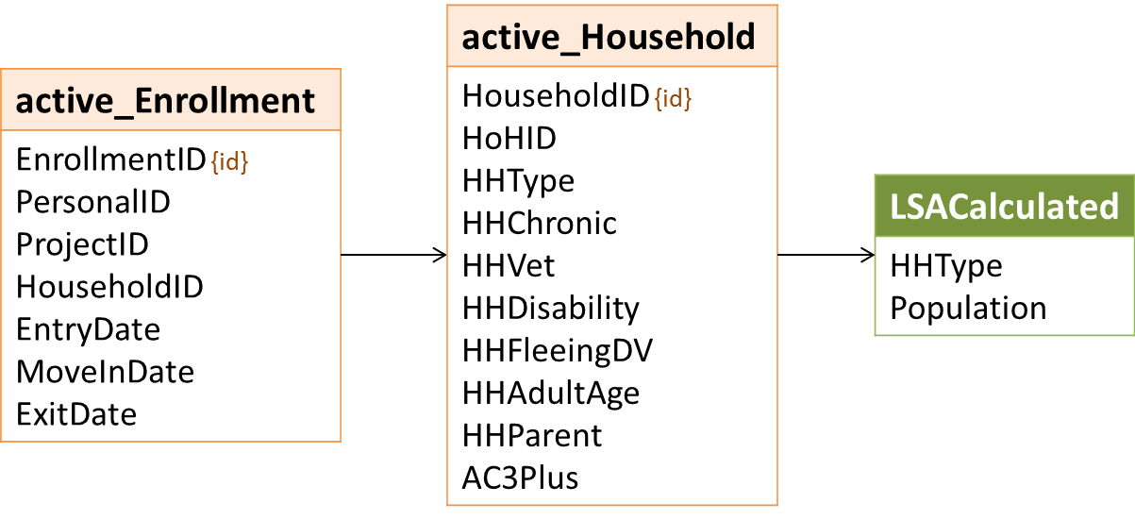

### Logic

LSACalculated requires counts of people in households with particular characteristics, grouped by **ProjectID** and **ProjectType.**

In the table below:

* The ID column is the **Population** value for the LSA Calculated file.
* The HHType column indicates the household types for which the population is relevant. ‘0’ indicates a count of all people, regardless of household type and including those in households of unknown type.
* The criteria column shows the selection criteria for these counts.

| ID | Household Population | HHType | Criteria |
| --- | --- | --- | --- |
| 0 | All | 0,1,2,3 | - |
| 1 | Youth 18-21 | 1 | **HHAdultAge** = 18 |
| 2 | Youth 22-24 | 1 | **HHAdultAge** = 24 |
| 3 | Veteran | 1,2 | **HHVet** = 1 |
| 4 | Non-Veteran 25+ | 1 | **HHVet** = 0 and **HHAdultAge** in (25,55) |
| 5 | Disabled Adult/HoH | 0,1,2,3 | **HHDisability** = 1 |
| 6 | Chronically Homeless Adult/HoH | 0,1,2,3 | **HHChronic** = 1 |
| 7 | Fleeing Domestic Violence | 0,1,2,3 | **HHFleeingDV** = 1 |
| 8 | Senior 55+ | 1 | **HHAdultAge** = 55 |
| 9 | Parenting Youth 18-24 | 2 | **HHParent** = 1 and **HHAdultAge** in (18,24) |
| 10 | Parenting Child | 3 | **HHParent** = 1 |

## LSACalculated Population Identifiers – Households

### Relevant Data

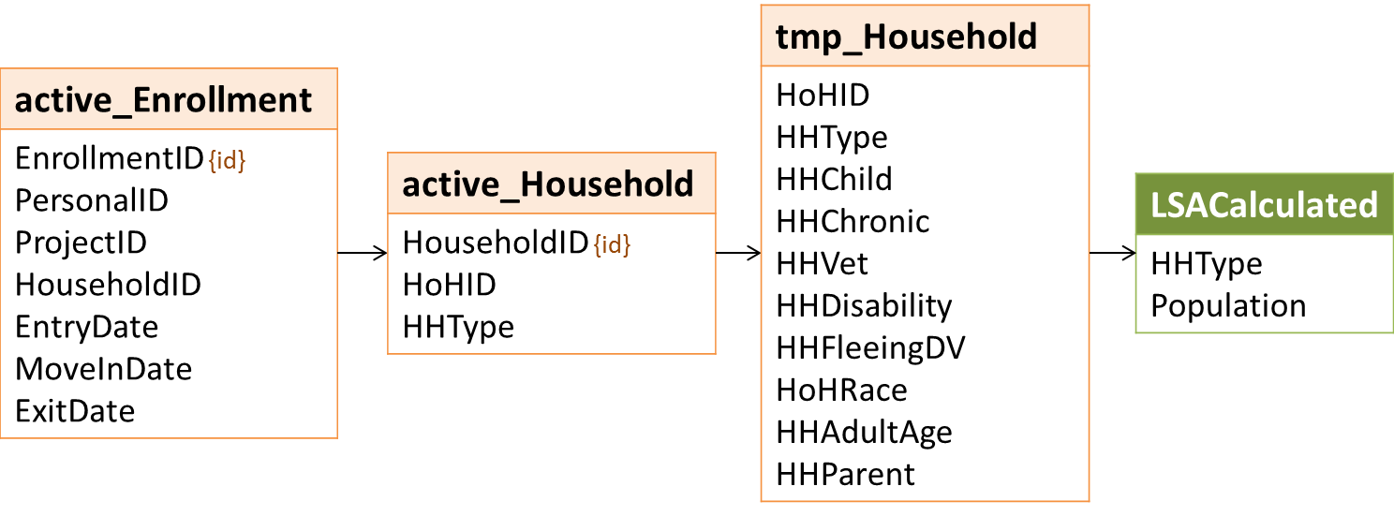

### Logic

For a systemwide LSA (**LSAScope** = 1) produced for a date range of October 1 to September 30 of the following year, LSACalculated requires counts of households with particular characteristics, grouped by **ProjectID** and **ProjectType.**

In the table below:

* The ID column is the **Population** value for the LSA Calculated file.
* The HHType column indicates the household types for which the population is relevant. ‘0’ indicates a count of all people, regardless of household type and including those in households of unknown type.
* The criteria column shows the selection criteria for these counts.

| ID | Household Population | HHType | Criteria |
| --- | --- | --- | --- |
| 0 | All | 0,1,2,3 |  |
| 1 | Youth 18-21 | 1 | **HHAdultAge** = 18 |
| 2 | Youth 22-24 | 1 | **HHAdultAge** = 24 |
| 3 | Veteran | 1,2 | **HHVet** = 1 |
| 4 | Non-Veteran 25+ | 1 | **HHVet** = 0 and **HHAdultAge** in (25,55) |
| 5 | Disabled Adult/HoH | 0,1,2,3 | **HHDisability** = 1 |
| 6 | Chronically Homeless Adult/HoH | 0,1,2,3 | **HHChronic** = 1 |
| 7 | Fleeing Domestic Violence | 0,1,2,3 | **HHFleeingDV** = 1 |
| 8 | Senior 55+ | 1 | **HHAdultAge** = 55 |
| 9 | Parenting Youth 18-24 | 2 | **HHParent** = 1 and **HHAdultAge** in (18,24) |
| 10 | Parenting Child | 3 | **HHParent** = 1 |
| 11 | 3+ Children | 2 | LSAHousehold: **HHChild** = 3  LSAExit: **AC3Plus** = 3 |
| 12 | First Time Homeless | 0,1,2,3 | **Stat** = 1 |
| 13 | Return After Exit to PH | 0,1,2,3 | **Stat** = 2 |
| 14 | Move-In to PSH in Report Period | 0,1,2,3 | **PSHMoveIn** = 1 |
| 15 | White, non-Hispanic/Latino HoH | 0,1,2,3 | **HoHRace** = 0 |
| 16 | White, Hispanic/Latino HoH | 0,1,2,3 | **HoHRace** = 1 |
| 17 | Black or African American HoH | 0,1,2,3 | **HoHRace** = 2 |
| 18 | Asian HoH | 0,1,2,3 | **HoHRace** = 3 |
| 19 | American Indian/Alaska Native HoH | 0,1,2,3 | **HoHRace** = 4 |
| 20 | Native Hawaiian/Other Pacific Islander HoH | 0,1,2,3 | **HoHRace** = 5 |
| 21 | Multi-Racial HoH | 0,1,2,3 | **HoHRace** = 6 |
| 22 | Non-Hispanic/Latino HoH | 0,1,2,3 | **HoHEthnicity** = 0 |
| 23 | Hispanic/Latino HoH | 0,1,2,3 | **HoHEthnicity** =1 |
| 39 | Youth 18-21 - Disabled Adult/HoH | 1 | **HHAdultAge** = 18 and **HHDisability** = 1 |
| 40 | Youth 18-21 - Fleeing Domestic Violence | 1 | **HHAdultAge** = 18 and **HHFleeingDV** = 1 |
| 41 | Youth 18-21 - First Time Homeless | 1 | **HHAdultAge** = 18 and **Stat** = 1 |
| 42 | Youth 18-21 - Return after Exit to PH | 1 | **HHAdultAge** = 18 and **Stat** = 2 |
| 43 | Youth 18-21 - Move-In to PSH in Report Period | 1 | **HHAdultAge** = 18 and **PSHMoveIn** = 1 |
| 44 | Youth 18-21 - White, non-Hispanic/Latino HoH | 1 | **HHAdultAge** = 18 and **HoHRace** = 0 |
| 45 | Youth 18-21 - White, Hispanic/Latino HoH | 1 | **HHAdultAge** = 18 and **HoHRace** = 1 |
| 46 | Youth 18-21 - Black or African American HoH | 1 | **HHAdultAge** = 18 and **HoHRace** = 2 |
| 47 | Youth 18-21 - Asian HoH | 1 | **HHAdultAge** = 18 and **HoHRace** = 3 |
| 48 | Youth 18-21 - American Indian/Alaska Native HoH | 1 | **HHAdultAge** = 18 and **HoHRace** = 4 |
| 49 | Youth 18-21 - Native Hawaiian/Other Pacific Islander HoH | 1 | **HHAdultAge** = 18 and **HoHRace** = 5 |
| 50 | Youth 18-21 - Multi-Racial HoH | 1 | **HHAdultAge** = 18 and **HoHRace** = 6 |
| 51 | Youth 18-21 - Non-Hispanic/Latino HoH | 1 | **HHAdultAge** = 18 and **HoHEthnicity** = 0 |
| 52 | Youth 18-21 - Hispanic/Latino HoH | 1 | **HHAdultAge** = 18 and **HoHEthnicity** =1 |
| 53 | Youth 22-24 - Disabled Adult/HoH | 1 | **HHAdultAge** = 24 and **HHDisability** = 1 |
| 54 | Youth 22-24 - Fleeing Domestic Violence | 1 | **HHAdultAge** = 24 and **HHFleeingDV** = 1 |
| 55 | Youth 22-24 - First Time Homeless | 1 | **HHAdultAge** = 24 and **Stat** = 1 |
| 56 | Youth 22-24 - Return after Exit to PH | 1 | **HHAdultAge** = 24 and **Stat** = 2 |
| 57 | Youth 22-24 - Move-In to PSH in Report Period | 1 | **HHAdultAge** = 24 and **PSHMoveIn** = 1 |
| 58 | Youth 22-24 - White, non-Hispanic/Latino HoH | 1 | **HHAdultAge** = 24 and **HoHRace** = 0 |
| 59 | Youth 22-24 - White, Hispanic/Latino HoH | 1 | **HHAdultAge** = 24 and **HoHRace** = 1 |
| 60 | Youth 22-24 - Black or African American HoH | 1 | **HHAdultAge** = 24 and **HoHRace** = 2 |
| 61 | Youth 22-24 - Asian HoH | 1 | **HHAdultAge** = 24 and **HoHRace** = 3 |
| 62 | Youth 22-24 - American Indian/Alaska Native HoH | 1 | **HHAdultAge** = 24 and **HoHRace** = 4 |
| 63 | Youth 22-24 - Native Hawaiian/Other Pacific Islander HoH | 1 | **HHAdultAge** = 24 and **HoHRace** = 5 |
| 64 | Youth 22-24 - Multi-Racial HoH | 1 | **HHAdultAge** = 24 and **HoHRace** = 6 |
| 65 | Youth 22-24 - Non-Hispanic/Latino HoH | 1 | **HHAdultAge** = 24 and **HoHEthnicity** = 0 |
| 66 | Youth 22-24 - Hispanic/Latino HoH | 1 | **HHAdultAge** = 24 and **HoHEthnicity** =1 |
| 67 | Non-Veteran 25+ - Disabled Adult/HoH | 1 | **HHVet** = 0 and **HHAdultAge** in (25,55) and **HHDisability** = 1 |
| 68 | Non-Veteran 25+ - Fleeing Domestic Violence | 1 | **HHVet** = 0 and **HHAdultAge** in (25,55) and **HHFleeingDV** = 1 |
| 69 | Non-Veteran 25+ - First Time Homeless | 1 | **HHVet** = 0 and **HHAdultAge** in (25,55) and **Stat** = 1 |
| 70 | Non-Veteran 25+ - Return after Exit to PH | 1 | **HHVet** = 0 and **HHAdultAge** in (25,55) and **Stat** = 2 |
| 71 | Non-Veteran 25+ - Move-In to PSH in Report Period | 1 | **HHVet** = 0 and **HHAdultAge** in (25,55) and **PSHMoveIn** = 1 |
| 72 | Non-Veteran 25+ - White, non-Hispanic/Latino HoH | 1 | **HHVet** = 0 and **HHAdultAge** in (25,55) and **HoHRace** = 0 |
| 73 | Non-Veteran 25+ - White, Hispanic/Latino HoH | 1 | **HHVet** = 0 and **HHAdultAge** in (25,55) and **HoHRace** = 1 |
| 74 | Non-Veteran 25+ - Black or African American HoH | 1 | **HHVet** = 0 and **HHAdultAge** in (25,55) and **HoHRace** = 2 |
| 75 | Non-Veteran 25+ - Asian HoH | 1 | **HHVet** = 0 and **HHAdultAge** in (25,55) and **HoHRace** = 3 |
| 76 | Non-Veteran 25+ - American Indian/Alaska Native HoH | 1 | **HHVet** = 0 and **HHAdultAge** in (25,55) and **HoHRace** = 4 |
| 77 | Non-Veteran 25+ - Native Hawaiian/Other Pacific Islander HoH | 1 | **HHVet** = 0 and **HHAdultAge** in (25,55) and **HoHRace** = 5 |
| 78 | Non-Veteran 25+ - Multi-Racial HoH | 1 | **HHVet** = 0 and **HHAdultAge** in (25,55) and **HoHRace** = 6 |
| 79 | Non-Veteran 25+ - Non-Hispanic/Latino HoH | 1 | **HHVet** = 0 and **HHAdultAge** in (25,55) and **HoHEthnicity** = 0 |
| 80 | Non-Veteran 25+ - Hispanic/Latino HoH | 1 | **HHVet** = 0 and **HHAdultAge** in (25,55) and **HoHEthnicity** =1 |
| 81 | Veteran - Disabled Adult/HoH | 1 | **HHVet** = 1 and **HHDisability** = 1 |
| 82 | Veteran - Fleeing Domestic Violence | 1 | **HHVet** = 1 and **HHFleeingDV** = 1 |
| 83 | Veteran - First Time Homeless | 1 | **HHVet** = 1 and **Stat** = 1 |
| 84 | Veteran - Return after Exit to PH | 1 | **HHVet** = 1 and **Stat** = 2 |
| 85 | Veteran - Move-In to PSH in Report Period | 1 | **HHVet** = 1 and **PSHMoveIn** = 1 |
| 86 | Veteran - White, non-Hispanic/Latino HoH | 1 | **HHVet** = 1 and **HoHRace** = 0 |
| 87 | Veteran - White, Hispanic/Latino HoH | 1 | **HHVet** = 1 and **HoHRace** = 1 |
| 88 | Veteran - Black or African American HoH | 1 | **HHVet** = 1 and **HoHRace** = 2 |
| 89 | Veteran - Asian HoH | 1 | **HHVet** = 1 and **HoHRace** = 3 |
| 90 | Veteran - American Indian/Alaska Native HoH | 1 | **HHVet** = 1 and **HoHRace** = 4 |
| 91 | Veteran - Native Hawaiian/Other Pacific Islander HoH | 1 | **HHVet** = 1 and **HoHRace** = 5 |
| 92 | Veteran - Multi-Racial HoH | 1 | **HHVet** = 1 and **HoHRace** = 6 |
| 93 | Veteran - Non-Hispanic/Latino HoH | 1 | **HHVet** = 1 and **HoHEthnicity** = 0 |
| 94 | Veteran - Hispanic/Latino HoH | 1 | **HHVet** = 1 and **HoHEthnicity** =1 |
| 95 | Veteran 55+ | 1 | **HHVet** = 1 and **HHAdultAge** = 55 |
| 96 | Non-Veteran 55+ | 1 | **HHVet** = 0 and **HHAdultAge** = 55 |

## LSACalculated Population Identifiers – People by Personal Characteristics

### Relevant Data

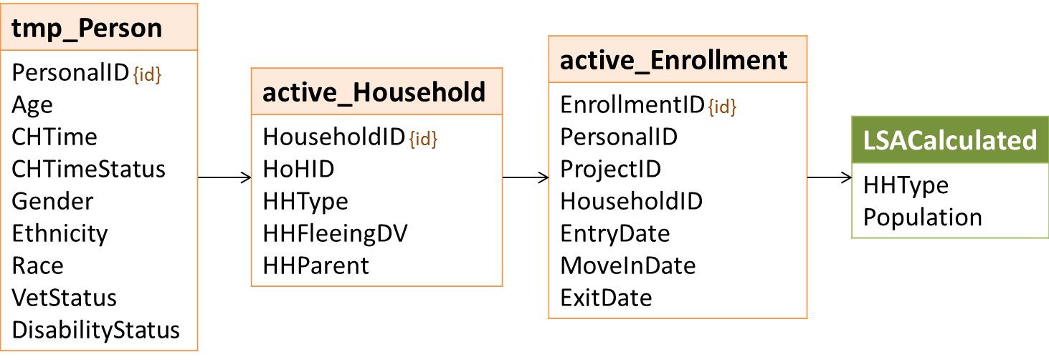

### Logic

For a systemwide LSA (**LSAScope** = 1) produced for a date range of October 1 to September 30 of the following year, LSACalculated requires counts of people with particular characteristics, grouped by **ProjectID** and **ProjectType.**

In the table below:

* The ID column is the **Population** value for the LSA Calculated file.
* The HHType column indicates the household types for which the population is relevant. ‘0’ indicates a count of all people, regardless of household type and including those in households of unknown type.
* The criteria column shows the selection criteria for these counts.

| ID | Household Population | HHType | Criteria |
| --- | --- | --- | --- |
| 3 | Veteran | 0,1,2 | **VetStatus** = 1 |
| 6 | Chronically Homeless Adult/HoH | 0,1,2,3 | **DisabilityStatus** = 1 and  **(CHTime**  = 365 and **CHTimeStatus** in (1,2); or  **CHTime**  = 400 and **CHTimeStatus** = 2 ) |
| 15 | White, non-Hispanic/Latino | 0,1,2,3 | **Race** = 0 |
| 16 | White, Hispanic/Latino | 0,1,2,3 | **Race** = 1 |
| 17 | Black or African American | 0,1,2,3 | **Race** = 2 |
| 18 | Asian | 0,1,2,3 | **Race** = 3 |
| 19 | American Indian or Alaska Native | 0,1,2,3 | **Race** = 4 |
| 20 | Native Hawaiian / Other Pacific Islander | 0,1,2,3 | **Race** = 5 |
| 21 | Multiple Races | 0,1,2,3 | **Race** = 6 |
| 22 | Non-Hispanic/Latino | 0,1,2,3 | **Ethnicity** = 0 |
| 23 | Hispanic/Latino | 0,1,2,3 | **Ethnicity** = 1 |
| 24 | <1 year | 0,1,2,3 | **Age** = 0 |
| 25 | 1 to 2 years | 0,1,2,3 | **Age** = 2 |
| 26 | 3 to 5 years | 0,1,2,3 | **Age** = 5 |
| 27 | 6 to 17 years | 0,1,2,3 | **Age** = 17 |
| 28 | 18 to 21 years | 0,1,2,3 | **Age** = 21 |
| 29 | 22 to 24 years | 0,1,2,3 | **Age** = 24 |
| 30 | 25 to 34 years | 0,1,2,3 | **Age** = 34 |
| 31 | 35 to 44 years | 0,1,2,3 | **Age** = 44 |
| 32 | 45 to 54 years | 0,1,2,3 | **Age** = 54 |
| 33 | 55 to 64 years | 0,1,2,3 | **Age** = 64 |
| 34 | 65 and older | 0,1,2,3 | **Age** = 65 |
| 35 | Female | 0,1,2,3 | **Gender** = 1 |
| 36 | Male | 0,1,2,3 | **Gender** = 2 |
| 37 | Transgender | 0,1,2,3 | **Gender** = 3 |
| 38 | Gender non-conforming | 0,1,2,3 | **Gender** = 4 |
| 97 | Veteran - Female | 0,1,2 | **VetStatus** = 1 and **Gender** = 1 |
| 98 | Veteran - Male | 0,1,2 | **VetStatus** = 1 and **Gender** = 2 |
| 99 | Veteran - Transgender | 0,1,2 | **VetStatus** = 1 and **Gender** = 3 |
| 100 | Veteran - Gender non-conforming | 0,1,2 | **VetStatus** = 1 and **Gender** = 4 |
| 101 | Veteran - White, non-Hispanic/Latino | 0,1,2 | **VetStatus** = 1 and **Race** = 0 |
| 102 | Veteran - White, Hispanic/Latino | 0,1,2 | **VetStatus** = 1 and **Race** = 1 |
| 103 | Veteran - Black or African American | 0,1,2 | **VetStatus** = 1 and **Race** = 2 |
| 104 | Veteran - Asian | 0,1,2 | **VetStatus** = 1 and **Race** = 3 |
| 105 | Veteran - American Indian or Alaska Native | 0,1,2 | **VetStatus** = 1 and **Race** = 4 |
| 106 | Veteran - Native Hawaiian / Other Pacific Islander | 0,1,2 | **VetStatus** = 1 and **Race** = 5 |
| 107 | Veteran - Multiple Races | 0,1,2 | **VetStatus** = 1 and **Race** = 6 |
| 108 | Veteran - Non-Hispanic/Latino | 0,1,2 | **VetStatus** = 1 and **Ethnicity** = 0 |
| 109 | Veteran - Hispanic/Latino | 0,1,2 | **VetStatus** = 1 and **Ethnicity** = 1 |
| 110 | Veteran - Chronically Homeless | 0,1,2 | **VetStatus** = 1 and **DisabilityStatus** = 1 and  ((**CHTime** = 365 and **CHTimeStatus** in (1,2)) or  (**CHTime** = 400 and **CHTimeStatus** = 2)) |
| 111 | Veteran - Disabled | 0,1,2 | **VetStatus** = 1 and **DisabilityStatus** = 2 |
| 112 | Veteran - Fleeing Domestic Violence | 0,1,2 | **VetStatus** = 1 and **HHFleeingDV** = 1 |
| 113 | Parenting Youth - Female | 2 | **HHParent** = 1 and **Age** in (21,24) and **Gender** = 1 |
| 114 | Parenting Youth - Male | 2 | **HHParent** = 1 and **Age** in (21,24) and **Gender** = 2 |
| 115 | Parenting Youth - Transgender | 2 | **HHParent** = 1 and **Age** in (21,24) and **Gender** = 3 |
| 116 | Parenting Youth - Gender non-conforming | 2 | **HHParent** = 1 and **Age** in (21,24) and **Gender** = 4 |
| 117 | Parenting Youth - White, non-Hispanic/Latino | 2 | **HHParent** = 1 and **Age** in (21,24) and **Race** = 0 |
| 118 | Parenting Youth - White, Hispanic/Latino | 2 | **HHParent** = 1 and **Age** in (21,24) and **Race** = 1 |
| 119 | Parenting Youth - Black or African American | 2 | **HHParent** = 1 and **Age** in (21,24) and **Race** = 2 |
| 120 | Parenting Youth - Asian | 2 | **HHParent** = 1 and **Age** in (21,24) and **Race** = 3 |
| 121 | Parenting Youth - American Indian or Alaska Native | 2 | **HHParent** = 1 and **Age** in (21,24) and **Race** = 4 |
| 122 | Parenting Youth - Native Hawaiian / Other Pacific Islander | 2 | **HHParent** = 1 and **Age** in (21,24) and **Race** = 5 |
| 123 | Parenting Youth - Multiple Races | 2 | **HHParent** = 1 and **Age** in (21,24) and **Race** = 6 |
| 124 | Parenting Youth - Non-Hispanic/Latino | 2 | **HHParent** = 1 and **Age** in (21,24) and **Ethnicity** = 0 |
| 125 | Parenting Youth - Hispanic/Latino | 2 | **HHParent** = 1 and **Age** in (21,24) and **Ethnicity** = 1 |
| 126 | Parenting Youth - Chronically Homeless | 2 | **HHParent** = 1 and **Age** in (21,24) and **DisabilityStatus** = 1 and  ((**CHTime** = 365 and **CHTimeStatus** in (1,2)) or  (**CHTime** = 400 and **CHTimeStatus** = 2)) |
| 127 | Parenting Youth - Disabled | 2 | **HHParent** = 1 and **Age** in (21,24) and **DisabilityStatus** = 2 |
| 128 | Parenting Youth - Fleeing Domestic Violence | 2 | **HHParent** = 1 and **Age** in (21,24) and **HHFleeingDV** = 1 |
| 129 | Parenting Child - Female | 3 | **HHParent** = 1 and **Gender** = 1 |
| 130 | Parenting Child - Male | 3 | **HHParent** = 1 and **Gender** = 2 |
| 131 | Parenting Child - Transgender | 3 | **HHParent** = 1 and **Gender** = 3 |
| 132 | Parenting Child - Gender non-conforming | 3 | **HHParent** = 1 and **Gender** = 4 |
| 133 | Parenting Child - White, non-Hispanic/Latino | 3 | **HHParent** = 1 and **Race** = 0 |
| 134 | Parenting Child - White, Hispanic/Latino | 3 | **HHParent** = 1 and **Race** = 1 |
| 135 | Parenting Child - Black or African American | 3 | **HHParent** = 1 and **Race** = 2 |
| 136 | Parenting Child - Asian | 3 | **HHParent** = 1 and **Race** = 3 |
| 137 | Parenting Child - American Indian or Alaska Native | 3 | **HHParent** = 1 and **Race** = 4 |
| 138 | Parenting Child - Native Hawaiian / Other Pacific Islander | 3 | **HHParent** = 1 and **Race** = 5 |
| 139 | Parenting Child - Multiple Races | 3 | **HHParent** = 1 and **Race** = 6 |
| 140 | Parenting Child - Non-Hispanic/Latino | 3 | **HHParent** = 1 and **Ethnicity** = 0 |
| 141 | Parenting Child - Hispanic/Latino | 3 | **HHParent** = 1 and **Ethnicity** = 1 |
| 142 | Parenting Child - Chronically Homeless | 3 | **HHParent** = 1 and **DisabilityStatus** = 1 and  ((**CHTime** = 365 and **CHTimeStatus** in (1,2)) or  (**CHTime** = 400 and **CHTimeStatus** = 2)) |
| 143 | Parenting Child - Disabled | 3 | **HHParent** = 1 and **DisabilityStatus** = 2 |
| 144 | Parenting Child - Fleeing Domestic Violence | 3 | **HHParent** = 1 and **HHFleeingDV** = 1 |
| 145 | Age 18-21 in AO Youth Household | 1 | **HHAdultAge** in (18,24) and active_Enrollment.**AgeGroup** = 21 |
| 146 | Age 22-24 in AO Youth Household | 1 | **HHAdultAge** = 24and active_Enrollment.**AgeGroup** = 24 |
| 147 | Age 18-21 in AC Parenting Youth Household | 2 | **HHParent** = 1 and **HHAdultAge** in (18,24) and active_Enrollment.**AgeGroup** = 21 |
| 148 | Age 22-24 in AC Parenting Youth Household | 2 | **HHParent** = 1 and **HHAdultAge** = 24and  active_Enrollment.**AgeGroup** = 24 |

## Get Average Days for Length of Time Homeless

The HDX 2.0 will use these values to populate the Length of Time Homeless table shell (see example in Appendix B).

### Cohort and Universe

For all LOTH averages, the value of **Cohort** is 1 and the value of **Universe** is -1.

### ReportRow and Source Columns for Value

For each **ReportRow** listed below, **Value** = the average of [Source Column] where [Source Column] > 0, rounded to the nearest whole number.

| Report Row Category | Source Column | ReportRow |
| --- | --- | --- |
| Days in ES/SH | **ESDays** | 1 |
| Days in TH | **THDays** | 2 |
| Days in ES/SH or TH | **ESTDays** | 3 |
| Days in RRH/PSH pre-move-in (excluding those overlapping with ES/SH/TH days) | **RRHPSHPreMoveInDays** | 4 |
| Days documented in ES/SH/TH or RRH/PSH pre-move-in total | **SystemHomelessDays** | 5 |
| Days homeless self-reported in 3.917 (excluding those overlapping with ES/SH/TH or RRH/PSH pre-move-in days) | **Other3917Days** | 6 |
| Days homeless total | **TotalHomelessDays** | 7 |
| Days housed in RRH | **RRHHousedDays** | 8 |
| Days documented homeless or housed in RRH total (excluding self-reported time) | **SystemDaysNotPSHHoused** | 9 |

### Population, HHType, and SystemPath

Generate rows 1-9 for each of the following household types and populations without regard to the value of tmp_Household.**SystemPath**. The value of LSACalculated.**SystemPath** should be -1 for these records.

| HHType / Population | Population Name | HHType |
| --- | --- | --- |
| 0 | All | 1 (AO) |
| 0 | All | 2 (AC) |
| 0 | All | 3 (CO) |
| 0 | All | All (including unknown) |
| 1 | Youth Household 18-21 | 1 (AO) |
| 2 | Youth Household 22-24 | 1 (AO) |
| 3 | Veteran Household | 1 (AO) |
| 4 | Non-Veteran Household 25+ | 1 (AO) |
| 5 | Household with Disabled Adult/HoH | 1 (AO) |
| 5 | Household with Disabled Adult/HoH | 2 (AC) |
| 5 | Household with Disabled Adult/HoH | 3 (CO) |
| 5 | Household with Disabled Adult/HoH | All (including unknown) |
| 6 | Household with Chronically Homeless Adult/HoH | 1 (AO) |
| 6 | Household with Chronically Homeless Adult/HoH | 2 (AC) |
| 6 | Household with Chronically Homeless Adult/HoH | 3 (CO) |
| 6 | Household with Chronically Homeless Adult/HoH | All (including unknown) |
| 7 | Household Fleeing Domestic Violence | 1 (AO) |
| 7 | Household Fleeing Domestic Violence | 2 (AC) |
| 7 | Household Fleeing Domestic Violence | 3 (CO) |
| 7 | Household Fleeing Domestic Violence | All (including unknown) |
| 8 | Senior Household 55+ | 1 (AO) |
| 9 | Parenting Youth Household 18-24 | 2 (AC) |
| 10 | Parenting Child Household | 3 (CO) |
| 11 | Household with 3+ Children | 2 (AC) |
| 12 | First Time Homeless Household | 1 (AO) |
| 12 | First Time Homeless Household | 2 (AC) |
| 12 | First Time Homeless Household | 3 (CO) |
| 12 | First Time Homeless Household | All (including unknown) |
| 13 | Household Returning After Exit to PH | 1 (AO) |
| 13 | Household Returning After Exit to PH | 2 (AC) |
| 13 | Household Returning After Exit to PH | 3 (CO) |
| 13 | Household Returning After Exit to PH | All (including unknown) |
| 14 | Household with PSH Move-In During Report Period | 1 (AO) |
| 14 | Household with PSH Move-In During Report Period | 2 (AC) |
| 14 | Household with PSH Move-In During Report Period | 3 (CO) |
| 14 | Household with PSH Move-In During Report Period | All (including unknown) |
| 15 | White, non-Hispanic/Latino HoH | 1 (AO) |
| 15 | White, non-Hispanic/Latino HoH | 2 (AC) |
| 15 | White, non-Hispanic/Latino HoH | 3 (CO) |
| 15 | White, non-Hispanic/Latino HoH | All (including unknown) |
| 16 | White, Hispanic/Latino HoH | 1 (AO) |
| 16 | White, Hispanic/Latino HoH | 2 (AC) |
| 16 | White, Hispanic/Latino HoH | 3 (CO) |
| 16 | White, Hispanic/Latino HoH | All (including unknown) |
| 17 | Black or African American HoH | 1 (AO) |
| 17 | Black or African American HoH | 2 (AC) |
| 17 | Black or African American HoH | 3 (CO) |
| 17 | Black or African American HoH | All (including unknown) |
| 18 | Asian HoH | 1 (AO) |
| 18 | Asian HoH | 2 (AC) |
| 18 | Asian HoH | 3 (CO) |
| 18 | Asian HoH | All (including unknown) |
| 19 | American Indian/Alaska Native HoH | 1 (AO) |
| 19 | American Indian/Alaska Native HoH | 2 (AC) |
| 19 | American Indian/Alaska Native HoH | 3 (CO) |
| 19 | American Indian/Alaska Native HoH | All (including unknown) |
| 20 | Native Hawaiian/Other Pacific Islander HoH | 1 (AO) |
| 20 | Native Hawaiian/Other Pacific Islander HoH | 2 (AC) |
| 20 | Native Hawaiian/Other Pacific Islander HoH | 3 (CO) |
| 20 | Native Hawaiian/Other Pacific Islander HoH | All (including unknown) |
| 21 | Multi-Racial HoH | 1 (AO) |
| 21 | Multi-Racial HoH | 2 (AC) |
| 21 | Multi-Racial HoH | 3 (CO) |
| 21 | Multi-Racial HoH | All (including unknown) |
| 22 | Non-Hispanic/Latino HoH | 1 (AO) |
| 22 | Non-Hispanic/Latino HoH | 2 (AC) |
| 22 | Non-Hispanic/Latino HoH | 3 (CO) |
| 22 | Non-Hispanic/Latino HoH | All (including unknown) |
| 23 | Hispanic/Latino HoH | 1 (AO) |
| 23 | Hispanic/Latino HoH | 2 (AC) |
| 23 | Hispanic/Latino HoH | 3 (CO) |
| 23 | Hispanic/Latino HoH | All (including unknown) |
| 39 | Youth Household 18-21 - Disabled Adult/HoH | 1 (AO) |
| 40 | Youth Household 18-21 - Fleeing Domestic Violence | 1 (AO) |
| 41 | Youth Household 18-21 - First Time Homeless | 1 (AO) |
| 42 | Youth Household 18-21 - Returning after Exit to PH | 1 (AO) |
| 43 | Youth Household 18-21 - PSH Move-In During Report Period | 1 (AO) |
| 44 | Youth Household 18-21 - White, non-Hispanic/Latino HoH | 1 (AO) |
| 45 | Youth Household 18-21 - White, Hispanic/Latino HoH | 1 (AO) |
| 46 | Youth Household 18-21 - Black or African American HoH | 1 (AO) |
| 47 | Youth Household 18-21 - Asian HoH | 1 (AO) |
| 48 | Youth Household 18-21 - American Indian/Alaska Native HoH | 1 (AO) |
| 49 | Youth Household 18-21 - Native Hawaiian/Other Pacific Islander HoH | 1 (AO) |
| 50 | Youth Household 18-21 - Multi-Racial HoH | 1 (AO) |
| 51 | Youth Household 18-21 - Non-Hispanic/Latino HoH | 1 (AO) |
| 52 | Youth Household 18-21 - Hispanic/Latino HoH | 1 (AO) |
| 53 | Youth Household 22-24 - Disabled Adult/HoH | 1 (AO) |
| 54 | Youth Household 22-24 - Fleeing Domestic Violence | 1 (AO) |
| 55 | Youth Household 22-24 - First Time Homeless | 1 (AO) |
| 56 | Youth Household 22-24 - Returning after Exit to PH | 1 (AO) |
| 57 | Youth Household 22-24 - PSH Move-In During Report Period | 1 (AO) |
| 58 | Youth Household 22-24 - White, non-Hispanic/Latino HoH | 1 (AO) |
| 59 | Youth Household 22-24 - White, Hispanic/Latino HoH | 1 (AO) |
| 60 | Youth Household 22-24 - Black or African American HoH | 1 (AO) |
| 61 | Youth Household 22-24 - Asian HoH | 1 (AO) |
| 62 | Youth Household 22-24 - American Indian/Alaska Native HoH | 1 (AO) |
| 63 | Youth Household 22-24 - Native Hawaiian/Other Pacific Islander HoH | 1 (AO) |
| 64 | Youth Household 22-24 - Multi-Racial HoH | 1 (AO) |
| 65 | Youth Household 22-24 - Non-Hispanic/Latino HoH | 1 (AO) |
| 66 | Youth Household 22-24 - Hispanic/Latino HoH | 1 (AO) |
| 67 | Non-Veteran Household 25+ - Disabled Adult/HoH | 1 (AO) |
| 68 | Non-Veteran Household 25+ - Fleeing Domestic Violence | 1 (AO) |
| 69 | Non-Veteran Household 25+ - First Time Homeless | 1 (AO) |
| 70 | Non-Veteran Household 25+ - Returning after Exit to PH | 1 (AO) |
| 71 | Non-Veteran Household 25+ - Household with PSH Move-In During Report Period | 1 (AO) |
| 72 | Non-Veteran Household 25+ - White, non-Hispanic/Latino HoH | 1 (AO) |
| 73 | Non-Veteran Household 25+ - White, Hispanic/Latino HoH | 1 (AO) |
| 74 | Non-Veteran Household 25+ - Black or African American HoH | 1 (AO) |
| 75 | Non-Veteran Household 25+ - Asian HoH | 1 (AO) |
| 76 | Non-Veteran Household 25+ - American Indian/Alaska Native HoH | 1 (AO) |
| 77 | Non-Veteran Household 25+ - Native Hawaiian/Other Pacific Islander HoH | 1 (AO) |
| 78 | Non-Veteran Household 25+ - Multi-Racial HoH | 1 (AO) |
| 79 | Non-Veteran Household 25+ - Non-Hispanic/Latino HoH | 1 (AO) |
| 80 | Non-Veteran Household 25+ - Hispanic/Latino HoH | 1 (AO) |
| 81 | Veteran Household - Disabled Adult/HoH | 1 (AO) |
| 82 | Veteran Household - Fleeing Domestic Violence | 1 (AO) |
| 83 | Veteran Household - First Time Homeless | 1 (AO) |
| 84 | Veteran Household - Returning after Exit to PH | 1 (AO) |
| 85 | Veteran Household - PSH Move-In During Report Period | 1 (AO) |
| 86 | Veteran Household - White, non-Hispanic/Latino HoH | 1 (AO) |
| 87 | Veteran Household - White, Hispanic/Latino HoH | 1 (AO) |
| 88 | Veteran Household - Black or African American HoH | 1 (AO) |
| 89 | Veteran Household - Asian HoH | 1 (AO) |
| 90 | Veteran Household - American Indian/Alaska Native HoH | 1 (AO) |
| 91 | Veteran Household - Native Hawaiian/Other Pacific Islander HoH | 1 (AO) |
| 92 | Veteran Household - Multi-Racial HoH | 1 (AO) |
| 93 | Veteran Household - Non-Hispanic/Latino HoH | 1 (AO) |

## Get Average Days for Length of Time Homeless by System Path

The HDX 2.0 will use these values to populate the Length of Time Homeless table shell (see example in Appendix B).

### Cohort and Universe

For all LOTH averages, the value of **Cohort** is 1 and the value of **Universe** is -1.

### ReportRow, SystemPath, and Source Columns for Value

For each **ReportRow** listed below, **Value** = the average of [Source Column] where [Source Column] > 0, rounded to the nearest whole number.

| Report Row Category | Source Column | ReportRow |
| --- | --- | --- |
| Days in ES/SH | **ESDays**  where **SystemPath** in (1,3,5,7,9,10,12) | 1 |
| Days in TH | **THDays**  where **SystemPath** in (2,3,6,7,12) | 2 |
| Days in ES/SH or TH | **ESTDays**  where **SystemPath** in (3,7,12) | 3 |
| Days in RRH/PSH pre-move-in (excluding those overlapping with ES/SH/TH days) | **RRHPSHPreMoveInDays**  where **SystemPath** in (4,5,6,7,10,11,12) | 4 |
| Days documented in ES/SH/TH or RRH/PSH pre-move-in total | **SystemHomelessDays**  where **SystemPath** in (5,6,7,10,11,12) | 5 |
| Days homeless self-reported in 3.917 (excluding those overlapping with ES/SH/TH or RRH/PSH pre-move-in days) | **Other3917Days**  where **SystemPath** <> -1 | 6 |
| Days homeless total | **TotalHomelessDays**  where **SystemPath** <> -1 | 7 |
| Days housed in RRH | **RRHHousedDays**  where **SystemPath** in (4,5,6,7,10,11,12) | 8 |
| Days documented homeless or housed in RRH total (excluding self-reported time) | **SystemDaysNotPSHHoused**  where **SystemPath** in (4,5,6,7,10,11,12) | 9 |

### Population and HHType

Generate rows 1-9 for each of the household types and populations below, using tmp_Household.**SystemPath** selection criteria shown above.

| Household Type / Population | Population | HHType |
| --- | --- | --- |
| All | 0 | 0 |
| AO Households | 0 | 1 |
| AC Households | 0 | 2 |
| CO Households | 0 | 3 |
| AO Households Youth 18-21 | 1 | 1 |
| AO Households Youth 22-24 | 2 | 1 |
| Veteran Households | 3 | 1 |
| Non-Veteran Households 25+ | 4 | 1 |

## Get Average Days for Cumulative Length of Time Housed in PSH

The HDX 2.0 will use these values to populate the Cumulative Length of Time Housed in PSH table shell (see example in Appendix B).

### ReportRow and Source Columns for Value

For each **ReportRow** listed below, **Value** = the average of [Source Column] where [Source Column] > 0, rounded to the nearest whole number.

| Report Row Category | Source Column | ReportRow |
| --- | --- | --- |
| Days housed in PSH – move-in in report period | **PSHHousedDays**  (where **PSHMoveIn** = 1) | 10 |
| Days housed in PSH – housed at report end | **PSHHousedDays**  (where **PSHMoveIn** in (1,2) and **PSHStatus** in (11,21)) | 11 |

### Population and HHType

Rows 10-11 are required for:

| Household Type / Population | Population | HHType |
| --- | --- | --- |
| All | 0 | 0 |
| AO Households | 0 | 1 |
| AC Households | 0 | 2 |
| CO Households | 0 | 3 |
| AO Households Youth 18-21 | 1 | 1 |
| AO Households Youth 22-24 | 2 | 1 |
| Veteran Households | 3 | 1 |
| Non-Veteran Households 25+ | 4 | 1 |

### Cohort, Universe, and SystemPath

For report rows 10-11, the values for these columns are always:

| Cohort | Universe | SystemPath |
| --- | --- | --- |
| 1 | -1 | -1 |

## Get Average Days for Length of Time in RRH Projects

The HDX 2.0 will use these values to populate the Length of Time in RRH Projects table shell (see example in Appendix B).

### ReportRow and Source Columns for Value

For each **ReportRow** listed below, **Value** =the average of [Source Column] where [Source Column] > 0, rounded to the nearest whole number.

| Report Row Category | Source Column | ReportRow |
| --- | --- | --- |
| RRH start to exit for households not placed in PH before exiting | **RRHPreMoveInDays** where  **RRHStatus** in (12,22) and **RRHMoveIn** in = 0 | 12 |
| RRH start to report end for active households not yet placed in PH | **RRHPreMoveInDays** where  **RRHStatus** in (11, 21) and **RRHMoveIn** in = 0 | 13 |
| RRH start to move-in for all households placed in PH | **RRHPreMoveInDays** where **RRHMoveIn** in (1,2) | 14 |
| RRH move-in to exit for households placed before exiting | **RRHHousedDays** where **RRHStatus** in (12,22) and **RRHMoveIn** in (1,2) | 15 |
| RRH move-in to report end for active households placed in PH | **RRHHousedDays** where **RRHStatus** in (11,21) and **RRHMoveIn** in (1,2) | 16 |

### Population and HHType

Rows 12-16 are required for:

| Household Type / Population | Population | HHType |
| --- | --- | --- |
| All | 0 | 0 |
| AO Households | 0 | 1 |
| AC Households | 0 | 2 |
| CO Households | 0 | 3 |
| AO Households Youth 18-21 | 1 | 1 |
| AO Households Youth 22-24 | 2 | 1 |
| Veteran Households | 3 | 1 |
| Non-Veteran Households 25+ | 4 | 1 |

### Cohort, Universe, and SystemPath

For rows 12-16, the values for these columns are always:

| Cohort | Universe | SystemPath |
| --- | --- | --- |
| 1 | -1 | -1 |

## Get Average Days for Days to Return/Re-engage by Last Project Type

The HDX 2.0 will use these values to populate the Days to Return/Re-engage by Last Project Type table shell (see example in Appendix B).

### ReportRow and Source Columns for Value

For each **ReportRow** listed below, **Value** = the average of [Source Column]where **ReturnTime** > 0, rounded to the nearest whole number.

| Report Row Category | Source Column | ReportRow |
| --- | --- | --- |
| Days to return after exit from SO | **ReturnTime** where **ExitFrom** = 1 | 17 |
| Days to return after exit from ES | **ReturnTime** where **ExitFrom** = 2 | 18 |
| Days to return after exit from TH | **ReturnTime** where **ExitFrom** = 3 | 19 |
| Days to return after exit from SH | **ReturnTime** where **ExitFrom** = 4 | 20 |
| Days to return after exit from RRH | **ReturnTime** where **ExitFrom** = 5 | 21 |
| Days to return after exit from PSH | **ReturnTime** where **ExitFrom** = 6 | 22 |

### Cohort

Rows 17-22 are required for exit cohorts -2, -1, and 0. Values used in LSACalculated are the same as the tmp_Exit.**Cohort** column:

| Cohort | Category |
| --- | --- |
| -2 | Exit in period (StartDate - 2 years) to (EndDate - 2 years) |
| -1 | Exit in period (StartDate - 1 year) to (EndDate - 1 year) |
| 0 | Exit in first six months of current report period |

### Universe

The value of **Universe** is based on LSAExit (tmp_Exit) **ExitTo**.

| Category | ExitTo | Universe |
| --- | --- | --- |
| Return 15-730 days after exit to permanent destination | **ExitTo** between 1 and 6 | 2 |
| Re-engage 15-730 days after exit to temporary destination | **ExitTo** between 7 and 14 | 3 |
| Re-engage 15-730 days after exit to unknown destination | **ExitTo** in (15,99) | 4 |

### Population, HHType, and SystemPath

Generate rows 17-22 for each of the following household types and populations without regard to the value of tmp_Exit.**SystemPath**. The value of LSACalculated.**SystemPath** should be -1 for these records.

| Household Type / Population | Population | HHType |
| --- | --- | --- |
| All | 0 | 0 |
| AO Households | 0 | 1 |
| AC Households | 0 | 2 |
| CO Households | 0 | 3 |
| AO Households Youth 18-21 | 1 | 1 |
| AO Households Youth 22-24 | 2 | 1 |
| Veteran Households | 3 | 1 |
| Non-Veteran Households 25+ | 4 | 1 |

## Get Average Days for Days to Return/Re-engage by Population

The HDX 2.0 will use these values to populate the Days to Return/Re-engage by Population Group table shell (see example in Appendix B).

### ReportRow and Source Columns for Value

For **ReportRow** 23, **Value** =the average of **ReturnTime** where **ReturnTime** > 0, rounded to the nearest whole number.

### Cohort

Row 23 is required for exit cohorts -2, -1, and 0. Values used in LSACalculated are the same as the tmp_Exit.**Cohort** column:

| Cohort | Category |
| --- | --- |
| -2 | Exit in period (StartDate - 2 years) to (EndDate - 2 years) |
| -1 | Exit in period (StartDate - 1 year) to (EndDate - 1 year) |
| 0 | Exit in first six months of current report period |

### Universe

The value of **Universe** is based on LSAExit (tmp_Exit) **ExitTo**.

| Category | ExitTo | Universe |
| --- | --- | --- |
| Return 15-730 days after exit to permanent destination | **ExitTo** between 1 and 6 | 2 |
| Re-engage 15-730 days after exit to temporary destination | **ExitTo** between 7 and 14 | 3 |
| Re-engage 15-730 days after exit to unknown destination | **ExitTo** in (15,99) | 4 |

### Population, HHType, and SystemPath

Generate row 23 for each of the following household types and populations without regard to the value of tmp_Household.**SystemPath**. The value of LSACalculated.**SystemPath** should be -1 for these records.

| HHType / Population | Population Name | HHType |
| --- | --- | --- |
| 0 | All | 1 (AO) |
| 0 | All | 2 (AC) |
| 0 | All | 3 (CO) |
| 0 | All | All (including unknown) |
| 1 | Youth Household 18-21 | 1 (AO) |
| 2 | Youth Household 22-24 | 1 (AO) |
| 3 | Veteran Household | 1 (AO) |
| 4 | Non-Veteran Household 25+ | 1 (AO) |
| 5 | Household with Disabled Adult/HoH | 1 (AO) |
| 5 | Household with Disabled Adult/HoH | 2 (AC) |
| 5 | Household with Disabled Adult/HoH | 3 (CO) |
| 5 | Household with Disabled Adult/HoH | All (including unknown) |
| 6 | Household with Chronically Homeless Adult/HoH | 1 (AO) |
| 6 | Household with Chronically Homeless Adult/HoH | 2 (AC) |
| 6 | Household with Chronically Homeless Adult/HoH | 3 (CO) |
| 6 | Household with Chronically Homeless Adult/HoH | All (including unknown) |
| 7 | Household Fleeing Domestic Violence | 1 (AO) |
| 7 | Household Fleeing Domestic Violence | 2 (AC) |
| 7 | Household Fleeing Domestic Violence | 3 (CO) |
| 7 | Household Fleeing Domestic Violence | All (including unknown) |
| 8 | Senior Household 55+ | 1 (AO) |
| 9 | Parenting Youth Household 18-24 | 2 (AC) |
| 10 | Parenting Child Household | 3 (CO) |
| 11 | Household with 3+ Children | 2 (AC) |
| 12 | First Time Homeless Household | 1 (AO) |
| 12 | First Time Homeless Household | 2 (AC) |
| 12 | First Time Homeless Household | 3 (CO) |
| 12 | First Time Homeless Household | All (including unknown) |
| 13 | Household Returning After Exit to PH | 1 (AO) |
| 13 | Household Returning After Exit to PH | 2 (AC) |
| 13 | Household Returning After Exit to PH | 3 (CO) |
| 13 | Household Returning After Exit to PH | All (including unknown) |
| 14 | Household with PSH Move-In During Report Period | 1 (AO) |
| 14 | Household with PSH Move-In During Report Period | 2 (AC) |
| 14 | Household with PSH Move-In During Report Period | 3 (CO) |
| 14 | Household with PSH Move-In During Report Period | All (including unknown) |
| 15 | White, non-Hispanic/Latino HoH | 1 (AO) |
| 15 | White, non-Hispanic/Latino HoH | 2 (AC) |
| 15 | White, non-Hispanic/Latino HoH | 3 (CO) |
| 15 | White, non-Hispanic/Latino HoH | All (including unknown) |
| 16 | White, Hispanic/Latino HoH | 1 (AO) |
| 16 | White, Hispanic/Latino HoH | 2 (AC) |
| 16 | White, Hispanic/Latino HoH | 3 (CO) |
| 16 | White, Hispanic/Latino HoH | All (including unknown) |
| 17 | Black or African American HoH | 1 (AO) |
| 17 | Black or African American HoH | 2 (AC) |
| 17 | Black or African American HoH | 3 (CO) |
| 17 | Black or African American HoH | All (including unknown) |
| 18 | Asian HoH | 1 (AO) |
| 18 | Asian HoH | 2 (AC) |
| 18 | Asian HoH | 3 (CO) |
| 18 | Asian HoH | All (including unknown) |
| 19 | American Indian/Alaska Native HoH | 1 (AO) |
| 19 | American Indian/Alaska Native HoH | 2 (AC) |
| 19 | American Indian/Alaska Native HoH | 3 (CO) |
| 19 | American Indian/Alaska Native HoH | All (including unknown) |
| 20 | Native Hawaiian/Other Pacific Islander HoH | 1 (AO) |
| 20 | Native Hawaiian/Other Pacific Islander HoH | 2 (AC) |
| 20 | Native Hawaiian/Other Pacific Islander HoH | 3 (CO) |
| 20 | Native Hawaiian/Other Pacific Islander HoH | All (including unknown) |
| 21 | Multi-Racial HoH | 1 (AO) |
| 21 | Multi-Racial HoH | 2 (AC) |
| 21 | Multi-Racial HoH | 3 (CO) |
| 21 | Multi-Racial HoH | All (including unknown) |
| 22 | Non-Hispanic/Latino HoH | 1 (AO) |
| 22 | Non-Hispanic/Latino HoH | 2 (AC) |
| 22 | Non-Hispanic/Latino HoH | 3 (CO) |
| 22 | Non-Hispanic/Latino HoH | All (including unknown) |
| 23 | Hispanic/Latino HoH | 1 (AO) |
| 23 | Hispanic/Latino HoH | 2 (AC) |
| 23 | Hispanic/Latino HoH | 3 (CO) |
| 23 | Hispanic/Latino HoH | All (including unknown) |
| 39 | Youth Household 18-21 - Disabled Adult/HoH | 1 (AO) |
| 40 | Youth Household 18-21 - Fleeing Domestic Violence | 1 (AO) |
| 41 | Youth Household 18-21 - First Time Homeless | 1 (AO) |
| 42 | Youth Household 18-21 - Returning after Exit to PH | 1 (AO) |
| 43 | Youth Household 18-21 - PSH Move-In During Report Period | 1 (AO) |
| 44 | Youth Household 18-21 - White, non-Hispanic/Latino HoH | 1 (AO) |
| 45 | Youth Household 18-21 - White, Hispanic/Latino HoH | 1 (AO) |
| 46 | Youth Household 18-21 - Black or African American HoH | 1 (AO) |
| 47 | Youth Household 18-21 - Asian HoH | 1 (AO) |
| 48 | Youth Household 18-21 - American Indian/Alaska Native HoH | 1 (AO) |
| 49 | Youth Household 18-21 - Native Hawaiian/Other Pacific Islander HoH | 1 (AO) |
| 50 | Youth Household 18-21 - Multi-Racial HoH | 1 (AO) |
| 51 | Youth Household 18-21 - Non-Hispanic/Latino HoH | 1 (AO) |
| 52 | Youth Household 18-21 - Hispanic/Latino HoH | 1 (AO) |
| 53 | Youth Household 22-24 - Disabled Adult/HoH | 1 (AO) |
| 54 | Youth Household 22-24 - Fleeing Domestic Violence | 1 (AO) |
| 55 | Youth Household 22-24 - First Time Homeless | 1 (AO) |
| 56 | Youth Household 22-24 - Returning after Exit to PH | 1 (AO) |
| 57 | Youth Household 22-24 - PSH Move-In During Report Period | 1 (AO) |
| 58 | Youth Household 22-24 - White, non-Hispanic/Latino HoH | 1 (AO) |
| 59 | Youth Household 22-24 - White, Hispanic/Latino HoH | 1 (AO) |
| 60 | Youth Household 22-24 - Black or African American HoH | 1 (AO) |
| 61 | Youth Household 22-24 - Asian HoH | 1 (AO) |
| 62 | Youth Household 22-24 - American Indian/Alaska Native HoH | 1 (AO) |
| 63 | Youth Household 22-24 - Native Hawaiian/Other Pacific Islander HoH | 1 (AO) |
| 64 | Youth Household 22-24 - Multi-Racial HoH | 1 (AO) |
| 65 | Youth Household 22-24 - Non-Hispanic/Latino HoH | 1 (AO) |
| 66 | Youth Household 22-24 - Hispanic/Latino HoH | 1 (AO) |
| 67 | Non-Veteran Household 25+ - Disabled Adult/HoH | 1 (AO) |
| 68 | Non-Veteran Household 25+ - Fleeing Domestic Violence | 1 (AO) |
| 69 | Non-Veteran Household 25+ - First Time Homeless | 1 (AO) |
| 70 | Non-Veteran Household 25+ - Returning after Exit to PH | 1 (AO) |
| 71 | Non-Veteran Household 25+ - Household with PSH Move-In During Report Period | 1 (AO) |
| 72 | Non-Veteran Household 25+ - White, non-Hispanic/Latino HoH | 1 (AO) |
| 73 | Non-Veteran Household 25+ - White, Hispanic/Latino HoH | 1 (AO) |
| 74 | Non-Veteran Household 25+ - Black or African American HoH | 1 (AO) |
| 75 | Non-Veteran Household 25+ - Asian HoH | 1 (AO) |
| 76 | Non-Veteran Household 25+ - American Indian/Alaska Native HoH | 1 (AO) |
| 77 | Non-Veteran Household 25+ - Native Hawaiian/Other Pacific Islander HoH | 1 (AO) |
| 78 | Non-Veteran Household 25+ - Multi-Racial HoH | 1 (AO) |
| 79 | Non-Veteran Household 25+ - Non-Hispanic/Latino HoH | 1 (AO) |
| 80 | Non-Veteran Household 25+ - Hispanic/Latino HoH | 1 (AO) |
| 81 | Veteran Household - Disabled Adult/HoH | 1 (AO) |
| 82 | Veteran Household - Fleeing Domestic Violence | 1 (AO) |
| 83 | Veteran Household - First Time Homeless | 1 (AO) |
| 84 | Veteran Household - Returning after Exit to PH | 1 (AO) |
| 85 | Veteran Household - PSH Move-In During Report Period | 1 (AO) |
| 86 | Veteran Household - White, non-Hispanic/Latino HoH | 1 (AO) |
| 87 | Veteran Household - White, Hispanic/Latino HoH | 1 (AO) |
| 88 | Veteran Household - Black or African American HoH | 1 (AO) |
| 89 | Veteran Household - Asian HoH | 1 (AO) |
| 90 | Veteran Household - American Indian/Alaska Native HoH | 1 (AO) |
| 91 | Veteran Household - Native Hawaiian/Other Pacific Islander HoH | 1 (AO) |
| 92 | Veteran Household - Multi-Racial HoH | 1 (AO) |
| 93 | Veteran Household - Non-Hispanic/Latino HoH | 1 (AO) |

## Get Average Days for Days to Return/Re-engage by System Path

The HDX 2.0 will use these values to populate the Days to Return/Re-engage by System Path table shell (see example in Appendix B).

### ReportRow and Source Column for Value

For each **ReportRow** listed below, **Value** = the average of **ReturnTime** where **ReturnTime** > 0 and **SystemPath** meets the listed criteria, rounded to the nearest whole number.

| Report Row Category | tmp_Exit Values | ReportRow |
| --- | --- | --- |
| Days to return after ES/SH only path | **SystemPath** = 1 | 24 |
| Days to return after TH path | **SystemPath** = 2 | 25 |
| Days to return after ES/SH/TH path | **SystemPath** = 3 | 26 |
| Days to return after RRH only path | **SystemPath** = 4 | 27 |
| Days to return after ES/SH/RRH path | **SystemPath** = 5 | 28 |
| Days to return after TH/RRH path | **SystemPath** = 6 | 29 |
| Days to return after ES/SH/TH/RRH path | **SystemPath** = 7 | 30 |
| Days to return after PSH only path | **SystemPath** = 8 | 31 |
| Days to return after shelter/PSH path | **SystemPath** = 9 | 32 |
| Days to return after ES/SH/RRH/PSH path | **SystemPath** = 10 | 33 |
| Days to return after RRH/PSH path | **SystemPath** = 11 | 34 |
| Days to return after other path | **SystemPath** = 12 | 35 |
| Days to return after any system path | **SystemPath** = <> -1 | 36 |

### Cohort

Rows 24-36 are required for exit cohorts -2, -1, and 0. Values used in LSACalculated are the same as the tmp_Exit.**Cohort** column:

| Cohort | Category |
| --- | --- |
| -2 | Exit in period (StartDate - 2 years) to (EndDate - 2 years) |
| -1 | Exit in period (StartDate - 1 year) to (EndDate - 1 year) |
| 0 | Exit in first six months of current report period |

### Universe

The value of **Universe** is based on LSAExit (tmp_Exit) **ExitTo**.

| Category | ExitTo | Universe |
| --- | --- | --- |
| Return 15-730 days after exit to permanent destination | **ExitTo** between 1 and 6 | 2 |
| Re-engage 15-730 days after exit to temporary destination | **ExitTo** between 7 and 14 | 3 |
| Re-engage 15-730 days after exit to unknown destination | **ExitTo** in (15,99) | 4 |

### Population and HHType

Rows 24-36 are required for:

| Household Type / Population | Population | HHType |
| --- | --- | --- |
| All | 0 | 0 |
| AO Households | 0 | 1 |
| AC Households | 0 | 2 |
| CO Households | 0 | 3 |
| AO Households Youth 18-21 | 1 | 1 |
| AO Households Youth 22-24 | 2 | 1 |
| Veteran Households | 3 | 1 |
| Non-Veteran Households 25+ | 4 | 1 |

## Get Average Days for Days to Return/Re-engage by Exit Destination

The HDX 2.0 will use these values to populate the Days to Return/Re-engage by Exit Destination table shell (see example in Appendix B).

### Universe, ReportRow, and Source Column for Value

For each **ReportRow** listed below, **Value** = the average of **ReturnTime** where **ReturnTime** > 0 and **SystemPath** meets the listed criteria, rounded to the nearest whole number.

The **ExitTo** column in tmp_Exit determines the **ReportRow** and **Universe**, which distinguishes between permanent, temporary, and unknown destination types.

| Report Row Category | tmp_Exit Identifiers | ReportRow | Universe |
| --- | --- | --- | --- |
| Days to return after PSH destination | **ExitTo** = 1 | 37 | 2 |
| Days to return after PH - rent with temp subsidy destination | **ExitTo** = 2 | 38 | 2 |
| Days to return after PH - rent/own with subsidy destination | **ExitTo** = 3 | 39 | 2 |
| Days to return after PH - rent/own no subsidy destination | **ExitTo** = 4 | 40 | 2 |
| Days to return after Family - permanent destination | **ExitTo** = 5 | 41 | 2 |
| Days to return after Friends - permanent destination | **ExitTo** = 6 | 42 | 2 |
| Days to return after Institutions - group/ assisted destination | **ExitTo** = 7 | 43 | 3 |
| Days to return after Institutions - medical destination | **ExitTo** = 8 | 44 | 3 |
| Days to return after Institutions - incarceration destination | **ExitTo** = 9 | 45 | 3 |
| Days to return after Temporary - not homeless destination | **ExitTo** = 10 | 46 | 3 |
| Days to return after Homeless - ES/SH/TH destination | **ExitTo** = 11 | 47 | 3 |
| Days to return after Homeless - Street destination | **ExitTo** = 12 | 48 | 3 |
| Days to return after Family - temporary destination | **ExitTo** = 13 | 49 | 3 |
| Days to return after Friends - temporary destination | **ExitTo** = 14 | 50 | 3 |
| Days to return after Deceased destination | **ExitTo** = 15 | 51 | 4 |
| Days to return after Unknown destination | **ExitTo** = 99 | 52 | 4 |

### Cohort

Rows 37-52 are required for exit cohorts -2, -1, and 0. Values used in LSACalculated are the same as the tmp_Exit.**Cohort** column:

| Cohort | Category |
| --- | --- |
| -2 | Exit in period (StartDate - 2 years) to (EndDate - 2 years) |
| -1 | Exit in period (StartDate - 1 year) to (EndDate - 1 year) |
| 0 | Exit in first six months of current report period |

### Population, HHType, and SystemPath

Generate rows 37-52 for each of the following household types and populations without regard to the value of tmp_Exit.**SystemPath**. The value of LSACalculated.**SystemPath** should be -1 for these records.

| Household Type / Population | Population | HHType |
| --- | --- | --- |
| All | 0 | 0 |
| AO Households | 0 | 1 |
| AC Households | 0 | 2 |
| CO Households | 0 | 3 |
| AO Households Youth 18-21 | 1 | 1 |
| AO Households Youth 22-24 | 2 | 1 |
| Veteran Households | 3 | 1 |
| Non-Veteran Households 25+ | 4 | 1 |

## Get Dates for LSACalculated Counts by Project ID and Project Type

### Relevant Data

**lsa_Report**

ReportStart

ReportEnd

**tmp_CohortDates**

Cohort

CohortStart

CohortEnd

### Logic

Counts of people and households by project and by project type are defined in sections 4.59-4.64. Counts for the report period as a whole are always required. In addition, point-in-time counts for each of the dates listed below if the date falls between ReportStart and ReportEnd.

| Category | Cohort | CohortStart | CohortEnd |
| --- | --- | --- | --- |
| Active in current report period | 1 | ReportStart | ReportEnd |
| Active October 31 | 10 | October 31 of ReportStart year | = CohortStart |
| Active January 31 | 11 | January 31 of ReportEnd year | = CohortStart |
| Active April 30 | 12 | April 30 of ReportEnd year | = CohortStart |
| Active July 31 | 13 | July 31 of ReportEnd year | = CohortStart |

## Get Counts of People by Project and Household Characteristics

### Relevant Data

**tmp_CohortDates**

Cohort

CohortStart

CohortEnd

**active_Household**

HouseholdID {id}

ProjectID

ProjectType

TrackingMethod

HHType

HHChronic

HHVet

HHDisability

HHFleeingDV

HHAdultAge

HHParent

**active_Enrollment**

EnrollmentID {id}

PersonalID

HouseholdID

EntryDate

MoveInDate

ExitDate

**LSACalculated**

Value

Cohort

Universe

Population

SystemPath

ProjectID

ReportRow

### ReportRow, Universe, ProjectID, and Value

**ReportRow** 53 counts people in households whose members have various characteristics.

The **Universe** for project-level counts is 10.

**ProjectID** must match a record in Project.csv for any record in LSACalculated where **Universe** = 10.

**Value** = a count of distinct **PersonalID***s* in active_Enrollment, grouped by **ProjectID**, with one or more enrollments that meet the criteria for the **Cohort**, **HHType**, and **Population** for the report row.

### Cohort

For each of the date ranges in tmp_CohortDates, cohort members include people (distinct **PersonalID**s) in active_Enrollment where:

* **ProjectType** in (1,2,3,8,13); and
* If **ProjectType** in (3,13), **MoveInDate** <= CohortEnd (do not count people not in housing); and
* If **ProjectType** in (1,2,8,), **EntryDate** <= CohortEnd; and
* If **TrackingMethod** = 3, there is a **BedNightDate** between CohortStart and CohortEnd; and
* **ExitDate** is null or **ExitDate** > CohortStart.

| Category | Cohort | CohortStart | CohortEnd |
| --- | --- | --- | --- |
| Active in current report period | 1 | ReportStart | ReportEnd |
| Active October 31 | 10 | October 31 of ReportStart year | = CohortStart |
| Active January 31 | 11 | January 31 of ReportEnd year | = CohortStart |
| Active April 30 | 12 | April 30 of ReportEnd year | = CohortStart |
| Active July 31 | 13 | July 31 of ReportEnd year | = CohortStart |

### Household Type and Population

Counts of people by household characteristics and project are required for each of the combinations of population and household type listed below.

People should be counted in all household types and populations for which they meet the criteria in a given cohort period. For example, an 18-year-old served alone and fleeing domestic violence should be counted in:

* ‘Youth Household 18-21’ with AO HHType; and
* ‘Household Fleeing Domestic Violence’ with both AO and ‘All (including unknown)’ HHTypes; and
* ‘All’ with both AO and ‘All (including unknown)’ HHTypes.

| Population | Population Name | HHType |
| --- | --- | --- |
| 0 | All | 1 (AO) |
| 0 | All | 2 (AC) |
| 0 | All | 3 (CO) |
| 0 | All | All (including unknown) |
| 1 | Youth Household 18-21 | 1 (AO) |
| 2 | Youth Household 22-24 | 1 (AO) |
| 3 | Veteran Household | 1 (AO) |
| 3 | Veteran Household | 2 (AC) |
| 5 | Household with Disabled Adult/HoH | 1 (AO) |
| 5 | Household with Disabled Adult/HoH | 2 (AC) |
| 5 | Household with Disabled Adult/HoH | 3 (CO) |
| 5 | Household with Disabled Adult/HoH | All (including unknown) |
| 6 | Household with Chronically Homeless Adult/HoH | 1 (AO) |
| 6 | Household with Chronically Homeless Adult/HoH | 2 (AC) |
| 6 | Household with Chronically Homeless Adult/HoH | 3 (CO) |
| 6 | Household with Chronically Homeless Adult/HoH | All (including unknown) |
| 7 | Household Fleeing Domestic Violence | 1 (AO) |
| 7 | Household Fleeing Domestic Violence | 2 (AC) |
| 7 | Household Fleeing Domestic Violence | 3 (CO) |
| 7 | Household Fleeing Domestic Violence | All (including unknown) |
| 9 | Parenting Youth Household 18-24 | 2 (AC) |
| 10 | Parenting Child Household | 3 (CO) |

### SystemPath

**SystemPath** is always -1 for counts of people by project.

## Get Counts of People by Project Type and Household Characteristics

### Relevant Data

**tmp_CohortDates**

Cohort

CohortStart

CohortEnd

**active_Household**

HouseholdID {id}

ProjectType

TrackingMethod

HHType

HHChronic

HHVet

HHDisability

HHFleeingDV

HHAdultAge

HHParent

**active_Enrollment**

EnrollmentID {id}

PersonalID

HouseholdID

EntryDate

MoveInDate

ExitDate

**LSACalculated**

Value

Cohort

Universe

Population

SystemPath

ProjectID

ReportRow

### ReportRow, Universe, and Value

**ReportRow** 53 counts people in households whose members have various characteristics.

The value in the Project.csv **ProjectType** column for these counts determines the **Universe:**

| Universe | Active Enrollment |
| --- | --- |
| 11=ES project type | **ProjectType** = 1 |
| 12=SH project type | **ProjectType** = 8 |
| 13=TH project type | **ProjectType** = 2 |
| 14=Housed in RRH | **ProjectType** = 13 |
| 15=Housed in PSH | **ProjectType** = 3 |
| 16=ES/SH/TH unduplicated | **ProjectType** in (1,8,2) |

**Value** = a count of distinct **PersonalID***s* in active_Enrollment, grouped by project type (**Universe**), with one or more enrollments that meet the criteria for the **Cohort**, **HHType**, and **Population** for the report row.

### Cohort

For each of the date ranges in tmp_CohortDates, cohort members include people (distinct **PersonalID**s) in tmp_Person with an active_Enrollment where:

* **ProjectType** in (1,2,3,8,13); and
* If **ProjectType** in (3,13), **MoveInDate** <= CohortEnd (do not count people not in housing); and
* If **ProjectType** in (1,2,8,), **EntryDate** <= CohortEnd; and
* If **TrackingMethod** = 3, there is a **BedNightDate** between CohortStart and CohortEnd; and
* **ExitDate** is null or **ExitDate** > CohortStart

| Category | Cohort | CohortStart | CohortEnd |
| --- | --- | --- | --- |
| Active in current report period | 1 | ReportStart | ReportEnd |
| Active October 31 | 10 | October 31 of ReportStart year | = CohortStart |
| Active January 31 | 11 | January 31 of ReportEnd year | = CohortStart |
| Active April 30 | 12 | April 30 of ReportEnd year | = CohortStart |
| Active July 31 | 13 | July 31 of ReportEnd year | = CohortStart |

### Household Type and Population

Counts of people by household characteristics and project type are required for each of the combinations of population and household type listed below.

People should be counted in all household types and populations for which they meet the criteria in a given cohort period. For example, an 18-year-old served alone and fleeing domestic violence should be counted in:

* ‘Youth Household 18-21’ with AO HHType; and
* ‘Household Fleeing Domestic Violence’ with both AO and ‘All (including unknown)’ HHTypes; and
* ‘All’ with both AO and ‘All (including unknown)’ HHTypes.

| Population | Population Name | HHType |
| --- | --- | --- |
| 0 | All | 1 (AO) |
| 0 | All | 2 (AC) |
| 0 | All | 3 (CO) |
| 0 | All | All (including unknown) |
| 1 | Youth Household 18-21 | 1 (AO) |
| 2 | Youth Household 22-24 | 1 (AO) |
| 3 | Veteran Household | 1 (AO) |
| 3 | Veteran Household | 2 (AC) |
| 4 | Non-Veteran Household 25+ | 1 (AO) |
| 5 | Household with Disabled Adult/HoH | 1 (AO) |
| 5 | Household with Disabled Adult/HoH | 2 (AC) |
| 5 | Household with Disabled Adult/HoH | 3 (CO) |
| 5 | Household with Disabled Adult/HoH | All (including unknown) |
| 6 | Household with Chronically Homeless Adult/HoH | 1 (AO) |
| 6 | Household with Chronically Homeless Adult/HoH | 2 (AC) |
| 6 | Household with Chronically Homeless Adult/HoH | 3 (CO) |
| 6 | Household with Chronically Homeless Adult/HoH | All (including unknown) |
| 7 | Household Fleeing Domestic Violence | 1 (AO) |
| 7 | Household Fleeing Domestic Violence | 2 (AC) |
| 7 | Household Fleeing Domestic Violence | 3 (CO) |
| 7 | Household Fleeing Domestic Violence | All (including unknown) |
| 8 | Senior Household 55+ | 1 (AO) |
| 9 | Parenting Youth Household 18-24 | 2 (AC) |
| 10 | Parenting Child Household | 3 (CO) |

### SystemPath and ProjectID

**SystemPath** is always -1 and **ProjectID** is always NULL for counts of people by project type.

## Get Counts of Households by Project

### Relevant Data

**tmp_CohortDates**

Cohort

CohortStart

CohortEnd

**active_Household**

HoHID

HHType

ProjectID

ProjectType

EntryDate

MoveInDate

ExitDate

TrackingMethod

HHChronic

HHVet

HHDisability

HHFleeingDV

HHAdultAge

HHParent

**LSACalculated**

Value

Cohort

Universe

Population

SystemPath

ProjectID

ReportRow

### ReportRow, Universe, ProjectID, and Value

**ReportRow** 54 counts households whose members have various characteristics.

The **Universe** for project-level counts is 10.

For any record in LSACalculated where Universe = 10, the value in the **ProjectID** must match a record in Project.csv.

**Value** = a count of distinct **HoHID/HHType***s* in active_Household, grouped by ProjectID, with one or more enrollments that meet the criteria for the **Cohort**, **HHType**, and **Population** for the report row.

### Cohort

For each of the date ranges in tmp_CohortDates, cohort members include households (distinct **HoHID**/**HHType**s) in tmp_Household where the HoHID has an active_Enrollment where:

* **ProjectType** in (1,2,3,8,13); and
* If **ProjectType** in (3,13), **MoveInDate** <= CohortEnd (do not count people not in housing); and
* If **ProjectType** in (1,2,8,), **EntryDate** <= CohortEnd; and
* If **TrackingMethod** = 3, there is a **BedNightDate** between CohortStart and CohortEnd; and
* **ExitDate** is null or **ExitDate** > CohortStart

| Category | Cohort | CohortStart | CohortEnd |
| --- | --- | --- | --- |
| Active in current report period | 1 | ReportStart | ReportEnd |
| Active October 31 | 10 | October 31 of ReportStart year | = CohortStart |
| Active January 31 | 11 | January 31 of ReportEnd year | = CohortStart |
| Active April 30 | 12 | April 30 of ReportEnd year | = CohortStart |
| Active July 31 | 13 | July 31 of ReportEnd year | = CohortStart |

### Household Type and Population

Counts of households by project are required for each of the following combinations of household type and population.

| Population | Population Name | HHType |
| --- | --- | --- |
| 0 | All | 1 (AO) |
| 0 | All | 2 (AC) |
| 0 | All | 3 (CO) |
| 0 | All | All (including unknown) |
| 1 | Youth Household 18-21 | 1 (AO) |
| 2 | Youth Household 22-24 | 1 (AO) |
| 3 | Veteran Household | 1 (AO) |
| 3 | Veteran Household | 2 (AC) |
| 5 | Household with Disabled Adult/HoH | 1 (AO) |
| 5 | Household with Disabled Adult/HoH | 2 (AC) |
| 5 | Household with Disabled Adult/HoH | 3 (CO) |
| 5 | Household with Disabled Adult/HoH | All (including unknown) |
| 6 | Household with Chronically Homeless Adult/HoH | 1 (AO) |
| 6 | Household with Chronically Homeless Adult/HoH | 2 (AC) |
| 6 | Household with Chronically Homeless Adult/HoH | 3 (CO) |
| 6 | Household with Chronically Homeless Adult/HoH | All (including unknown) |
| 7 | Household Fleeing Domestic Violence | 1 (AO) |
| 7 | Household Fleeing Domestic Violence | 2 (AC) |
| 7 | Household Fleeing Domestic Violence | 3 (CO) |
| 7 | Household Fleeing Domestic Violence | All (including unknown) |
| 9 | Parenting Youth Household 18-24 | 2 (AC) |
| 10 | Parenting Child Household | 3 (CO) |

### SystemPath

**SystemPath** is always -1 for counts of households by project.

## Get Counts of Households by Project Type

### Relevant Data

**tmp_CohortDates**

Cohort

CohortStart

CohortEnd

**active_Household**

HoHID

HHType

ProjectType

EntryDate

MoveInDate

ExitDate

TrackingMethod

HHChronic

HHVet

HHDisability

HHFleeingDV

HHAdultAge

HHParent

**LSACalculated**

Value

Cohort

Universe

Population

SystemPath

ProjectID

ReportRow

### ReportRow, Universe, and Value

**ReportRow** 54 counts households whose members have various characteristics.

The value in the Project.csv **ProjectType** column for these counts determines the **Universe:**

| Universe | Active Enrollment |
| --- | --- |
| 11=ES project type | **ProjectType** = 1 |
| 12=SH project type | **ProjectType** = 8 |
| 13=TH project type | **ProjectType** = 2 |
| 14=Housed in RRH | **ProjectType** = 13 |
| 15=Housed in PSH | **ProjectType** = 3 |
| 16=ES/SH/TH unduplicated | **ProjectType** in (1,8,2) |

**Value** = a count of distinct **HoHID/HHType***s* in active_Household, grouped by project type (**Universe**), with one or more enrollments that meet the criteria for the **Cohort**, **HHType**, and **Population** for the report row.

Counts are unduplicated across projects, but not across project types.

* A household with overlapping enrollments in two emergency shelters on a given date should be counted once in ES and once in the combined ES/SH/TH project group.
* A household with overlapping enrollments in an emergency shelter and a Safe Haven should be counted once in ES, once in SH, and once in the combined ES/SH/TH project group.

### Cohort

For each of the date ranges in tmp_CohortDates, cohort members include households (distinct **HoHID**/**HHType**s) in tmp_Household where the HoHID has an active_Enrollment where:

* **ProjectType** in (1,2,3,8,13); and
* If **ProjectType** in (3,13), **MoveInDate** <= CohortEnd (do not count people not in housing); and
* If **ProjectType** in (1,2,8,), **EntryDate** <= CohortEnd; and
* If **TrackingMethod** = 3, there is a **BedNightDate** between CohortStart and CohortEnd; and
* **ExitDate** is null or **ExitDate** > CohortStart

| Category | Cohort | CohortStart | CohortEnd |
| --- | --- | --- | --- |
| Active in current report period | 1 | ReportStart | ReportEnd |
| Active October 31 | 10 | October 31 of ReportStart year | = CohortStart |
| Active January 31 | 11 | January 31 of ReportEnd year | = CohortStart |
| Active April 30 | 12 | April 30 of ReportEnd year | = CohortStart |
| Active July 31 | 13 | July 31 of ReportEnd year | = CohortStart |

### Household Type and Population

Counts of households by project type are required for each of the following combinations of household type and population.

| Population | Population Name | HHType |
| --- | --- | --- |
| 0 | All | 1 (AO) |
| 0 | All | 2 (AC) |
| 0 | All | 3 (CO) |
| 0 | All | All (including unknown) |
| 1 | Youth Household 18-21 | 1 (AO) |
| 2 | Youth Household 22-24 | 1 (AO) |
| 3 | Veteran Household | 1 (AO) |
| 3 | Veteran Household | 2 (AC) |
| 4 | Non-Veteran Household 25+ | 1 (AO) |
| 5 | Household with Disabled Adult/HoH | 1 (AO) |
| 5 | Household with Disabled Adult/HoH | 2 (AC) |
| 5 | Household with Disabled Adult/HoH | 3 (CO) |
| 5 | Household with Disabled Adult/HoH | All (including unknown) |
| 6 | Household with Chronically Homeless Adult/HoH | 1 (AO) |
| 6 | Household with Chronically Homeless Adult/HoH | 2 (AC) |
| 6 | Household with Chronically Homeless Adult/HoH | 3 (CO) |
| 6 | Household with Chronically Homeless Adult/HoH | All (including unknown) |
| 7 | Household Fleeing Domestic Violence | 1 (AO) |
| 7 | Household Fleeing Domestic Violence | 2 (AC) |
| 7 | Household Fleeing Domestic Violence | 3 (CO) |
| 7 | Household Fleeing Domestic Violence | All (including unknown) |
| 8 | Senior Household 55+ | 1 (AO) |
| 9 | Parenting Youth Household 18-24 | 2 (AC) |
| 10 | Parenting Child Household | 3 (CO) |

### SystemPath and ProjectID

**SystemPath** is always -1 and **ProjectID** is always NULL for counts of households by project type.

## Get Counts of People by Project and Personal Characteristics

### Relevant Data

**tmp_CohortDates**

Cohort

CohortStart

CohortEnd

**tmp_Person**

PersonalID {id}

VetStatus

CHTime

CHTimeStatus

**active_Enrollment**

EnrollmentID {id}

PersonalID

AgeGroup

ProjectType

EntryDate

MoveInDate

ExitDate

**LSACalculated**

Value

Cohort

Universe

Population

SystemPath

ProjectID

ReportRow

### ReportRow, Universe, ProjectID, and Value

**ReportRow** 55 counts people based on their own personal characteristics; for example, only veterans are included in the ‘Veteran’ count.

**Value** = a count of distinct **PersonalID***s* in tmp_Person active in relevant projects (**ProjectID**)during the cohort period (**Cohort**) that meet the criteria for inclusion based on household type and personal characteristics in tmp_Person.

The value in the **ProjectID** column for these counts must match a record in Project.csv.

|  |  |  |
| --- | --- | --- |
| Universe | Active Enrollment | Counts |
| 10=Project-level | **ProjectType** in (1,2,3,8,13) | Group by **ProjectID** |

### Cohort

For each of the date ranges in tmp_CohortDates, cohort members include people (distinct **PersonalID**s) in tmp_Person with an active_Enrollment where:

* **ProjectType** in (1,2,3,8,13); and
* If **ProjectType** in (3,13), **MoveInDate** <= CohortEnd (do not count people not in housing); and
* If **ProjectType** in (1,2,8,), **EntryDate** <= CohortEnd; and
* If **TrackingMethod** = 3, there is a **BedNightDate** between CohortStart and CohortEnd; and
* **ExitDate** is null or **ExitDate** > CohortStart

| Category | Cohort | CohortStart | CohortEnd |
| --- | --- | --- | --- |
| Active in current report period | 1 | ReportStart | ReportEnd |
| Active October 31 | 10 | October 31 of ReportStart year | = CohortStart |
| Active January 31 | 11 | January 31 of ReportEnd year | = CohortStart |
| Active April 30 | 12 | April 30 of ReportEnd year | = CohortStart |
| Active July 31 | 13 | July 31 of ReportEnd year | = CohortStart |

### HouseholdType and Population

Counts of people by project and personal characteristics are required for each of the following combinations of household type and population.

| Population | Population Name | HHType |
| --- | --- | --- |
| 3 | Veteran | 1 (AO) |
| 3 | Veteran | 2 (AC) |
| 3 | Veteran | All (including unknown) |
| 6 | Chronically Homeless Adult/HoH | 1 (AO) |
| 6 | Chronically Homeless Adult/HoH | 2 (AC) |
| 6 | Chronically Homeless Adult/HoH | 3 (CO) |
| 6 | Chronically Homeless Adult/HoH | All (including unknown) |
| 145 | Age 18-21 in AO Youth Household | 1 (AO) |
| 146 | Age 22-24 in AO Youth Household | 1 (AO) |
| 147 | Age 18-21 in AC Parenting Youth Household | 2 (AC) |
| 148 | Age 22-24 in AC Parenting Youth Household | 2 (AC) |

### SystemPath

**SystemPath** is always -1 for counts of people by **ProjectID**.

## Get Counts of People by Project Type and Personal Characteristics

### Relevant Data

**active_Household**

HoHID

HHType

HHParent

HHAdultAge

**tmp_CohortDates**

Cohort

CohortStart

CohortEnd

**tmp_Person**

PersonalID {id}

Age

Gender

Race

Ethnicity

VetStatus

DisabilityStatus

CHTime

CHTimeStatus

DVStatus

**active_Enrollment**

HouseholdID

PersonalID

ProjectType

EntryDate

MoveInDate

ExitDate

**LSACalculated**

Value

Cohort

Universe

Population

SystemPath

ProjectID

ReportRow

### Universe, and Value

**Value** = a count of distinct **PersonalID***s* in tmp_Person active in relevant project types (**Universe**)during the cohort period (**Cohort**) that meet the criteria for based on household type and personal characteristics in tmp_Person.

The value in the Project.csv **ProjectType** column for these counts determines the **Universe:**

| Universe | Active Enrollment |
| --- | --- |
| 11=ES project type | **ProjectType** = 1 |
| 12=SH project type | **ProjectType** = 8 |
| 13=TH project type | **ProjectType** = 2 |
| 14=Housed in RRH | **ProjectType** = 13 |
| 15=Housed in PSH | **ProjectType** = 3 |

### Population, Household Type, and ReportRow

These counts are required in LSA Calculated only if:

* ReportStart is October 1
* ReportEnd is September 30 of the following year
* LSAReport.**LSAScope** = 1

**ReportRow** 55 counts people based on their own personal characteristics; for example, only veterans are included in the ‘Veteran’ count.

| Population | Population Name | HHType |
| --- | --- | --- |
| 3 | Veteran | 1 (AO) |
| 3 | Veteran | 2 (AC) |
| 3 | Veteran | All (including unknown) |
| 6 | Chronically Homeless Adult/HoH | 1 (AO) |
| 6 | Chronically Homeless Adult/HoH | 2 (AC) |
| 6 | Chronically Homeless Adult/HoH | 3 (CO) |
| 6 | Chronically Homeless Adult/HoH | All (including unknown) |
| 15 | White, non-Hispanic/Latino | 1 (AO) |
| 15 | White, non-Hispanic/Latino | 2 (AC) |
| 15 | White, non-Hispanic/Latino | 3 (CO) |
| 15 | White, non-Hispanic/Latino | All (including unknown) |
| 16 | White, Hispanic/Latino | 1 (AO) |
| 16 | White, Hispanic/Latino | 2 (AC) |
| 16 | White, Hispanic/Latino | 3 (CO) |
| 16 | White, Hispanic/Latino | All (including unknown) |
| 17 | Black or African American | 1 (AO) |
| 17 | Black or African American | 2 (AC) |
| 17 | Black or African American | 3 (CO) |
| 17 | Black or African American | All (including unknown) |
| 18 | Asian | 1 (AO) |
| 18 | Asian | 2 (AC) |
| 18 | Asian | 3 (CO) |
| 18 | Asian | All (including unknown) |
| 19 | American Indian or Alaska Native | 1 (AO) |
| 19 | American Indian or Alaska Native | 2 (AC) |
| 19 | American Indian or Alaska Native | 3 (CO) |
| 19 | American Indian or Alaska Native | All (including unknown) |
| 20 | Native Hawaiian / Other Pacific Islander | 1 (AO) |
| 20 | Native Hawaiian / Other Pacific Islander | 2 (AC) |
| 20 | Native Hawaiian / Other Pacific Islander | 3 (CO) |
| 20 | Native Hawaiian / Other Pacific Islander | All (including unknown) |
| 21 | Multi-Racial | 1 (AO) |
| 21 | Multi-Racial | 2 (AC) |
| 21 | Multi-Racial | 3 (CO) |
| 21 | Multi-Racial | All (including unknown) |
| 22 | Non-Hispanic/Latino | 1 (AO) |
| 22 | Non-Hispanic/Latino | 2 (AC) |
| 22 | Non-Hispanic/Latino | 3 (CO) |
| 22 | Non-Hispanic/Latino | All (including unknown) |
| 23 | Hispanic/Latino | 1 (AO) |
| 23 | Hispanic/Latino | 2 (AC) |
| 23 | Hispanic/Latino | 3 (CO) |
| 23 | Hispanic/Latino | All (including unknown) |
| 24 | <1 year | 2 (AC) |
| 24 | <1 year | 3 (CO) |
| 24 | <1 year | All (including unknown) |
| 25 | 1 to 2 years | 2 (AC) |
| 25 | 1 to 2 years | 3 (CO) |
| 25 | 1 to 2 years | All (including unknown) |
| 26 | 3 to 5 years | 2 (AC) |
| 26 | 3 to 5 years | 3 (CO) |
| 26 | 3 to 5 years | All (including unknown) |
| 27 | 6 to 17 years | 2 (AC) |
| 27 | 6 to 17 years | 3 (CO) |
| 27 | 6 to 17 years | All (including unknown) |
| 28 | 18 to 21 years | 1 (AO) |
| 28 | 18 to 21 years | 2 (AC) |
| 28 | 18 to 21 years | All (including unknown) |
| 29 | 22 to 24 years | 1 (AO) |
| 29 | 22 to 24 years | 2 (AC) |
| 29 | 22 to 24 years | All (including unknown) |
| 30 | 25 to 34 years | 1 (AO) |
| 30 | 25 to 34 years | 2 (AC) |
| 30 | 25 to 34 years | All (including unknown) |
| 31 | 35 to 44 years | 1 (AO) |
| 31 | 35 to 44 years | 2 (AC) |
| 31 | 35 to 44 years | All (including unknown) |
| 32 | 45 to 54 years | 1 (AO) |
| 32 | 45 to 54 years | 2 (AC) |
| 32 | 45 to 54 years | All (including unknown) |
| 33 | 55 to 64 years | 1 (AO) |
| 33 | 55 to 64 years | 2 (AC) |
| 33 | 55 to 64 years | All (including unknown) |
| 34 | 65 and older | 1 (AO) |
| 34 | 65 and older | 2 (AC) |
| 34 | 65 and older | All (including unknown) |
| 35 | Female | 1 (AO) |
| 35 | Female | 2 (AC) |
| 35 | Female | 3 (CO) |
| 35 | Female | All (including unknown) |
| 36 | Male | 1 (AO) |
| 36 | Male | 2 (AC) |
| 36 | Male | 3 (CO) |
| 36 | Male | All (including unknown) |
| 37 | Transgender | 1 (AO) |
| 37 | Transgender | 2 (AC) |
| 37 | Transgender | 3 (CO) |
| 37 | Transgender | All (including unknown) |
| 38 | Gender non-conforming | 1 (AO) |
| 38 | Gender non-conforming | 2 (AC) |
| 38 | Gender non-conforming | 3 (CO) |
| 38 | Gender non-conforming | All (including unknown) |
| 97 | Veteran - Female | 1 (AO) |
| 97 | Veteran - Female | 2 (AC) |
| 97 | Veteran - Female | All (including unknown) |
| 97 | Veteran - Gender non-conforming | 1 (AO) |
| 97 | Veteran - Gender non-conforming | 2 (AC) |
| 97 | Veteran - Gender non-conforming | All (including unknown) |
| 98 | Veteran - Male | 1 (AO) |
| 98 | Veteran - Male | 2 (AC) |
| 98 | Veteran - Male | All (including unknown) |
| 99 | Veteran - Transgender | 1 (AO) |
| 99 | Veteran - Transgender | 2 (AC) |
| 99 | Veteran - Transgender | All (including unknown) |
| 101 | Veteran - White, non-Hispanic/Latino | 1 (AO) |
| 101 | Veteran - White, non-Hispanic/Latino | 2 (AC) |
| 101 | Veteran - White, non-Hispanic/Latino | All (including unknown) |
| 102 | Veteran - White, Hispanic/Latino | 1 (AO) |
| 102 | Veteran - White, Hispanic/Latino | 2 (AC) |
| 102 | Veteran - White, Hispanic/Latino | All (including unknown) |
| 103 | Veteran - Black or African American | 1 (AO) |
| 103 | Veteran - Black or African American | 2 (AC) |
| 103 | Veteran - Black or African American | All (including unknown) |
| 104 | Veteran - Asian | 1 (AO) |
| 104 | Veteran - Asian | 2 (AC) |
| 104 | Veteran - Asian | All (including unknown) |
| 105 | Veteran - American Indian or Alaska Native | 1 (AO) |
| 105 | Veteran - American Indian or Alaska Native | 2 (AC) |
| 105 | Veteran - American Indian or Alaska Native | All (including unknown) |
| 106 | Veteran - Native Hawaiian / Other Pacific Islander | 1 (AO) |
| 106 | Veteran - Native Hawaiian / Other Pacific Islander | 2 (AC) |
| 106 | Veteran - Native Hawaiian / Other Pacific Islander | All (including unknown) |
| 107 | Veteran - Multiple Races | 1 (AO) |
| 107 | Veteran - Multiple Races | 2 (AC) |
| 107 | Veteran - Multiple Races | All (including unknown) |
| 108 | Veteran - Non-Hispanic/Latino | 1 (AO) |
| 108 | Veteran - Non-Hispanic/Latino | 2 (AC) |
| 108 | Veteran - Non-Hispanic/Latino | All (including unknown) |
| 109 | Veteran - Hispanic/Latino | 1 (AO) |
| 109 | Veteran - Hispanic/Latino | 2 (AC) |
| 109 | Veteran - Hispanic/Latino | All (including unknown) |
| 110 | Veteran - Chronically Homeless | 1 (AO) |
| 110 | Veteran - Chronically Homeless | 2 (AC) |
| 110 | Veteran - Chronically Homeless | All (including unknown) |
| 111 | Veteran - Disabled | 1 (AO) |
| 111 | Veteran - Disabled | 2 (AC) |
| 111 | Veteran - Disabled | All (including unknown) |
| 112 | Veteran - Fleeing Domestic Violence | 1 (AO) |
| 112 | Veteran - Fleeing Domestic Violence | 2 (AC) |
| 112 | Veteran - Fleeing Domestic Violence | All (including unknown) |
| 113 | Parenting Youth - Female | 2 (AC) |
| 114 | Parenting Youth - Male | 2 (AC) |
| 115 | Parenting Youth - Transgender | 2 (AC) |
| 116 | Parenting Youth - Gender non-conforming | 2 (AC) |
| 117 | Parenting Youth - White, non-Hispanic/Latino | 2 (AC) |
| 118 | Parenting Youth - White, Hispanic/Latino | 2 (AC) |
| 119 | Parenting Youth - Black or African American | 2 (AC) |
| 120 | Parenting Youth - Asian | 2 (AC) |
| 121 | Parenting Youth - American Indian or Alaska Native | 2 (AC) |
| 122 | Parenting Youth - Native Hawaiian / Other Pacific Islander | 2 (AC) |
| 123 | Parenting Youth - Multiple Races | 2 (AC) |
| 124 | Parenting Youth - Non-Hispanic/Latino | 2 (AC) |
| 125 | Parenting Youth - Hispanic/Latino | 2 (AC) |
| 126 | Parenting Youth - Chronically Homeless | 2 (AC) |
| 127 | Parenting Youth - Disabled | 2 (AC) |
| 128 | Parenting Youth - Fleeing Domestic Violence | 2 (AC) |
| 129 | Parenting Child - Female | 3 (CO) |
| 130 | Parenting Child - Male | 3 (CO) |
| 131 | Parenting Child - Transgender | 3 (CO) |
| 132 | Parenting Child - Gender non-conforming | 3 (CO) |
| 133 | Parenting Child - White, non-Hispanic/Latino | 3 (CO) |
| 134 | Parenting Child - White, Hispanic/Latino | 3 (CO) |
| 135 | Parenting Child - Black or African American | 3 (CO) |
| 136 | Parenting Child - Asian | 3 (CO) |
| 137 | Parenting Child - American Indian or Alaska Native | 3 (CO) |
| 138 | Parenting Child - Native Hawaiian / Other Pacific Islander | 3 (CO) |
| 139 | Parenting Child - Multiple Races | 3 (CO) |
| 140 | Parenting Child - Non-Hispanic/Latino | 3 (CO) |
| 141 | Parenting Child - Hispanic/Latino | 3 (CO) |
| 142 | Parenting Child - Chronically Homeless | 3 (CO) |
| 143 | Parenting Child - Disabled | 3 (CO) |
| 144 | Parenting Child - Fleeing Domestic Violence | 3 (CO) |
| 145 | Age 18-21 in AO Youth Household | 1 (AO) |
| 146 | Age 22-24 in AO Youth Household | 1 (AO) |
| 147 | Age 18-21 in AC Parenting Youth Household | 2 (AC) |
| 148 | Age 22-24 in AC Parenting Youth Household | 2 (AC) |

### Cohort

An active enrollment in the report period for a relevant project is all that is required to count clients in **Cohort** 1.

For the four point in time counts, an active enrollment must meet the following criteria:

* **ProjectType** in (1,2,3,8,13)
* If **ProjectType** in (3,13), **MoveInDate** <= [Date] (do not count people not in housing)
* If **ProjectType** in (1,2,8,), **EntryDate** <= [Date]
* If **TrackingMethod** = 3, there is a **BedNightDate** = [Date]
* **ExitDate** is null or **ExitDate** > [Date]

| Cohort | Category | Notes |
| --- | --- | --- |
| 1 | Active in the current report period | ReportStart – ReportEnd |
| 10 | Active October 31 | Use ReportStart year |
| 11 | Active January 31 | Use ReportEnd year |
| 12 | Active April 30 | Use ReportEnd year |
| 13 | Active July 31 | Use ReportEnd year |

### SystemPath and ProjectID

**SystemPath** is always -1 and **ProjectID** is always NULL for counts of people by project type.

## Get Counts of Bednights by ProjectID and Household Characteristics

### Relevant Data

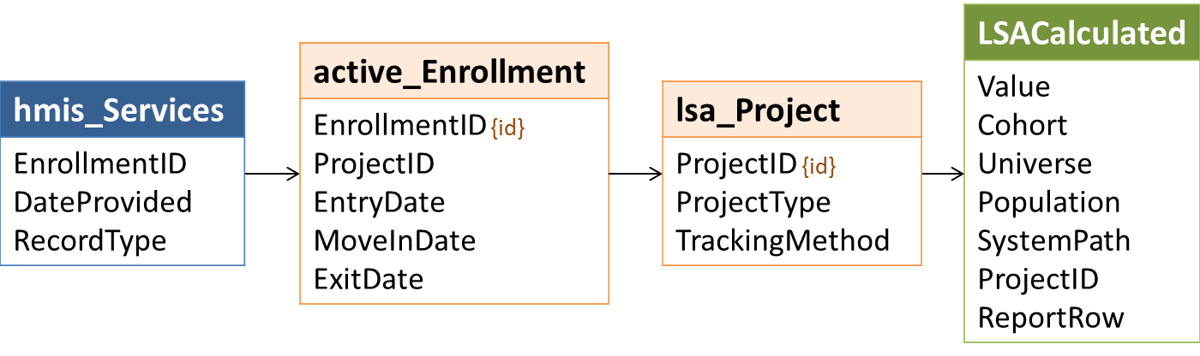

### ReportRow, Universe, ProjectID, and Value

**ReportRow** 56 counts bed nights in the LSA report period for people in households whose members have various characteristics, grouped by **ProjectID**.

The **Universe** for project-level counts is 10; all project-level counts must have a value in the **ProjectID** column that matches a record in Project.csv.

**Value** = a count of the combination of [Date] and distinct **PersonalID***s* in tmp_Person that meet the criteria for inclusion in the cohort, universe, household type, and population, grouped by **ProjectID,** where [Date] is between ReportStart and ReportEnd and:

### Cohort

For the date range in tmp_CohortDates where **Cohort** = 1, cohort members include people (distinct **PersonalID**s) in tmp_Person with an active_Enrollment where:

* **ProjectType** in (1,2,3,8,13); and
* If **ProjectType** in (3,13), **MoveInDate** <= CohortEnd (do not count people not in housing); and
* If **ProjectType** in (1,2,8,), **EntryDate** <= CohortEnd; and
* If **TrackingMethod** = 3, there is a **BedNightDate** between CohortStart and CohortEnd; and
* **ExitDate** is null or **ExitDate** > CohortStart

### Household Type and Population

Project-level counts of bed nights in the LSA report period are required for people served in the following combinations of household type and population.

| Population | Population Name | HHType |
| --- | --- | --- |
| 0 | All | 1 (AO) |
| 0 | All | 2 (AC) |
| 0 | All | 3 (CO) |
| 0 | All | All (including unknown) |
| 1 | Youth Household 18-21 | 1 (AO) |
| 2 | Youth Household 22-24 | 1 (AO) |

### SystemPath

**SystemPath** is always -1 for counts of bednights.

## Get Counts of Bednights by Project Type and Household Characteristics

### Relevant Data



### ReportRow, Universe, and Value

**ReportRow** 56 counts bed nights in the LSA report period for people in households whose members have various characteristics, grouped by **Universe**.

The value in the Project.csv **ProjectType** column for these counts determines the **Universe:**

| Universe | Active Enrollment |
| --- | --- |
| 11=ES project type | **ProjectType** = 1 |
| 12=SH project type | **ProjectType** = 8 |
| 13=TH project type | **ProjectType** = 2 |
| 14=Housed in RRH | **ProjectType** = 13 |
| 15=Housed in PSH | **ProjectType** = 3 |
| 16= ES/SH/TH unduplicated | **ProjectType** in (1,8,2) |

**Value** = a count of each distinct combination of [Date] and distinct **PersonalID***s* in tmp_Person that meet the criteria for inclusion in the cohort, universe, household type, and population, grouped by **ProjectID,** where [Date] is between ReportStart and ReportEnd.

### Cohort

For the date range in tmp_CohortDates where **Cohort** = 1, cohort members include people (distinct **PersonalID**s) in tmp_Person with an active_Enrollment where:

* **ProjectType** in (1,2,3,8,13); and
* If **ProjectType** in (3,13), **MoveInDate** <= CohortEnd (do not count people not in housing); and
* If **ProjectType** in (1,2,8,), **EntryDate** <= CohortEnd; and
* If **TrackingMethod** = 3, there is a **BedNightDate** between CohortStart and CohortEnd; and
* **ExitDate** is null or **ExitDate** > CohortStart

### Household Type and Population

Project-level counts of bed nights in the LSA report period are required for people served in the following combinations of household type and population.

| Population | Population Name | HHType |
| --- | --- | --- |
| 0 | All | 1 (AO) |
| 0 | All | 2 (AC) |
| 0 | All | 3 (CO) |
| 0 | All | All (including unknown) |
| 1 | Youth Household 18-21 | 1 (AO) |
| 2 | Youth Household 22-24 | 1 (AO) |

### SystemPath and ProjectID

**SystemPath** is always -1 for counts of bednights; **ProjectID** should be NULL for counts by project type.

## Get Counts of Bednights by ProjectID and Personal Characteristics

### Relevant Data



### ProjectID and Value

**Value** = a count of the combination of [Date] and distinct **PersonalID***s* in tmp_Person active in relevant projects (**ProjectID**)that meet the criteria for inclusion based on household type and personal characteristics in tmp_Person, grouped by **ProjectID,** where [Date] is between ReportStart and ReportEnd and:

| Project | [Date] | [Date] |
| --- | --- | --- |
| **ProjectType** in (3,13) | **>=MoveInDate** | <= (**ExitDate** – 1 day)or,  If **ExitDate** is null, ReportEnd |
| **ProjectType** in (2,3,8) or **TrackingMethod** = 0 | **>=EntryDate** | <= (**ExitDate** – 1 day) or,  If **ExitDate** is null, ReportEnd |
| **TrackingMethod** = 3 | *=BedNightDate* | |

The value in the **ProjectID** column for these counts must match a record in Project.csv.

### Population, Household Type, and ReportRow

These counts are required in LSACalculated only if:

* ReportStart is October 1
* ReportEnd is September 30 of the following year
* LSAReport.**LSAScope** = 1

**ReportRow** 57 counts bed nights for people based on their own personal characteristics; for example, only veterans are included in the ‘Veteran’ count.

| Population | Population Name | HHType |
| --- | --- | --- |
| 3 | Veteran | 1 (AO) |
| 3 | Veteran | 2 (AC) |
| 3 | Veteran | All (including unknown) |
| 6 | Chronically Homeless Adult/HoH | 1 (AO) |
| 6 | Chronically Homeless Adult/HoH | 2 (AC) |
| 6 | Chronically Homeless Adult/HoH | 3 (CO) |
| 6 | Chronically Homeless Adult/HoH | All (including unknown) |

### Other Columns

| Cohort | Universe | SystemPath |
| --- | --- | --- |
| 1 (active in report period) | 10 (project-level) | -1 (n/a) |

## Get Counts of Bednights by Project Type and Personal Characteristics

### Relevant Data



### ReportRow, Universe, and Value

**ReportRow** 57 counts bed nights for people based on their own personal characteristics; for example, only bednights for veterans are included in the ‘Veteran’ count.

The value in the Project.csv **ProjectType** column for these counts determines the **Universe:**

| Universe | Active Enrollment |
| --- | --- |
| 11=ES project type | **ProjectType** = 1 |
| 12=SH project type | **ProjectType** = 8 |
| 13=TH project type | **ProjectType** = 2 |
| 14=Housed in RRH | **ProjectType** = 13 |
| 15=Housed in PSH | **ProjectType** = 3 |
| 16= ES/SH/TH unduplicated | **ProjectType** in (1,8,2) |

**Value** = a count of each distinct combination of [Date] and distinct **PersonalID***s* in tmp_Person that meet the criteria for inclusion in the cohort, universe, household type, and population, grouped by **ProjectID,** where [Date] is between ReportStart and ReportEnd.

### Cohort

For the date range in tmp_CohortDates where **Cohort** = 1, cohort members include people (distinct **PersonalID**s) in tmp_Person with an active_Enrollment where:

* **ProjectType** in (1,2,3,8,13); and
* If **ProjectType** in (3,13), **MoveInDate** <= CohortEnd (do not count people not in housing); and
* If **ProjectType** in (1,2,8,), **EntryDate** <= CohortEnd; and
* If **TrackingMethod** = 3, there is a **BedNightDate** between CohortStart and CohortEnd; and
* **ExitDate** is null or **ExitDate** > CohortStart

| Universe | Active Enrollment |
| --- | --- |
| 11=ES project type | **ProjectType** = 1 |
| 12=SH project type | **ProjectType** = 8 |
| 13=TH project type | **ProjectType** = 2 |
| 14=Housed in RRH | **ProjectType** = 13 |
| 15=Housed in PSH | **ProjectType** = 3 |
| 16=ES/SH/TH unduplicated | **ProjectType** in (1,8,2) |

### Household Type and Population

Counts of bednights are required for the following combinations of personal characteristic and household type.

| Population | Population Name | HHType |
| --- | --- | --- |
| 3 | Veteran | 1 (AO) |
| 3 | Veteran | 2 (AC) |
| 3 | Veteran | All (including unknown) |
| 6 | Chronically Homeless Adult/HoH | 1 (AO) |
| 6 | Chronically Homeless Adult/HoH | 2 (AC) |
| 6 | Chronically Homeless Adult/HoH | 3 (CO) |
| 6 | Chronically Homeless Adult/HoH | All (including unknown) |

### Other Columns

| Cohort | SystemPath |
| --- | --- |
| 1 (active in report period) | -1 (n/a) |

## Set LSAReport Data Quality Values for Report Period

Note that data quality is assessed systemwide at a much broader level than actual LSA reporting. For example, the data quality columns look at race, ethnicity, etc. for children who are not heads of household. This is done to get a sense of systemwide data quality and we anticipate the release of separate specifications for HMIS output based on this logic. See **Appendix A** for a table illustrating how the data quality data points will be evaluated by reviewers.

### UnduplicatedClient1

A count of distinct **PersonalID**s in active_Enrollment.

### UnduplicatedAdult1

A count of distinct **PersonalID**s in active_Enrollment where **AgeGroup** between 18 and 65.

### AdultHoHEntry1

A count of distinct **EnrollmentID**s in active_Enrollment where **AgeGroup** between 18 and 65 or **RelationshipToHoH** = 1.

### ClientEntry1

A count of distinct **EnrollmentID**s in active_Enrollment.

### ClientExit1

A count of distinct **EnrollmentID**s in active_Enrollment where **ExitDate** between ReportStart and ReportEnd.

### Household1

A count of distinct **HouseholdID**s in active_Enrollment.

### HoHPermToPH1

A count of distinct **EnrollmentID**s in active_Enrollment where heads of household served in RRH or PSH projects exited to a permanent housing destination:

|  |  |
| --- | --- |
| active_Enrollment* | **Condition** |
| **RelationshipToHoH** | 1 |
| **ExitDate** | is not null |
| lsa_Project | **Condition** |
| **ProjectType** | in (3,13) |
| hmis_Exit | **Condition** |
| *Destination* | Permanent - in (3,31,19,20,21,26,28,10,11,22,23) |

* Throughout the data quality section, the dark purple rows starting with “active_,” “lsa_” and “dq_” refer to LSA column or construct sources. The light green shaded rows starting with ”hmis_” refer to HMIS sources.

### NoCoC

A count of distinct *EnrollmentID*s in hmis_Enrollment for continuum projects that operate in the ReportCoC where there is no value for *EnrollmentCoC*.

|  |  |
| --- | --- |
| hmis_Enrollment | **Condition** |
| *RelationshipToHoH* | 1 |
| *EntryDate* | <= ReportEnd |
| hmis_Exit | **Condition** |
| *ExitDate* | >= ReportStart or NULL |
| hmis_Project | **Condition** |
| *ProjectType* | in (1,2,3,8,13)) |
| *ContinuumProject* | 1 |
| hmis_ProjectCoC | **Condition** |
| *CoCCode* | ReportCoC |
| hmis_EnrollmentCoC | **Condition** |
| *CoCCode* | is null |

### DOB1

A count of distinct **PersonalID**s in active_Enrollment where:

|  |  |
| --- | --- |
| active_Enrollment | **Condition** |
| **AgeGroup** | in (98,99) |

### Gender1

A count of distinct **PersonalID**s in active_Enrollment – including children not served as head of household – where:

|  |  |
| --- | --- |
| hmis_Client | **Condition** |
| *Gender* | Not between 0 and 4 |

### Race1

A count of distinct **PersonalID**s in active_Enrollment – including children not served as head of household – where:

|  |  |
| --- | --- |
| hmis_Client | **Condition** |
| *Race* | in (98,99) |

### Ethnicity1

A count of distinct **PersonalID**s in active_Enrollment – including children not served as head of household – where:

|  |  |
| --- | --- |
| hmis_Client | **Condition** |
| *Ethnicity* | not in (0,1) |

### VetStatus1

A count of distinct **PersonalID**s in active_Enrollment where:

|  |  |
| --- | --- |
| active_Enrollment | **Condition** |
| **AgeGroup** | Between 18 and 65 |
| hmis_Client | **Condition** |
| **VeteranStatus** | Not in (0,1) or is null |

### RelationshipToHoH1

A count of distinct **EnrollmentID**s in active_Enrollment where:

|  |  |
| --- | --- |
| active_Enrollment | **Condition** |
| **RelationshipToHoH** | Not between 1 and 5 |

### DisablingCond1

A count of distinct **EnrollmentID**s in active_Enrollment – including children not served as head of household – where:

|  |  |
| --- | --- |
| hmis_Enrollment | **Condition** |
| *DisablingCondition* | not in (0,1) |

### LivingSituation1

A count of distinct **EnrollmentID**s in active_Enrollment – including adults not served as head of household – where **AgeGroup** between 18 and 65 or **RelationshipToHoH** = 1 and:

|  |  |
| --- | --- |
| hmis_Enrollment | **Condition** |
| *LivingSituation* | in (8,9,99) or is null |

### LengthOfStay1

A count of distinct **EnrollmentID**s in active_Enrollment where **AgeGroup** between 18 and 65 or **RelationshipToHoH** = 1 and:

|  |  |
| --- | --- |
| hmis_Enrollment | **Condition** |
| *LengthOfStay* | in (8,9,99) or is null |

### HomelessDate1

A count of distinct **EnrollmentID**s in active_Enrollment where **AgeGroup** between 18 and 65 or **RelationshipToHoH** = 1 and the record meets any of the four conditions below:

|  |  |  |  |  |
| --- | --- | --- | --- | --- |
| hmis_Enrollment | **Condition 1** | **Condition 2** | **Condition 3** | **Condition 4** |
| *DateToESSHStreet* | > *EntryDate* | null | null | null |
| *LivingSituation* | -- | in (1,16,18,27) | -- | in (4,5,6,7,15,24) |
| *LengthOfStay* | -- | -- | in (10,11) | in (2,3) |
| *PreviousStreetESSH* | -- | -- | 1 or is null | 1 or is null |

### TimesHomeless1

A count of distinct **EnrollmentID**s in active_Enrollment where **AgeGroup** between 18 and 65 or **RelationshipToHoH** = 1 and:

|  |  |
| --- | --- |
| hmis_Enrollment | **Condition** |
| *TimesHomeless* | Not between 1 and 4 |

### MonthsHomeless1

A count of distinct **EnrollmentID**s in active_Enrollment where **AgeGroup** between 18 and 65 or **RelationshipToHoH** = 1 and:

|  |  |
| --- | --- |
| hmis_Enrollment | **Condition** |
| *MonthsHomeless* | Not between 101 and 113 |

### DV1

A count of distinct **EnrollmentID**s in active_Enrollment where **AgeGroup** between 18 and 65 or **RelationshipToHoH** = 1 and:

There is no associated record of DE *4.11 DomesticViolence* with a *DataCollectionStage* = 1; or:

|  |  |  |  |
| --- | --- | --- | --- |
| hmis_HealthAndDV | **Condition 1** | **OR** | **Condition 2** |
| *DataCollectionStage* | 1 | | 1 |
| *DomesticViolenceVictim* | in (8,9,99) or is null | | 1 |
| *CurrentlyFleeing* | (any) | | in (8,9,99) or is null |

### Destination1

A count of distinct **EnrollmentID**s in active_Enrollment where **ExitDate** between ReportStart and ReportEnd and:

|  |  |
| --- | --- |
| hmis_Exit | **Condition** |
| *Destination* | in (8,9,17,30,99) |

### NotOneHoH1

A count of distinct **HouseholdID**s in active_Enrollment where there is no designated head of household or where there is more than one designated head of household:

|  |  |
| --- | --- |
| hmis_Enrollment | **Condition** |
| *RelationshipToHoH* | 1 |
| COUNT (distinct *EnrollmentID)* | <>1 |

### MoveInDate1

A count of distinct **EnrollmentID**s in active_Enrollment where heads of household served in RRH or PSH projects exited to a permanent housing destination and **MoveInDate** is null or **MoveInDate** not between **EntryDate** and **ExitDate**.

|  |  |
| --- | --- |
| active_Enrollment | **Condition** |
| **RelationshipToHoH** | 1 |
| **ExitDate** | is not null |
| **MoveInDate** | is null or not between **EntryDate** and **ExitDate** |
| lsa_Project | **Condition** |
| **ProjectType** | in (3,13) |
| hmis_Exit | **Condition** |
| *Destination* | Permanent - in (3,31,19,20,21,26,28,10,11,22,23) |

## Get Relevant Enrollments for Three Year Data Quality Checks

### Data Construct: dq_Enrollment

|  |  |
| --- | --- |
| EnrollmentID | Distinct *EnrollmentIDs* active in the three years between (ReportStart – 2 years) and ReportEnd; foreign key for HMIS enrollment records. |
| PersonalID | Foreign key –hmis_Client. |
| HouseholdID | From enrollment. |
| RelationshipToHoH | From enrollment. |
| ProjectType | From hmis_Project. |
| EntryDate | *EntryDate* for the enrollment. |
| MoveInDate | *MoveInDate* for RRH/PSH enrollments, if any. |
| ExitDate | *ExitDate* for the EnrollmentID, if any. |
| Adult | 0 (no, child), 1 (yes), 99 (unknown). |
| SSNValid | 0 (no, does not meet checked criteria), 1 (meets checked criteria). |

### Relevant Data

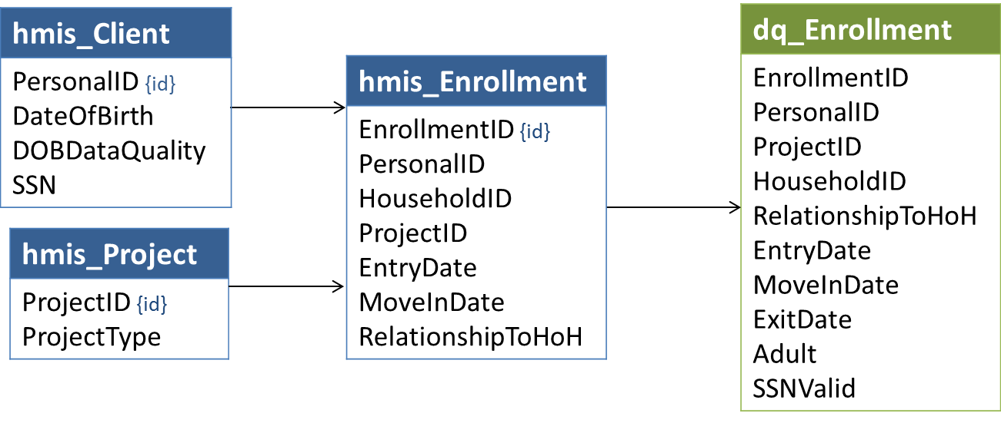

### Logic

The inclusion criteria for dq_Enrollment are similar to – but less stringent than – than those used to identify clients active in the report period:

* *EntryDate* <= ReportEnd
* *ExitDate* is NULL or *ExitDate* >= (ReportEnd – 3 years)
* *ProjectType* in (1,2,3,8,13)
* ContinuumProject = 1
* There is a record where *EnrollmentCoC* = ReportCoC dated on or before ReportEnd associated with any *EnrollmentID* that shares the same *HouseholdID*

#### Adult

An individual’s status as adult, child, or unknown is based on *DOBDataQuality* and *DOB* in relation to *EntryDate.*

| Priority | Condition | Adult |
| --- | --- | --- |
| 1 | *DOBDataQuality* in (8,9) | 99 |
| 2 | *DOBDataQuality* not in (1,2) | 99 |
| 3 | *DOB* is missing or set to a system default | 99 |
| 4 | *DOB* *> EntryDate* | 99 |
| 5 | *RelationshipToHoH* = 1 and *DOB* *= EntryDate* | 99 |
| 5 | [*DOB* *+* 105 years] *<=* **AgeDate** | 99 |
| 6 | [*DOB* *+* 18 years] *<=* **AgeDate** | 1 |
| 7 | (other) | 0 |

#### SSNValid

**SSNValid** = 0 for any *SSN* where:

* Length(*SSN*) <>9; or
* *SSN* is null or set to system default; or
* *SSN* begins with ‘000’, ‘666’, or ‘9’; or
* *SSN* middle 2 digits are ‘00’ (e.g. 999-00-9999); or
* *SSN* last 4 digits are ‘0000’; or
* *SSN* contains any character other than 0-9; or
* *SSN* in ('111111111', '222222222', '333333333', '444444444', '555555555', '777777777', '888888888')

Otherwise, **SSNValid** = 1. (These checks will not catch every invalid SSN, but those that meet the criteria will be assumed to be valid.)

## Set LSAReport Data Quality Values for Three Year Period

### UnduplicatedClient3

A count of distinct **PersonalID**s in dq_Enrollment.

### UnduplicatedAdult3

A count of distinct **PersonalID**s in dq_Enrollment where **Adult** = 1.

### AdultHoHEntry3

A count of distinct **EnrollmentID**s in dq_Enrollment where **Adult** = 1 or **RelationshipToHoH** = 1.

### ClientEntry3

A count of distinct **EnrollmentID**s in dq_Enrollment.

### ClientExit3

A count of distinct **EnrollmentID**s in dq_Enrollment where **ExitDate** between (ReportStart – 2 years) and ReportEnd.

### Household3

A count of distinct **HouseholdID**s in dq_Enrollment.

### HoHPermToPH3

A count of distinct **EnrollmentID**s in dq_Enrollment where heads of household served in RRH or PSH projects exited to a permanent housing destination:

|  |  |
| --- | --- |
| dq_Enrollment | **Condition** |
| **RelationshipToHoH** | 1 |
| **ExitDate** | is not null |
| **ProjectType** | in (3,13) |
| hmis_Exit | **Condition** |
| *Destination* | Permanent - in (3,31,19,20,21,26,28,10,11,22,23) |

### SSNNotProvided

A count of distinct **PersonalID**s in dq_Enrollment where the client either did not know or refused to provide a Social Security number:

|  |  |
| --- | --- |
| hmis_Client | **Condition** |
| *SSNDataQuality* | in (8,9) |

### SSNMissingOrInvalid

A count of distinct **PersonalID**s in dq_Enrollment where the SSN is not consistent with Social Security Administration guidelines for a valid SSN and the **PersonalID** was not counted in **SSNNotProvided**.

|  |  |
| --- | --- |
| dq_Enrollment | **Condition** |
| **SSNValid** | 0 |
| hmis_Client | **Condition** |
| *SSNDataQuality* | NOT in (8,9) or is null |

### ClientSSNNotUnique

A count of distinct **PersonalID**s in dq_Enrollment that have the same (apparently valid) hmis_Client.*SSN* as one or more other **PersonalID**s that appear in dq_Enrollment:

|  |  |
| --- | --- |
| dq_Enrollment | **Condition** |
| **SSNValid** | 1 |
| hmis_Client | **Condition** |
| *SSNDataQuality* | In (1,2) |
| *SSN* | Not in the SSN values counted in **SSNMissingOrInvalid** |
| *SSN* | = hmis_Client.*SSN* where *PersonalID* <> dq_Enrollment.**PersonalID** |

### DistinctSSNValueNotUnique

A count of distinct (apparently valid) *SSN*values in hmis_Client which are shared by more than one dq_Enrollment.**PersonalID**:

|  |  |
| --- | --- |
| dq_Enrollment | **Condition** |
| **SSNValid** | 1 |
| hmis_Client | **Condition** |
| *PersonalID* | in dq_Enrollment.**PersonalID** |
| Count (distinct *PersonalID*) | >1 |

### DOB3

A count of distinct **PersonalID**s in dq_Enrollment where:

|  |  |
| --- | --- |
| dq_Enrollment | **Condition** |
| **Adult** | 99 |

### Gender3

A count of distinct **PersonalID**s in dq_Enrollment where:

|  |  |
| --- | --- |
| hmis_Client | **Condition** |
| *Gender* | not between 0 and 4 or is null |

### Race3

A count of distinct **PersonalID**s in dq_Enrollment where:

|  |  |
| --- | --- |
| hmis_Client | **Condition** |
| *Race* | in (8,9,99) or is null |

### Ethnicity3

A count of distinct **PersonalID**s in dq_Enrollment where:

|  |  |
| --- | --- |
| hmis_Client | **Condition** |
| *Ethnicity* | not in (0,1) or is null |

### VetStatus3

A count of distinct **PersonalID**s in dq_Enrollment where:

|  |  |
| --- | --- |
| dq_Enrollment | **Condition** |
| **Adult** | 1 |
| hmis_Client | **Condition** |
| *VeteranStatus* | not in (0,1) or is null |

### RelationshipToHoH3

A count of distinct **EnrollmentID**s in dq_Enrollment where:

|  |  |
| --- | --- |
| dq_Enrollment | **Condition** |
| **RelationshipToHoH** | not between 1 and 5 or is null |

### DisablingCond3

A count of distinct **EnrollmentID**s in dq_Enrollment – including children not served as head of household – where:

|  |  |
| --- | --- |
| hmis_Enrollment | **Condition** |
| *DisablingCondition* | not in (0,1) or is null |

### LivingSituation3

A count of distinct **EnrollmentID**s in dq_Enrollment where **AgeGroup** between 18 and 65 or **RelationshipToHoH** = 1 and:

|  |  |
| --- | --- |
| hmis_Enrollment | **Condition** |
| *LivingSituation* | in (8,9,99) or is null |

### LengthOfStay3

A count of distinct **EnrollmentID**s in dq_Enrollment where **AgeGroup** between 18 and 65 or **RelationshipToHoH** = 1 and:

|  |  |
| --- | --- |
| hmis_Enrollment | **Condition** |
| *LengthOfStay* | in (8,9,99) or is null |

### HomelessDate3

A count of distinct **EnrollmentID**s in dq_Enrollment where **Adult** = 1 or **RelationshipToHoH** = 1 and the record meets any of the four conditions below:

|  |  |  |  |  |
| --- | --- | --- | --- | --- |
| hmis_Enrollment | **Condition 1** | **Condition 2** | **Condition 3** | **Condition 4** |
| *DateToESSHStreet* | > *EntryDate* | null | null | null |
| *LivingSituation* | -- | in (1,16,18,27) | -- | in (4,5,6,7,15,24) |
| *LengthOfStay* | -- | -- | in (10,11) | in (2,3) |
| *PreviousStreetESSH* | -- | -- | 1 or is null | 1 or is null |

### TimesHomeless3

A count of distinct **EnrollmentID**s in dq_Enrollment where **Adult** = 1 or **RelationshipToHoH** = 1 and:

|  |  |
| --- | --- |
| hmis_Enrollment | **Condition** |
| *TimesHomeless* | Not between 1 and 4 |

### MonthsHomeless3

A count of distinct **EnrollmentID**s in dq_Enrollment where **Adult** = 1 or **RelationshipToHoH** = 1 and:

|  |  |
| --- | --- |
| hmis_Enrollment | **Condition** |
| *MonthsHomeless* | Not between 101 and 113 |

### DV3

A count of distinct **EnrollmentID**s in dq_Enrollment where **Adult** = 1 or **RelationshipToHoH** = 1 and:

There is no associated record of DE *4.11 DomesticViolence* with a *DataCollectionStage* = 1; or the record meets either of the two conditions below:

|  |  |  |  |
| --- | --- | --- | --- |
| hmis_HealthAndDV | **Condition 1** | **OR** | **Condition 2** |
| *DataCollectionStage* | 1 | | 1 |
| *DomesticViolenceVictim* | in (8,9,99) or is null | | 1 |
| *CurrentlyFleeing* | (any) | | in (8,9,99) or is null |

### Destination3

A count of distinct **EnrollmentID**s in dq_Enrollment where **ExitDate** between ReportStart and ReportEnd and:

|  |  |
| --- | --- |
| hmis_Exit | **Condition** |
| *Destination* | in (8,9,17,30,99) |

### NotOneHoH3

A count of distinct **HouseholdID**s in dq_Enrollment where there is no designated head of household or where there is more than one designated head of household:

|  |  |
| --- | --- |
| hmis_Enrollment | **Condition** |
| *RelationshipToHoH* | 1 |
| Count (distinct *EnrollmentID)* | <>1 |

### MoveInDate3

A count of distinct **EnrollmentID**s in dq_Enrollment where heads of household served in RRH or PSH projects exited to a permanent housing destination and **MoveInDate** is null or **MoveInDate** not between **EntryDate** and **ExitDate**.

|  |  |
| --- | --- |
| dq_Enrollment | **Condition** |
| **RelationshipToHoH** | 1 |
| **ExitDate** | is not null |
| **MoveInDate** | is null or not between **EntryDate** and **ExitDate** |
| **ProjectType** | in (3,13) |
| hmis_Exit | **Condition** |
| *Destination* | Permanent - in (3,31,19,20,21,26,28,10,11,22,23) |

## Set LSAReport ReportDate

Set LSAReport.**ReportDate** = the system date/time when all data required to produce the LSA CSV files has been generated.

## Select Data for Export to LSA CSV Files

### LSAPerson

LSAPerson includes 24 columns. **RowTotal** is a count of distinct **PersonalID**s in tmp_Person, grouped by values in all of the columns below. The data type for every column in LSAPerson is integer; no value may be null.

| # | Column Name |
| --- | --- |
| 1 | **RowTotal** |
| 2 | **Age** |
| 3 | **Gender** |
| 4 | **Race** |
| 5 | **Ethnicity** |
| 6 | **VetStatus** |
| 7 | **DisabilityStatus** |
| 8 | **CHTime** |
| 9 | **CHTimeStatus** |
| 10 | **DVStatus** |
| 11 | **HHTypeEST** |
| 12 | **HoHEST** |
| 13 | **HHTypeRRH** |
| 14 | **HoHRRH** |
| 15 | **HHTypePSH** |
| 16 | **HoHPSH** |
| 17 | **HHChronic** |
| 18 | **HHVet** |
| 19 | **HHDisability** |
| 20 | **HHFleeingDV** |
| 21 | **HHAdultAge** |
| 22 | **HHParent** |
| 23 | **AC3Plus** |
| 24 | **ReportID** |

### LSAHousehold

LSAHousehold includes 42 columns. **RowTotal** is a count of distinct combinations of **HoHID** and **HHType** from tmp_Household, grouped by the values in all other columns. All of the column in LSAHousehold are integers; none may be null.

In tmp_Household, the following columns are populated with actual counts of days because they are needed to generate averages for LSACalculated:

|  |  |  |
| --- | --- | --- |
| **ESDays** | **RRHPreMoveInDays** | **SystemHomelessDays** |
| **THDays** | **RRHPSHPreMoveInDays** | **Other3917Days** |
| **ESTDays** | **RRHHousedDays** | **TotalHomelessDays** |

For export, the actual counts are grouped into categories as shown below.

*Not applicable* (-1) is not valid for **SystemHomelessDays**, **Other3917Days**, or **TotalHomelessDays**. For the other columns listed above, it should be used consistent with the logic in Section 4.36.

| Value | System Use/Homeless Days | Criteria |
| --- | --- | --- |
| -1 | Not applicable | For **ESDays**, **THDays**, and **ESTDays**:   * **ESTStatus** = 0   For **RRHPreMoveInDays**:   * **RRHStatus** = 0   For **RRHPSHPreMoveInDays**:   * **RRHStatus** = 0 and **PSHStatus** = 0   For **RRHHousedDays**:   * **RRHMoveIn** not in (1,2) |
| 0 | 0 days | [Days] = 0 and n/a criteria are not met |
| 7 | 1-7 days | [Days] between 1 and 7 |
| 30 | 8-30 days | [Days] between 8 and 30 |
| 60 | 31-60 days | [Days] between 31 and 60 |
| 90 | 61-90 days | [Days] between 61 and 90 |
| 180 | 91-180 days | [Days] between 91 and 180 |
| 365 | 181-365 days | [Days] between 181 and 365 |
| 547 | 366-547 days | [Days] between 366 and 547 |
| 730 | 548-730 days | [Days] between 548 and 730 |
| 1094 | 731-1094 days | [Days] between 731 and 1094 |
| 1095 | 1095 days+ | [Days] > 1094 |

Actual values in the **PSHHousedDays** column also have to be grouped into upload categories; the groupings differ from those used for the other columns of system use days:

| Value | Time Housed in PSH | Criteria |
| --- | --- | --- |
| -1 | Not applicable | **PSHMoveIn** not in (1,2) |
| 3 | Up to 3 months | **PSHHousedDays** < 90 |
| 6 | 3-6 months | **PSHHousedDays** between 91 and 180 |
| 12 | 6-12 months | **PSHHousedDays** between 181 and 365 |
| 24 | 12-24 months | **PSHHousedDays** between 366 and 180 |
| 36 | 25-36 months | **PSHHousedDays** between 731 and 730 |
| 48 | 37-48 months | **PSHHousedDays** between 1096 and 1460 |
| 60 | 49-60 months | **PSHHousedDays** between 1461and 1825 |
| 84 | 5-7 years | **PSHHousedDays** between 1826 and 2555 |
| 120 | 8-10 years | **PSHHousedDays** between 2556 and 3650 |
| 121 | 10+ years | **PSHHousedDays** > 3650 |

LSAHousehold includes 42 columns. **RowTotal** is a count of distinct combinations of **HoHID** and **HHType** from tmp_Household, grouped by the values in all other columns. All of the column in LSAHousehold are integers; none may be null.

| # | Column Name |
| --- | --- |
| 1 | **RowTotal** |
| 2 | **Stat** |
| 3 | **ReturnTime** |
| 4 | **HHType** |
| 5 | **HHChronic** |
| 6 | **HHVet** |
| 7 | **HHDisability** |
| 8 | **HHFleeingDV** |
| 9 | **HoHRace** |
| 10 | **HoHEthnicity** |
| 11 | **HHAdult** |
| 12 | **HHChild** |
| 13 | **HHNoDOB** |
| 14 | **HHAdultAge** |
| 15 | **HHParent** |
| 16 | **ESTStatus** |
| 17 | **RRHStatus** |
| 18 | **RRHMoveIn** |
| 19 | **PSHStatus** |
| 20 | **PSHMoveIn** |
| 21 | **ESDays** (group as shown above) |
| 22 | **THDays** (group as shown above) |
| 23 | **ESTDays** (group as shown above) |
| 24 | **ESTGeography** |
| 25 | **ESTLivingSit** |
| 26 | **ESTDestination** |
| 27 | **RRHPreMoveInDays** (group as shown above) |
| 28 | **RRHPSHPreMoveInDays** (group as shown above) |
| 29 | **RRHHousedDays** (group as shown above) |
| 30 | **SystemDaysNotPSHHoused** |
| 31 | **RRHGeography** |
| 32 | **RRHLivingSit** |
| 33 | **RRHDestination** |
| 34 | **SystemHomelessDays** (group as shown above) |
| 35 | **Other3917Days** (group as shown above) |
| 36 | **TotalHomelessDays** (group as shown above) |
| 37 | **PSHGeography** |
| 38 | **PSHLivingSit** |
| 39 | **PSHDestination** |
| 40 | **PSHHousedDays** (group as shown above) |
| 41 | **SystemPath** |
| 42 | **ReportID** |

### LSAExit

LSAExit includes 17 columns. **RowTotal** is a count of distinct combinations of **Cohort, HoHID** and **HHType** from tmp_Exit, grouped by the values in all other columns.

In tmp_Exit, **ReturnTime** is populated with actual counts of days because they are needed to generate averages for LSACalculated. For export, the actual counts are grouped into categories as shown below.

| Value | Return Time | From | To |
| --- | --- | --- | --- |
| -1 | Not applicable | -1 | -1 |
| 30 | 15-30 days | 15 | 30 |
| 60 | 31-60 days | 31 | 60 |
| 90 | 61-90 days | 61 | 90 |
| 180 | 91-180 days | 91 | 180 |
| 365 | 181-365 days | 181 | 365 |
| 547 | 366-547 days | 366 | 547 |
| 730 | 548-730 days | 548 | 730 |

All of the column in LSAExit are integers; none may be null.

| # | Column Name |
| --- | --- |
| 1 | **RowTotal** |
| 2 | **Cohort** |
| 3 | **Stat** |
| 4 | **ExitFrom** |
| 5 | **ExitTo** |
| 6 | **ReturnTime** (group as shown above) |
| 7 | **HHType** |
| 8 | **HHVet** |
| 9 | **HHDisability** |
| 10 | **HHFleeingDV** |
| 11 | **HoHRace** |
| 12 | **HoHEthnicity** |
| 13 | **HHAdultAge** |
| 14 | **HHParent** |
| 15 | **AC3Plus** |
| 16 | **SystemPath** |
| 17 | **ReportID** |

### LSACalculated

LSACalculated has nine columns. With the exception of **ProjectID,** the datatype for all columns is integer and none may be null.

The data type for the **ProjectID** column is an alphanumeric string of no more than 32 characters.

* If **Universe** <> 10, **ProjectID** must be null.
* If **Universe** = 10, **ProjectID** must match a record in Project.csv.

| # | Column Name |
| --- | --- |
| 1 | **Value** |
| 2 | **Cohort** |
| 3 | **Universe** |
| 4 | **HHType** |
| 5 | **Population** |
| 6 | **SystemPath** |
| 7 | **ProjectID** |
| 8 | **ReportRow** |
| 9 | **ReportID** |

### LSAReport

LSAReport has 61 columns; none may be null. Data types are shown below.

| # | Column Name | Data Type |
| --- | --- | --- |
| 1 | **ReportID** | Integer |
| 2 | **ReportDate** | Date/time |
| 3 | **ReportStart** | Date |
| 4 | **ReportEnd** | Date |
| 5 | **ReportCoC** | 6 character string (XX-999) |
| 6 | **SoftwareVendor** | String; up to 50 characters or ‘n/a’ |
| 7 | **SoftwareName** | String; up to 50 characters or ‘n/a’ |
| 8 | **VendorContact** | String; up to 50 characters or ‘n/a’ |
| 9 | **VendorEmail** | String; up to 50 characters or ‘n/a’ |
| 10 | **LSAScope** | Integer |
| 11 | **UnduplicatedClient1** | Integer |
| 12 | **UnduplicatedClient3** | Integer |
| 13 | **UnduplicatedAdult1** | Integer |
| 14 | **UnduplicatedAdult3** | Integer |
| 15 | **AdultHoHEntry1** | Integer |
| 16 | **AdultHoHEntry3** | Integer |
| 17 | **ClientEntry1** | Integer |
| 18 | **ClientEntry3** | Integer |
| 19 | **ClientExit1** | Integer |
| 20 | **ClientExit3** | Integer |
| 21 | **Household1** | Integer |
| 22 | **Household3** | Integer |
| 23 | **HoHPermToPH1** | Integer |
| 24 | **HoHPermToPH3** | Integer |
| 25 | **NoCoC** | Integer |
| 26 | **SSNNotProvided** | Integer |
| 27 | **SSNMissingOrInvalid** | Integer |
| 28 | **ClientSSNNotUnique** | Integer |
| 29 | **DistinctSSNValueNotUnique** | Integer |
| 30 | **DOB1** | Integer |
| 31 | **DOB3** | Integer |
| 32 | **Gender1** | Integer |
| 33 | **Gender3** | Integer |
| 34 | **Race1** | Integer |
| 35 | **Race3** | Integer |
| 36 | **Ethnicity1** | Integer |
| 37 | **Ethnicity3** | Integer |
| 38 | **VetStatus1** | Integer |
| 39 | **VetStatus3** | Integer |
| 40 | **RelationshipToHoH1** | Integer |
| 41 | **RelationshipToHoH3** | Integer |
| 42 | **DisablingCond1** | Integer |
| 43 | **DisablingCond3** | Integer |
| 44 | **LivingSituation1** | Integer |
| 45 | **LivingSituation3** | Integer |
| 46 | **LengthOfStay1** | Integer |
| 47 | **LengthOfStay3** | Integer |
| 48 | **HomelessDate1** | Integer |
| 49 | **HomelessDate3** | Integer |
| 50 | **TimesHomeless1** | Integer |
| 51 | **TimesHomeless3** | Integer |
| 52 | **MonthsHomeless1** | Integer |
| 53 | **MonthsHomeless3** | Integer |
| 54 | **DV1** | Integer |
| 55 | **DV3** | Integer |
| 56 | **Destination1** | Integer |
| 57 | **Destination3** | Integer |
| 58 | **NotOneHoH1** | Integer |
| 59 | **NotOneHoH3** | Integer |
| 60 | **MoveInDate1** | Integer |
| 61 | **MoveInDate3** | Integer |

Appendix A. Data Quality Summary Output

This is a depiction of how the data quality data points will be evaluated by reviewers. It is also an example of output that may be useful to produce for CoC review on a system and project-by-project level.

| Record Counts | ReportStart - ReportEnd | (ReportStart – 2 years) - ReportEnd |
| --- | --- | --- |
| Total number of clients | **UnduplicatedClient1** | **UnduplicatedClient3** |
| Total number of adults | **UnduplicatedAdult1** | **UnduplicatedAdult3** |
| Active enrollments (adult/HoH) | **AdultHoHEntry1** | **AdultHoHEntry3** |
| Active enrollments (all clients) | **ClientEntry1** | **ClientEntry3** |
| Exits (all clients) | **ClientExit1** | **ClientExit3** |
| Household enrollments | **Household1** | **Household3** |

| **No Client Location / CoC Code** | **All** |
| --- | --- |
| Total household enrollments for continuum projects with no Enrollment CoC | **NoCoC** |

| Social Security Number Data Quality | (ReportStart – 2 years) – ReportEnd |
| --- | --- |
| Total number of clients | **Unduplicated3** |
| SSN - client doesn’t know / refused | **SSNNotProvided** |
| SSN not valid | **SSNMissingOrInvalid** |
| % missing/invalid | **SSNNotProvided** + **SSNMissingOrInvalid** / **Unduplicated3** * 100 |
| Clients with non-unique SSN values | **ClientSSNNotUnique** |
| # SSN values shared by <1 client | **DistinctSSNValueNotUnique** |

### Data Quality Summary

ReportStart - ReportEnd

| Field | Denominator | Numerator | Result |
| --- | --- | --- | --- |
| Date of Birth | Unduplicated1 | DOB1 | % |
| Gender | Unduplicated1 | Gender1 | % |
| Race | Unduplicated1 | Race1 | % |
| Ethnicity | Unduplicated1 | Ethnicity1 | % |
| Veteran Status | UnduplicatedAdult1 | VetStatus1 | % |
| Relationship to HoH | ClientEntry1 | RelationshipToHoH1 | % |
| Disabling Condition | ClientEntry1 | DisablingCond1 | % |
| Living Situation | AdultHoHEntry1 | LivingSituation1 | % |
| LengthOfStay | AdultHoHEntry1 | LengthOfStay1 | % |
| Date to Street/ES/SH | AdultHoHEntry1 | HomelessDate1 | % |
| Times Homeless Last 3 Years | AdultHoHEntry1 | TimesHomeless1 | % |
| MonthsHomeless Last 3 years | AdultHoHEntry1 | MonthsHomeless1 | % |
| Domestic Violence | AdultHoHEntry1 | DV1 | % |
| Destination | ClientExit1 | Destination1 | % |
| <> 1 Heads of Household | Household1 | NotOneHoH1 | % |
| RRH/PSH MoveIn Date | HoHPermtoPH1 | MoveInDate1 | % |

(ReportStart – 2 years) - ReportEnd

| Field | Denominator | Numerator | Result |
| --- | --- | --- | --- |
| Date of Birth | Unduplicated3 | DOB3 | % |
| Gender | Unduplicated3 | Gender3 | % |
| Race | Unduplicated3 | Race3 | % |
| Ethnicity | Unduplicated3 | Ethnicity3 | % |
| Veteran Status | UnduplicatedAdult3 | VetStatus3 | % |
| Relationship to HoH | ClientEntry3 | RelationshipToHoH3 | % |
| Disabling Condition | ClientEntry3 | DisablingCond3 | % |
| Living Situation | AdultHoHEntry3 | LivingSituation3 | % |
| LengthOfStay | AdultHoHEntry3 | LengthOfStay3 | % |
| Date to Street/ES/SH | AdultHoHEntry3 | HomelessDate3 | % |
| Times Homeless Last 3 Years | AdultHoHEntry3 | TimesHomeless3 | % |
| MonthsHomeless Last 3 years | AdultHoHEntry3 | MonthsHomeless3 | % |
| Domestic Violence | AdultHoHEntry3 | DV3 | % |
| Destination | ClientExit3 | Destination3 | % |
| <> 1 Heads of Household | Household3 | NotOneHoH3 | % |
| RRH/PSH MoveIn Date | HoHPermtoPH3 | MoveInDate3 | % |

Appendix B. HDX 2.0 Table Shells for Report Output

This section includes examples of the kinds of results that can be generated by the HDX 2.0 based on data in the uploaded CSV files. They are included to provide context for business logic and the contents of the HDX 2.0 HMIS Upload CSV files. **HMIS applications are not required to produce these report tables for display to users.**

For each table shell, the LSA CSV files and columns specific to the content of each table shell are listed.

Project Group Demographics

Demographics are reported for clients served in the current report period. All demographic data comes from LSAHousehold.csv (if reported for heads of household only) and LSAPerson.csv (all others).

These 12 table shells include output for each of the three project groups: 1. ES/SH/TH, 2. RRH, and 3. PSH; clients and households are counted in all project groups in which they were served.

Full Demographics reporting will be generated for AO, AC, and CO household types. In addition, demographics tables will be generated for the following groups of people:

* Chronically Homeless People in AO Households
* Veterans in AO Households
* Veterans in AC Households

In addition, a subset of demographics table shells will be generated for people in the following populations:

* AO - Young Adults 18-21
* AO - Young Adults 22-24
* CO - Unaccompanied Children <18
* AC – Parenting Youth 18-24
* CO - Parenting Children <18
* AC - Veteran Households
* AO - Veteran Households
* AO - Non-Veterans Age 25+
* AO - Chronically Homeless

All household members are included in total counts for populations regardless of personal demographics. For example, non-veteran adults served with veteran household members are included in demographics reporting for the ‘AO - Veteran Households’ population.

A summary matrix of reporting by household type and population is in Appendix C.

### Age – All Clients

| Source File | Source Columns |
| --- | --- |
| LSAPerson | **Age** |

Age is reported as a person-level characteristic calculated as of each client’s earliest active date in the report period, regardless of project group or household type.

Age is the only demographic reported for people under age 18 who are not served as a head of household.

| Age Groups | ES/SH/TH | RRH | PSH |
| --- | --- | --- | --- |
| <1 | # | # | # |
| 1 to 2 | # | # | # |
| 3 to 5 | # | # | # |
| 6 to 17 | # | # | # |
| 18 to 21 | # | # | # |
| 22 to 24 | # | # | # |
| 25 to 34 | # | # | # |
| 35 to 44 | # | # | # |
| 45 to 54 | # | # | # |
| 55 to 64 | # | # | # |
| 65 and older | # | # | # |
| Client doesn’t know/refused | # | # | # |
| Missing/invalid | # | # | # |

### Veteran Status – Adults

| Source File | Source Columns |
| --- | --- |
| LSAPerson | **VetStatus** |

Reporting on Veteran Status is not produced for CO households.

| Veteran Status | ES/SH/TH | RRH | PSH |
| --- | --- | --- | --- |
| Veteran | # | # | # |
| Non-veteran | # | # | # |
| Client doesn’t know/refused | # | # | # |
| Missing/invalid | # | # | # |

### Gender – Heads of Household/Adults

|  |  |
| --- | --- |
| Source File | Source Columns |
| LSAPerson | **Gender** |

Reporting on Gender.

| Gender | ES/SH/TH | RRH | PSH |
| --- | --- | --- | --- |
| Female | # | # | # |
| Male | # | # | # |
| Transgender | # | # | # |
| Gender non-conforming | # | # | # |
| Client doesn’t know/refused | # | # | # |
| Missing/invalid | # | # | # |

### Ethnicity – Heads of Household/Adults

|  |  |
| --- | --- |
| Source File | Source Columns |
| LSAPerson | **Ethnicity** |

Reporting on Ethnicity.

| Ethnicity | ES/SH/TH | RRH | PSH |
| --- | --- | --- | --- |
| Non-Hispanic/Non-Latino | # | # | # |
| Hispanic/Latino | # | # | # |
| Client doesn’t know/refused | # | # | # |
| Missing/invalid | # | # | # |

### Race – Heads of Household/Adults

| Source File | Source Columns |
| --- | --- |
| LSAPerson | **Race** |

Reporting on Race.

| Race | ES/SH/TH | RRH | PSH |
| --- | --- | --- | --- |
| White, Non-Hispanic/Non-Latino | # | # | # |
| White, Hispanic/Latino | # | # | # |
| Black or African American | # | # | # |
| Asian | # | # | # |
| American Indian or Alaska Native | # | # | # |
| Native Hawaiian / Other Pacific Islander | # | # | # |
| Multiple Races | # | # | # |
| Client doesn’t know/refused | # | # | # |
| Missing/invalid | # | # | # |

### Chronic Homelessness and Disabling Condition – Heads of Household/Adults

| Source File | Source Columns |
| --- | --- |
| LSAPerson | **DisabilityStatus, CHTime, CHTimeStatus** |

Other HUD reporting on chronic homelessness is limited to counting people who meet all of the criteria and those who do not. The LSA includes more detail about those who do not meet all of the criteria. The object is to provide information about people who:

* Don’t meet all the criteria of the HUD definition of chronic homelessness but may have similar needs, e.g. people who are disabled and have been in ES/SH or in a place not meant for habitation for at least 365 days over three years, but in fewer than four episodes.
* Might be chronically homeless but can’t be identified because of missing data.

In combination, the values in **CHTime** and **CHTimeStatus** are related to if/how clients meet the time criteria for chronic homelessness:

Like other demographics table shells, data are reported separately by project group (EST, RRH, and PSH) instead of the **CHTime**, **CHTimeStatus**, and **DisabilityStatus** values shown below; the upload values are included as a reference.

| Chronic Homelessness and Disabling Condition | CHTime | CHTimeStatus | DisabilityStatus |
| --- | --- | --- | --- |
| Chronically homeless | 365 | (1,2) | 1 |
| Meets CH LOTH, but no disabling condition | 365 | (1,2) | 0 |
| Meets CH LOTH, but unknown, refused or missing disabling condition | 365 | (1,2) | 99 |
| Meets CH LOTH and disabling conditions, but insufficient occasions | 365 | 3 | 1 |
| Meets CH LOTH but insufficient occasions and no disabling condition | 365 | 3 | 0 |
| Meets CH LOTH but insufficient occasions and missing disabling condition | 365 | 3 | 99 |
| Meets CH LOTH but not continuous and missing 3.917 data, has disabling condition | 365 | 99 | 1 |
| Meets CH LOTH but not continuous and missing 3.917 data, no disabling condition | 365 | 99 | 0 |
| Meets CH LOTH but not continuous and missing 3.917 data, missing disabling condition | 365 | 99 | 99 |
| Disabling conditions, but insufficient LOT | <365 | (any) | 1 |
| Disabling condition, but missing LOT | 999 | (any) | 1 |
| No disabling condition and insufficient LOT | <365 | (any) | 0 |
| No disabling condition and missing LOT | 999 | (any) | 0 |
| Missing disabling condition and insufficient or missing LOT | <> 365 | (any) | 99 |

### Domestic Violence – Heads of Household/Adults

| Source File | Source Columns |
| --- | --- |
| LSAPerson | **DVStatus** |

Domestic violence (DV) status for heads of household and adults is reported as a person-level characteristic; i.e.; if a client is identified as fleeing DV on any active enrollment, that client is reported as fleeing DV for all household types and populations in which s/he is counted.

HUD recognizes that *4.11 Domestic Violence Status*, the HMIS data element that serves as the source for this report table, is not a universal data element, and that rates of missing data may be higher for this table shell than for others.

| Domestic Violence Status | ES/SH/TH | RRH | PSH |
| --- | --- | --- | --- |
| Not a victim of domestic violence | # | # | # |
| Victim/survivor of domestic violence; currently fleeing domestic violence | # | # | # |
| Victim/survivor of domestic violence; not currently fleeing | # | # | # |
| Victim/survivor of domestic violence; fleeing status unknown | # | # | # |
| Client doesn’t know/refused | # | # | # |
| Missing/invalid | # | # | # |

### Household Composition – Heads of Household

| Source File | Source Columns |
| --- | --- |
| LSAHousehold | **HHAdult, HHChild, HHNoDOB** |

The household compositions reported in LSA include all people served with the head of household in the relevant household type. Household composition for an HoH served in households of varying compositions within the same household type will be reported in the category that includes all household members. For example, the household composition for an AO household where the head of household was served once alone and once with another adult will be ‘Household of 2 or more adults.’

Selection criteria for each category are included in the table below.

| Household Composition | Selection Criteria | ES/SH/TH | RRH | PSH |
| --- | --- | --- | --- | --- |
| Household of 1 person | (HHAdult = 1 or HHChild = 1)  and HHAdult +HHChild + HHNoDOB = 1 | # | # | # |
| Household of 2 or more adults | HHAdult > 1  and HHChild = 0 and HHNoDOB = 0 | # | # | # |
| Household of 2 or more children | HHChild > 1  and HHAdult = 0 HHNoDOB = 0 | # | # | # |
| One adult with 1-2 children | HHAdult = 1 and HHChild in (1,2)  and HHNoDOB = 0 | # | # | # |
| One adult with 3 or more children | HHAdult = 1 and HHChild = 3  and HHNoDOB = 0 | # | # | # |
| Two or more adults with 1-2 children | HHAdult > 1 and HHChild in (1,2)  and HHNoDOB = 0 | # | # | # |
| Two or more adults with 3 or more children | HHAdult > 1 and HHChild = 3  and HHNoDOB = 0 | # | # | # |
| Other (only AC with unknown DOB household member) | HHAdult > 0  and HHChild > 0  and HHNoDOB > 0 | # | # | # |

### Living Situation – Heads of Household

| Source File | Source Columns |
| --- | --- |
| LSAHousehold | **ESTLivingSit, RRHLivingSit, PSHLivingSit** |

This identifies the earliest *LivingSituation* associated with an active enrollment in the project group. There is not a one-to-one relationship between HMIS response categories for *LivingSituation* and LSA reporting categories.

The upload includes separate living situations for each project group in which a household was served, so heads of household served in multiple project groups with different living situations will be counted in the appropriate row for each project group.

| Living Situation | ES/SH/TH | RRH | PSH |
| --- | --- | --- | --- |
| Homeless - Street | # | # | # |
| Homeless - ES/SH | # | # | # |
| Interim Housing | # | # | # |
| Homeless - TH | # | # | # |
| Hotel/Motel - no voucher | # | # | # |
| Residential project | # | # | # |
| Family | # | # | # |
| Friends | # | # | # |
| PSH | # | # | # |
| PH - own | # | # | # |
| PH - rent no subsidy | # | # | # |
| PH - rent with subsidy | # | # | # |
| Foster care | # | # | # |
| Long-term care | # | # | # |
| Institutions – incarceration | # | # | # |
| Institutions - medical | # | # | # |
| Unknown | # | # | # |

### Destination – Heads of Household

| Source File | Source Columns |
| --- | --- |
| LSAHousehold | **ESTDestination, RRHDestination, PSHDestination** |

This identifies the most recent destination for heads of household who exited from a relevant project type during the report period and were not active in that project group on the last day of the report period. Several of the HMIS response categories for data element 3.12 *Destination* are grouped together for LSA reporting.

Destinations will be reported for heads of household in each project group for which the criteria apply; heads of household may have destinations in more than one project group, or may have a destination reported in one project group even if enrolled in another on the last day of the LSA report period.

| Destination | ES/SH/TH | RRH | PSH |
| --- | --- | --- | --- |
| PSH | # | # | # |
| PH - rent/temp subsidy | # | # | # |
| PH - rent/own with subsidy | # | # | # |
| PH - rent/own no subsidy | # | # | # |
| Family - perm | # | # | # |
| Friends - perm | # | # | # |
| Institutions - group/assisted | # | # | # |
| Institutions - medical | # | # | # |
| Institutions - incarceration | # | # | # |
| Temporary - not homeless | # | # | # |
| Homeless - ES/SH/TH | # | # | # |
| Homeless - Street | # | # | # |
| Family - temp | # | # | # |
| Friends - temp | # | # | # |
| Deceased | # | # | # |
| Unknown | # | # | # |
| PSH | # | # | # |
| PH - rent/temp subsidy | # | # | # |

### Geography – Heads of Household

| Source File | Source Columns |
| --- | --- |
| LSAHousehold | **ESTGeography, RRHGeography, PSHGeography** |

This identifies *Geography* for the project of the most recent active enrollment in a relevant project type during the LSA report period for heads of household.

A head of household will be counted in each project group for which the criteria apply.

| Geography | ES/SH/TH | RRH | PSH |
| --- | --- | --- | --- |
| City | # | # | # |
| Suburb | # | # | # |
| Rural | # | # | # |
| Unknown | # | # | # |

### System Engagement Status – Heads of Household

| Source File | Source Columns |
| --- | --- |
| LSAHousehold | **Stat** |

For heads of household, this identifies system engagement status on the first day of the LSA report period based on previous enrollments, if any. Any prior system use by the head of household must have occurred in the same household type and as the designated head of household in order to be relevant.

* Households active on the first day or who enter less than 14 days after an exit prior to the start of the report period are considered continuously engaged.
* Households who enter during the report period and have no enrollments in a continuum ES, SH, TH, RRH, or PSH project in the two years prior to entry are reported as first time homeless.
* Households who enter during the report period and exited from a continuum ES, SH, TH, RRH, or PSH project 15-730 days prior to their earliest active enrollment are grouped based on the destination type (permanent, temporary, or unknown) associated with that exit.

This is reported as a household-level characteristic and is not specific to project groups; heads of household served in multiple project groups will be counted in the same row/with the same engagement status for each project group in which they were served.

| Engagement Status | ES/SH/TH | RRH | PSH |
| --- | --- | --- | --- |
| First time homeless or inactive more than 2 years | # | # | # |
| Return after exit to permanent destination | # | # | # |
| Re-engage after exit to temporary destination | # | # | # |
| Re-engage after exit to unknown destination | # | # | # |
| Continuously engaged | # | # | # |

System Use

System use table shells include system-wide housing outcomes/exit destinations, length of time homeless, and information about time to placement and length of stay for PSH and RRH projects.

### Length of Time Homeless

| Source File | Source Columns |
| --- | --- |
| LSAHousehold | **SystemPath, ESDays, THDays, ESTDays, RRHPSHPreMoveInDays, RRHHousedDays, SystemDaysNotPSHHoused, SystemHomelessDays, Other3917Days, TotalHomelessDays** |
| LSACalculated | **ReportRow** =1-9 (labeled below) |

The Length of Time Homeless table shell is generated (in whole or in part) a total of 148 times.

**It is produced for all households in each of the three household types and five populations:**

* All households
* Adult-only households
  + Adult-only veteran households
  + Adult-only non-veteran households 25+
  + Unaccompanied young adults 18-21
  + Unaccompanied young adults 22-24
* Adult-child households
* Child-only households

**For each of the eight groups above, it is produced separately for the subset of households served in each of 12 System Paths:**

* ES/SH only
* TH only
* ES/SH + TH
* RRH only
* ES/SH + RRH
* TH + RRH
* ES/SH + TH + RRH
* PSH only
* ES/SH + PSH
* ES/SH + RRH + PSH
* RRH + PSH
* All other paths

**For each of the eight groups above, it is also produced separately for the subset of households in the following populations:**

* Households with a disabled adult or HoH
* Households currently fleeing domestic violence
* First-time homeless households
* Households returning after an exit to PH
* Households that moved into PSH during the current report period

**And, it is produced for:**

* AO Senior households 55+
* AO Veteran households 55+
* AC Parenting youth households 18-24
* AC Households with at least one adult and 3+ children

**The table counts households grouped by the total number of days spent in each System Path project type and other days homeless as reported in the data element *3.917 Living Situation*. It includes all households served in ES/SH/TH/RRH projects during the report period. Households served only in PSH are:**

* Included if they were homeless at some point during the report period;
* Excluded if they were housed in PSH on ReportStart and remained housed until exit or ReportEnd.

The numbers in the ‘Average in days’ column below indicate the LSACalculated **ReportRow** value for each category.

| Number of… | # households | 0 | 1-7 | 8-30 | 31-60 | 61-90 | 91-180 | 181-365 | 366-547 | 548-730 | 731-1094 | 1095 + | Average |
| --- | --- | --- | --- | --- | --- | --- | --- | --- | --- | --- | --- | --- | --- |
| Households in this Path Group | # | n/a | n/a | n/a | n/a | n/a | n/a | n/a | n/a | n/a | n/a | n/a | n/a |
| Days in ES/SH | n/a | # | # | # | # | # | # | # | # | # | # | # | 1 |
| Days in TH | n/a | # | # | # | # | # | # | # | # | # | # | # | 2 |
| Days in ES/SH or TH | n/a | # | # | # | # | # | # | # | # | # | # | # | 3 |
| Days in RRH/PSH pre-move-in (excluding those overlapping with ES/SH/TH days) | n/a | # | # | # | # | # | # | # | # | # | # | # | 4 |
| Days documented in ES/SH/TH or RRH/PSH pre-move-in total | n/a | # | # | # | # | # | # | # | # | # | # | # | 5 |
| Days homeless self-reported in 3.917 (excluding those overlapping with ES/SH/TH or RRH/PSH pre-move-in days) | n/a | # | # | # | # | # | # | # | # | # | # | # | 6 |
| Days homeless total | n/a | # | # | # | # | # | # | # | # | # | # | # | 7 |
| Days housed in RRH | n/a | # | # | # | # | # | # | # | # | # | # | # | 8 |
| Days documented homeless or housed in RRH total (excluding self-reported time) | n/a | # | # | # | # | # | # | # | # | # | # | # | 9 |
| # entering PSH w/ no move-in by last day | # | n/a | n/a | n/a | n/a | n/a | n/a | n/a | n/a | n/a | n/a | n/a | n/a |

In reporting for specific System Paths, the HDX 2.0 will omit irrelevant rows of the table shell. For example, for the ‘TH only’ System Path, the HDX 2.0 will not calculate rows for other project types:

| Number of days… | # households | 0 | 1-7 | 8-30 | 31-60 | 61-90 | 91-180 | 181-365 | 366-547 | 548-730 | 731-1094 | 1095 + | Average |
| --- | --- | --- | --- | --- | --- | --- | --- | --- | --- | --- | --- | --- | --- |
| Households in this Path Group | # | n/a | n/a | n/a | n/a | n/a | n/a | n/a | n/a | n/a | n/a | n/a | n/a |
| In TH | n/a | # | # | # | # | # | # | # | # | # | # | # | 2 |
| Homeless per *3.917 Living Situation* | n/a | # | # | # | # | # | # | # | # | # | # | # | 6 |
| Days homeless total | n/a | # | # | # | # | # | # | # | # | # | # | # | 7 |

### Exit Destinations by System Path

| Source File | Source Columns |
| --- | --- |
| LSAHousehold | **ESTStatus, RRHStatus, PSHStatus** (not reported; identifies exiters), **SystemPath**, **PSHDestination** (if household was served in PSH), **RRHDestination** (if household was served in RRH and not in PSH), **ESTDestination** (If household was not served in PSH or RRH) |

This table shell is generated 8 times, once each for:

* All households
* Adult-only households
  + Adult-only veteran households
  + Adult-only non-veteran households 25+
  + Unaccompanied young adults 18-21
  + Unaccompanied young adults 22-24
* Adult-child households
* Child-only households

Reporting is limited to heads of household who exited all active enrollments by the end of the LSA report period. Only one exit destination is counted for each household. For households served in multiple project groups, the destination used for reporting is prioritized by project group:

* PSH destinations are reported for all households served in PSH.
* RRH destinations are reported for all households served in RRH (and not in PSH).
* ES/SH/TH destinations are reported for households served only in the ES/SH/TH project group.

| System Path | PSH | PH - rent/temp subsidy | PH - rent/own with subsidy | PH - rent/own no subsidy | Family - perm | Friends - perm | Institutions - group/assisted | Institutions - medical | Institutions - incarceration | Temporary - not homeless | Homeless - ES/SH/TH | Homeless - Street | Family - temp | Friends - temp | Deceased | Unknown | Total Exited | Total Active on Last Day |
| --- | --- | --- | --- | --- | --- | --- | --- | --- | --- | --- | --- | --- | --- | --- | --- | --- | --- | --- |
| ES/SH only | # | # | # | # | # | # | # | # | # | # | # | # | # | # | # | # | # | # |
| TH only | # | # | # | # | # | # | # | # | # | # | # | # | # | # | # | # | # | # |
| ES/SH, TH | # | # | # | # | # | # | # | # | # | # | # | # | # | # | # | # | # | # |
| RRH only | # | # | # | # | # | # | # | # | # | # | # | # | # | # | # | # | # | # |
| ES/SH, RRH | # | # | # | # | # | # | # | # | # | # | # | # | # | # | # | # | # | # |
| TH, RRH | # | # | # | # | # | # | # | # | # | # | # | # | # | # | # | # | # | # |
| ES/SH, TH, RRH | # | # | # | # | # | # | # | # | # | # | # | # | # | # | # | # | # | # |
| PSH only | # | # | # | # | # | # | # | # | # | # | # | # | # | # | # | # | # | # |
| ES/SH, PSH | # | # | # | # | # | # | # | # | # | # | # | # | # | # | # | # | # | # |
| ES/SH, RRH, PSH | # | # | # | # | # | # | # | # | # | # | # | # | # | # | # | # | # | # |
| RRH, PSH | # | # | # | # | # | # | # | # | # | # | # | # | # | # | # | # | # | # |
| All other | # | # | # | # | # | # | # | # | # | # | # | # | # | # | # | # | # | # |
| Total | # | # | # | # | # | # | # | # | # | # | # | # | # | # | # | # | # | # |

### Exit Destinations by Population

| Source File | Source Columns |
| --- | --- |
| LSAHousehold | **ESTStatus, RRHStatus, PSHStatus** (not reported; identifies exiters), **PSHDestination** (if household was served in PSH), **RRHDestination** (if household was served in RRH and not in PSH), **ESTDestination** (If household was not served in PSH or RRH) |

Housing outcome summaries – effectively, only the Total row of the *Exit Destinations by System Path* table – are produced for 15 populations:

* AO Senior households 55+
* AC Parenting youth households 18-24
* AC Households with at least one adult and 3+ children

Separately for each household type (AO, AC, CO):

* Households with disabled adult/HoH
* Households currently fleeing DV
* First time homeless households
* Households who return/re-engage

| Population | PSH | PH - rent with temp subsidy | PH - rent/own with subsidy | PH - rent/own no subsidy | Family - permanent | Friends - permanent | Institutions - group/ assisted | Institutions - medical | Institutions - incarceration | Temporary - not homeless | Homeless - ES/SH/TH | Homeless - Street | Family - temporary | Friends - temporary | Deceased | Unknown | Total Exited | Total Active on Last Day |
| --- | --- | --- | --- | --- | --- | --- | --- | --- | --- | --- | --- | --- | --- | --- | --- | --- | --- | --- |
| (from list above) | # | # | # | # | # | # | # | # | # | # | # | # | # | # | # | # | # | # |

### Cumulative Length of Time Housed in PSH

| Source File | Source Columns |
| --- | --- |
| LSAHousehold | **PSHStatus, PSHMoveIn, PSHHousedDays** |
| LSACalculated | All columns where **ReportRow** =10-11 |

This table is reports on heads of household who were housed in PSH – i.e., have a *MoveInDate* that occurred on or before ReportEnd – during an active PSH enrollment. It is generated 8 times, once each for:

* All households
* Adult-only households
  + Adult-only veteran households
  + Adult-only non-veteran households 25+
  + Unaccompanied young adults 18-21
  + Unaccompanied young adults 22-24
* Adult-child households
* Child-only households

The numbers in the ‘Average in days’ column below indicate the LSACalculated **ReportRow** value for each category.

| Time in PSH after Housing Move-in Date for households who were… | # HH | Up to 3 months | 3 - 6 months | 6 - 12 months | 12 - 24 months | 25 - 36 months | 37 - 48 months | 49 - 60 months | 5 - 7 years | 8 - 10 years | 10+ years | Average in days |
| --- | --- | --- | --- | --- | --- | --- | --- | --- | --- | --- | --- | --- |
| Housed in PSH (with Move-in Date) at report start… | # | n/a | n/a | n/a | n/a | n/a | n/a | n/a | n/a | n/a | n/a | n/a |
| … & exited during report period | # | # | # | # | # | # | # | # | # | # | # | n/a |
| Moved in to PSH during report period | # | n/a | n/a | n/a | n/a | n/a | n/a | n/a | n/a | n/a | n/a | n/a |
| Exited from PSH during report period | # | # | # | # | # | # | # | # | # | # | # | 10 |
| Housed in PSH at report end | # | # | # | # | # | # | # | # | # | # | # | 11 |
| Turnover  (# housed prior to report start and active on last day) / (# housed prior to report start and either active on last day or exited during report period) | % | n/a | n/a | n/a | n/a | n/a | n/a | n/a | n/a | n/a | n/a | n/a |

### Length of Time in RRH Projects

| Source File | Source Columns |
| --- | --- |
| LSAHousehold | **RRHStatus, RRHMoveIn, RRHPreMoveInDays, RRHHousedDays** |
| LSACalculated | **ReportRow** =12-16 (labeled below) |

This reports on heads of household with an active RRH enrollment during the LSA report period. It is generated 8 times, once each for:

* All households
* Adult-only households
  + Adult-only veteran households
  + Adult-only non-veteran households 25+
  + Unaccompanied young adults 18-21
  + Unaccompanied young adults 22-24
* Adult-child households
* Child-only households

The numbers in the ‘Average in days’ column below indicate the LSACalculated **ReportRow** value for each category.

| Total number of days… | # HH | 0 days | 1-7 days | 8-30 days | 31-60 days | 61-90 days | 91-180 days | 181-365 days | 366-547 days | 548-730 days | 731 days+ | Average in days |
| --- | --- | --- | --- | --- | --- | --- | --- | --- | --- | --- | --- | --- |
| Households that entered RRH | # | n/a | n/a | n/a | n/a | n/a | n/a | n/a | n/a | n/a | n/a | n/a |
| In RRH from start to exit for households not placed in PH before exiting | # | n/a | # | # | # | # | # | # | # | # | # | 12 |
| In RRH from start to report end for active households not yet placed in PH | # | n/a | # | # | # | # | # | # | # | # | # | 13 |
| In RRH from start to move-in for all households placed in PH | # | # | # | # | # | # | # | # | # | # | # | 14 |
| In RRH from move-in to exit for households placed in PH before exiting RRH | # | # | # | # | # | # | # | # | # | # | # | 15 |
| In RRH from move-in to report end for active households placed in PH | # | n/a | # | # | # | # | # | # | # | # | # | 16 |

Returns and Re-Engagement

Returns reporting for each of the three exit cohorts (two years, one year, and six month cohorts) is independent of the others; there is no reporting across cohorts. A complete set of LSA report tables is generated for each cohort.

### Days to Return/Re-engage by Exit Destination

| Source File | Source Columns |
| --- | --- |
| LSAReturns | **Cohort, ExitTo, ReturnTime** |
| LSACalculated | All columns where **ReportRow** =37-52 |

This table is produced a total of 24 times. For each of the three returns cohorts, it is produced once each for:

* All households
* Adult-only households
  + Adult-only veteran households
  + Adult-only non-veteran households 25+
  + Unaccompanied young adults 18-21
  + Unaccompanied young adults 22-24
* Adult-child households
* Child-only households

The numbers in the ‘Average # days’ column below indicate the LSACalculated **ReportRow** value for each destination category.

| Destination | Total # exited | 15-30 days | 31-60 days | 61-90 days | 91-180 days | 181-365 days | 366-547 days | 548-730 days | Average # days | Total return/re-engage | Did not return/re-engage |
| --- | --- | --- | --- | --- | --- | --- | --- | --- | --- | --- | --- |
| PSH | # | # | # | # | # | # | # | # | 37 | # | # |
| PH - rent with temp subsidy | # | # | # | # | # | # | # | # | 38 | # | # |
| PH - rent/own with subsidy | # | # | # | # | # | # | # | # | 39 | # | # |
| PH - rent/own no subsidy | # | # | # | # | # | # | # | # | 40 | # | # |
| Family - permanent | # | # | # | # | # | # | # | # | 41 | # | # |
| Friends - permanent | # | # | # | # | # | # | # | # | 42 | # | # |
| Institutions - group/ assisted | # | # | # | # | # | # | # | # | 43 | # | # |
| Institutions - medical | # | # | # | # | # | # | # | # | 44 | # | # |
| Institutions - incarceration | # | # | # | # | # | # | # | # | 45 | # | # |
| Temporary - not homeless | # | # | # | # | # | # | # | # | 46 | # | # |
| Homeless - ES/SH/TH | # | # | # | # | # | # | # | # | 47 | # | # |
| Homeless - Street | # | # | # | # | # | # | # | # | 48 | # | # |
| Family - temporary | # | # | # | # | # | # | # | # | 49 | # | # |
| Friends - temporary | # | # | # | # | # | # | # | # | 50 | # | # |
| Deceased | # | # | # | # | # | # | # | # | 51 | # | # |
| Unknown | # | # | # | # | # | # | # | # | 52 | # | # |

### Days to Return/Re-engage by Last Project Type

| **Source File** | **Source Columns** |
| --- | --- |
| LSAReturns | **Cohort, ExitFrom, ReturnTime, ExitTo** (not reported; identifies destination type) |
| LSACalculated | All columns where **ReportRow** =17-23 |

This table is produced a total of 72 times. For each of the eight standard reporting groups in each of the three returns cohorts, it generated separately for:

* Households that exited to permanent destinations;
* Households that exited to temporary destinations;
* Households that exited to unknown (including deceased) destinations.

The numbers in the ‘Average # days’ column below indicate the LSACalculated **ReportRow** value for each project type.

| Project Type Exited From | Total # exited | 15-30 days | 31-60 days | 61-90 days | 91-180 days | 181-365 days | 366-547 days | 548-730 days | Average # days | Total return/re-engage | Did not return/re-engage |
| --- | --- | --- | --- | --- | --- | --- | --- | --- | --- | --- | --- |
| SO | # | # | # | # | # | # | # | # | 17 | # | # |
| ES | # | # | # | # | # | # | # | # | 18 | # | # |
| TH | # | # | # | # | # | # | # | # | 19 | # | # |
| SH | # | # | # | # | # | # | # | # | 20 | # | # |
| RRH | # | # | # | # | # | # | # | # | 21 | # | # |
| PSH | # | # | # | # | # | # | # | # | 22 | # | # |
| Total | # | # | # | # | # | # | # | # | 23 | # | # |

### Days to Return/Re-engage by System Path

| **Source File** | **Source Columns** |
| --- | --- |
| LSAReturns | **ExitTo** (not reported; identifies destination type), **Cohort, SystemPath, ReturnTime** |
| LSACalculated | **Cohort, Population, Universe, ReportRow, AverageDays** |

This table is produced 72 times. For each of the eight standard reporting groups in each of the three returns cohorts, it generated separately for:

* Households that exited to permanent destinations;
* Households that exited to temporary destinations;
* Households that exited to unknown (including deceased) destinations.

The numbers in the ‘Average # days’ column below indicate the LSACalculated **ReportRow** value for each system path.

| System Path | Total # exited | 15-30 days | 31-60 days | 61-90 days | 91-180 days | 181-365 days | 366-547 days | 548-730 days | Average # days | Total return/re-engage | Did not return/re-engage |
| --- | --- | --- | --- | --- | --- | --- | --- | --- | --- | --- | --- |
| ES/SH only | # | # | # | # | # | # | # | # | 24 | # | # |
| TH only | # | # | # | # | # | # | # | # | 25 | # | # |
| ES/SH + TH | # | # | # | # | # | # | # | # | 26 | # | # |
| RRH only | # | # | # | # | # | # | # | # | 27 | # | # |
| ES/SH + RRH | # | # | # | # | # | # | # | # | 28 | # | # |
| TH + RRH | # | # | # | # | # | # | # | # | 29 | # | # |
| ES/SH + TH + RRH | # | # | # | # | # | # | # | # | 30 | # | # |
| PSH only | # | # | # | # | # | # | # | # | 31 | # | # |
| ES/SH + PSH | # | # | # | # | # | # | # | # | 32 | # | # |
| ES/SH + RRH + PSH | # | # | # | # | # | # | # | # | 33 | # | # |
| RRH + PSH | # | # | # | # | # | # | # | # | 34 | # | # |
| All other | # | # | # | # | # | # | # | # | 35 | # | # |
| Total | # | # | # | # | # | # | # | # | 36 | # | # |

### Days to Return/Re-engage by Population Group

| **Source File** | **Source Columns** |
| --- | --- |
| LSAReturns | **ExitTo** (not reported; identifies destination type), **Cohort, Stat, ReturnTime, HHType, HHVet, HHDisability, HHFleeingDV, HHAdultAge, HHParent, AC3Plus** |
| LSACalculated | **Cohort, Population, Universe, ReportRow, AverageDays** |

See Get Average Days for Days to Return/Re-engage by Populationfor the list of household types and populations for which this summary is produced.

| Population | Total # exited | 15-30 days | 31-60 days | 61-90 days | 91-180 days | 181-365 days | 366-547 days | 548-730 days | Average # days | Total return/re-engage | Did not return/re-engage |
| --- | --- | --- | --- | --- | --- | --- | --- | --- | --- | --- | --- |
| Population | # | # | # | # | # | # | # | # | # | # | # |

APPENDIX C: Summary Matrix of LSA Report Output

Demographics

Demographic report tables include output in separate columns for each of the three project groups: ES/SH/TH, RRH, and PSH; the client universe is limited to persons and households served during the report period. The data sources for report content are LSAPerson.csv and LSAHousehold.csv.

| **Reported For** | All | Adults | Heads of Household and Adults | | | | | Heads of Household | | | | |
| --- | --- | --- | --- | --- | --- | --- | --- | --- | --- | --- | --- | --- |
| **Persons in…** | Age | Vet Status | Gender | Ethnicity | Race | CH and Disability | DV Status | HH Makeup | Living Situation | Housing Outcomes | Geography | System Engagement Status |
| **AC Households** | X | X | X | X | X | X | X | X | X | X | X | n/a |
| ...Veteran | X | n/a | X | X | X | X | X | X | X | X | X | n/a |
| ...Disabled Adult/HoH | X | n/a | n/a | n/a | n/a | n/a | n/a | n/a | n/a | n/a | n/a | n/a |
| ...Parenting Youth 18-24 | X | X | n/a | X | X | X | X | X | X | X | X | n/a |
| **AO Households** | X | X | X | X | X | X | X | n/a | X | X | X | n/a |
| ...Chronically Homeless | X | X | X | X | X | n/a | X | n/a | X | X | X | n/a |
| ...Disabled Adult/HoH | X | n/a | n/a | n/a | n/a | n/a | n/a | n/a | n/a | n/a | n/a | n/a |
| ...Non-Veteran 25+ | X | n/a | X | X | X | X | X | n/a | X | X | X | n/a |
| ...Veteran | X | n/a | X | X | X | X | X | n/a | X | X | X | n/a |
| ...Unaccompanied Young Adults 18-21 | n/a | X | X | X | X | X | X | n/a | X | X | X | n/a |
| ... Unaccompanied Young Adults 18-24 | n/a | X | X | X | X | X | X | n/a | X | X | X | n/a |
| ... Unaccompanied Young Adults 22-24 | n/a | X | X | X | X | X | X | n/a | X | X | X | n/a |
| **CO Households** | X | n/a | X | X | X | X | X | n/a | X | X | X | n/a |
| ...Parenting Children | n/a | n/a | n/a | X | X | X | X | X | X | X | X | n/a |
| ...Unaccompanied Children | X | n/a | X | X | X | X | X | n/a | X | X | X | n/a |
| ...Disabled HoH | X | n/a | X | X | X | X | X | n/a | X | X | X | n/a |
| Veterans Only | | | | | | | | | | | | |
| ...served in AO Households | X | n/a | X | X | X | X | X | n/a | n/a | n/a | n/a | n/a |
| ...served in AC Households | X | n/a | X | X | X | X | X | n/a | n/a | n/a | n/a | n/a |
| Chronically Homeless Persons Only | | | | | | | | | | | | |
| ...served in AO Households | X | n/a | X | X | X | X | X | n/a | n/a | n/a | n/a | n/a |

Length of Time Homeless

Length of Time Homeless data sources are LSAHousehold.csv and LSACalculated.csv.

|  | **All HoH** | **Heads of Household Served in Specific System Paths** | | | | | | | | | | | |
| --- | --- | --- | --- | --- | --- | --- | --- | --- | --- | --- | --- | --- | --- |
| **Heads of Household in…** | Summary | ES/SH | TH | ES/SH  TH | RRH | ES/SH  RRH | TH  RRH | ES/SH  TH  RRH | PSH | ES/SH  PSH | ES/SH  RRH  PSH | RRH  PSH | All other paths |
| **All Households** | X | X | X | X | X | X | X | X | X | X | X | X | X |
| **AO Households** | X | X | X | X | X | X | X | X | X | X | X | X | X |
| ...Disabled Adult/HoH | X | n/a | n/a | n/a | n/a | n/a | n/a | n/a | n/a | n/a | n/a | n/a | n/a |
| ...Currently Fleeing DV | X | n/a | n/a | n/a | n/a | n/a | n/a | n/a | n/a | n/a | n/a | n/a | n/a |
| ...Senior 55+ | X | n/a | n/a | n/a | n/a | n/a | n/a | n/a | n/a | n/a | n/a | n/a | n/a |
| ...First Time Homeless | X | n/a | n/a | n/a | n/a | n/a | n/a | n/a | n/a | n/a | n/a | n/a | n/a |
| ... Returning to System | X | n/a | n/a | n/a | n/a | n/a | n/a | n/a | n/a | n/a | n/a | n/a | n/a |
| ...Move-In to PSH in Rpt Period | X | n/a | n/a | n/a | n/a | n/a | n/a | n/a | n/a | n/a | n/a | n/a | n/a |
| …with White, non-Hispanic/Latino HoH | X | n/a | n/a | n/a | n/a | n/a | n/a | n/a | n/a | n/a | n/a | n/a | n/a |
| …with White, Hispanic/Latino HoH | X | n/a | n/a | n/a | n/a | n/a | n/a | n/a | n/a | n/a | n/a | n/a | n/a |
| ...with American Indian/Alaska Native HoH | X | n/a | n/a | n/a | n/a | n/a | n/a | n/a | n/a | n/a | n/a | n/a | n/a |
| ...with Asian American HoH | X | n/a | n/a | n/a | n/a | n/a | n/a | n/a | n/a | n/a | n/a | n/a | n/a |
| ...with Black / African American HoH | X | n/a | n/a | n/a | n/a | n/a | n/a | n/a | n/a | n/a | n/a | n/a | n/a |
| ...with Native Hawaiian/Other Pacific Islander HoH | X | n/a | n/a | n/a | n/a | n/a | n/a | n/a | n/a | n/a | n/a | n/a | n/a |
| …with Multi-Racial HoH | X | n/a | n/a | n/a | n/a | n/a | n/a | n/a | n/a | n/a | n/a | n/a | n/a |
| …with Hispanic/Latino HoH | X | n/a | n/a | n/a | n/a | n/a | n/a | n/a | n/a | n/a | n/a | n/a | n/a |
| …with Non-Hispanic/Latino HoH | X | n/a | n/a | n/a | n/a | n/a | n/a | n/a | n/a | n/a | n/a | n/a | n/a |
| **AO Non-Veteran 25+** | X | X | X | X | X | X | X | X | X | X | X | X | X |
| ...Disabled Adult/HoH | X | n/a | n/a | n/a | n/a | n/a | n/a | n/a | n/a | n/a | n/a | n/a | n/a |
| ...Currently Fleeing DV | X | n/a | n/a | n/a | n/a | n/a | n/a | n/a | n/a | n/a | n/a | n/a | n/a |
| ...First Time Homeless | X | n/a | n/a | n/a | n/a | n/a | n/a | n/a | n/a | n/a | n/a | n/a | n/a |
| ... Returning to System | X | n/a | n/a | n/a | n/a | n/a | n/a | n/a | n/a | n/a | n/a | n/a | n/a |
| ...Move-In to PSH in Rpt Period | X | n/a | n/a | n/a | n/a | n/a | n/a | n/a | n/a | n/a | n/a | n/a | n/a |
| …with White, non-Hispanic/Latino HoH |  | n/a | n/a | n/a | n/a | n/a | n/a | n/a | n/a | n/a | n/a | n/a | n/a |
| …with White, Hispanic/Latino HoH |  | n/a | n/a | n/a | n/a | n/a | n/a | n/a | n/a | n/a | n/a | n/a | n/a |
| ...with American Indian/Alaska Native HoH | X | n/a | n/a | n/a | n/a | n/a | n/a | n/a | n/a | n/a | n/a | n/a | n/a |
| ...with Asian American HoH | X | n/a | n/a | n/a | n/a | n/a | n/a | n/a | n/a | n/a | n/a | n/a | n/a |
| ...with Black / African American HoH | X | n/a | n/a | n/a | n/a | n/a | n/a | n/a | n/a | n/a | n/a | n/a | n/a |
| ...with Native Hawaiian/Other Pacific Islander HoH | X | n/a | n/a | n/a | n/a | n/a | n/a | n/a | n/a | n/a | n/a | n/a | n/a |
| …with Multi-Racial HoH | X | n/a | n/a | n/a | n/a | n/a | n/a | n/a | n/a | n/a | n/a | n/a | n/a |
| …with Hispanic/Latino HoH | X | n/a | n/a | n/a | n/a | n/a | n/a | n/a | n/a | n/a | n/a | n/a | n/a |
| …with Non-Hispanic/Latino HoH | X | n/a | n/a | n/a | n/a | n/a | n/a | n/a | n/a | n/a | n/a | n/a | n/a |
| ...55+ | X | n/a | n/a | n/a | n/a | n/a | n/a | n/a | n/a | n/a | n/a | n/a | n/a |
| **AO Veteran** | X | X | X | X | X | X | X | X | X | X | X | X | X |
| ...Disabled Adult/HoH | X | n/a | n/a | n/a | n/a | n/a | n/a | n/a | n/a | n/a | n/a | n/a | n/a |
| ...Currently Fleeing DV | X | n/a | n/a | n/a | n/a | n/a | n/a | n/a | n/a | n/a | n/a | n/a | n/a |
| ...First Time Homeless | X | n/a | n/a | n/a | n/a | n/a | n/a | n/a | n/a | n/a | n/a | n/a | n/a |
| ... Returning to System | X | n/a | n/a | n/a | n/a | n/a | n/a | n/a | n/a | n/a | n/a | n/a | n/a |
| ...Move-In to PSH in Rpt Period | X | n/a | n/a | n/a | n/a | n/a | n/a | n/a | n/a | n/a | n/a | n/a | n/a |
| …with White, non-Hispanic/Latino HoH | X | n/a | n/a | n/a | n/a | n/a | n/a | n/a | n/a | n/a | n/a | n/a | n/a |
| …with White, Hispanic/Latino HoH | X | n/a | n/a | n/a | n/a | n/a | n/a | n/a | n/a | n/a | n/a | n/a | n/a |
| ...with American Indian/Alaska Native HoH | X | n/a | n/a | n/a | n/a | n/a | n/a | n/a | n/a | n/a | n/a | n/a | n/a |
| ...with Asian American HoH | X | n/a | n/a | n/a | n/a | n/a | n/a | n/a | n/a | n/a | n/a | n/a | n/a |
| ...with Black / African American HoH | X | n/a | n/a | n/a | n/a | n/a | n/a | n/a | n/a | n/a | n/a | n/a | n/a |
| ...with Native Hawaiian/Other Pacific Islander HoH | X | n/a | n/a | n/a | n/a | n/a | n/a | n/a | n/a | n/a | n/a | n/a | n/a |
| …with Multi-Racial HoH | X | n/a | n/a | n/a | n/a | n/a | n/a | n/a | n/a | n/a | n/a | n/a | n/a |
| …with Hispanic/Latino HoH | X | n/a | n/a | n/a | n/a | n/a | n/a | n/a | n/a | n/a | n/a | n/a | n/a |
| …with Non-Hispanic/Latino HoH | X | n/a | n/a | n/a | n/a | n/a | n/a | n/a | n/a | n/a | n/a | n/a | n/a |
| ... 55+ | X | n/a | n/a | n/a | n/a | n/a | n/a | n/a | n/a | n/a | n/a | n/a | n/a |
| **AO Young Adults 18-21** | X | X | X | X | X | X | X | X | X | X | X | X | X |
| ...Disabled Adult/HoH | X | n/a | n/a | n/a | n/a | n/a | n/a | n/a | n/a | n/a | n/a | n/a | n/a |
| ...Currently Fleeing DV | X | n/a | n/a | n/a | n/a | n/a | n/a | n/a | n/a | n/a | n/a | n/a | n/a |
| ...First Time Homeless | X | n/a | n/a | n/a | n/a | n/a | n/a | n/a | n/a | n/a | n/a | n/a | n/a |
| ... Returning to System | X | n/a | n/a | n/a | n/a | n/a | n/a | n/a | n/a | n/a | n/a | n/a | n/a |
| ...Move-In to PSH in Rpt Period | X | n/a | n/a | n/a | n/a | n/a | n/a | n/a | n/a | n/a | n/a | n/a | n/a |
| …with White, non-Hispanic/Latino HoH | X | n/a | n/a | n/a | n/a | n/a | n/a | n/a | n/a | n/a | n/a | n/a | n/a |
| …with White, Hispanic/Latino HoH | X | n/a | n/a | n/a | n/a | n/a | n/a | n/a | n/a | n/a | n/a | n/a | n/a |
| ...with American Indian/Alaska Native HoH | X | n/a | n/a | n/a | n/a | n/a | n/a | n/a | n/a | n/a | n/a | n/a | n/a |
| ...with Asian American HoH | X | n/a | n/a | n/a | n/a | n/a | n/a | n/a | n/a | n/a | n/a | n/a | n/a |
| ...with Black / African American HoH | X | n/a | n/a | n/a | n/a | n/a | n/a | n/a | n/a | n/a | n/a | n/a | n/a |
| ...with Native Hawaiian/Other Pacific Islander HoH | X | n/a | n/a | n/a | n/a | n/a | n/a | n/a | n/a | n/a | n/a | n/a | n/a |
| …with Multi-Racial HoH | X | n/a | n/a | n/a | n/a | n/a | n/a | n/a | n/a | n/a | n/a | n/a | n/a |
| …with Hispanic/Latino HoH | X | n/a | n/a | n/a | n/a | n/a | n/a | n/a | n/a | n/a | n/a | n/a | n/a |
| …with Non-Hispanic/Latino HoH | X | n/a | n/a | n/a | n/a | n/a | n/a | n/a | n/a | n/a | n/a | n/a | n/a |
| **AO Young Adults 22-24** | X | X | X | X | X | X | X | X | X | X | X | X | X |
| ...Disabled Adult/HoH | X | n/a | n/a | n/a | n/a | n/a | n/a | n/a | n/a | n/a | n/a | n/a | n/a |
| ...Currently Fleeing DV | X | n/a | n/a | n/a | n/a | n/a | n/a | n/a | n/a | n/a | n/a | n/a | n/a |
| ...First Time Homeless | X | n/a | n/a | n/a | n/a | n/a | n/a | n/a | n/a | n/a | n/a | n/a | n/a |
| ... Returning to System | X | n/a | n/a | n/a | n/a | n/a | n/a | n/a | n/a | n/a | n/a | n/a | n/a |
| ...Move-In to PSH in Rpt Period | X | n/a | n/a | n/a | n/a | n/a | n/a | n/a | n/a | n/a | n/a | n/a | n/a |
| …with White, non-Hispanic/Latino HoH | X | n/a | n/a | n/a | n/a | n/a | n/a | n/a | n/a | n/a | n/a | n/a | n/a |
| …with White, Hispanic/Latino HoH | X | n/a | n/a | n/a | n/a | n/a | n/a | n/a | n/a | n/a | n/a | n/a | n/a |
| ...with American Indian/Alaska Native HoH | X | n/a | n/a | n/a | n/a | n/a | n/a | n/a | n/a | n/a | n/a | n/a | n/a |
| ...with Asian American HoH | X | n/a | n/a | n/a | n/a | n/a | n/a | n/a | n/a | n/a | n/a | n/a | n/a |
| ...with Black / African American HoH | X | n/a | n/a | n/a | n/a | n/a | n/a | n/a | n/a | n/a | n/a | n/a | n/a |
| ...with Native Hawaiian/Other Pacific Islander HoH | X | n/a | n/a | n/a | n/a | n/a | n/a | n/a | n/a | n/a | n/a | n/a | n/a |
| …with Multi-Racial HoH | X | n/a | n/a | n/a | n/a | n/a | n/a | n/a | n/a | n/a | n/a | n/a | n/a |
| …with Hispanic/Latino HoH | X | n/a | n/a | n/a | n/a | n/a | n/a | n/a | n/a | n/a | n/a | n/a | n/a |
| …with Non-Hispanic/Latino HoH | X | n/a | n/a | n/a | n/a | n/a | n/a | n/a | n/a | n/a | n/a | n/a | n/a |
| **AC Households** | X | X | X | X | X | X | X | X | X | X | X | X | X |
| ...Disabled Adult/HoH | X | n/a | n/a | n/a | n/a | n/a | n/a | n/a | n/a | n/a | n/a | n/a | n/a |
| ...Currently Fleeing DV | X | n/a | n/a | n/a | n/a | n/a | n/a | n/a | n/a | n/a | n/a | n/a | n/a |
| ...Parenting Youth 18-24 | X | n/a | n/a | n/a | n/a | n/a | n/a | n/a | n/a | n/a | n/a | n/a | n/a |
| ...Three or More Children | X | n/a | n/a | n/a | n/a | n/a | n/a | n/a | n/a | n/a | n/a | n/a | n/a |
| ...First Time Homeless | X | n/a | n/a | n/a | n/a | n/a | n/a | n/a | n/a | n/a | n/a | n/a | n/a |
| ... Returning to System | X | n/a | n/a | n/a | n/a | n/a | n/a | n/a | n/a | n/a | n/a | n/a | n/a |
| ...Move-In to PSH in Rpt Period | X | n/a | n/a | n/a | n/a | n/a | n/a | n/a | n/a | n/a | n/a | n/a | n/a |
| …with White, non-Hispanic/Latino HoH | X | n/a | n/a | n/a | n/a | n/a | n/a | n/a | n/a | n/a | n/a | n/a | n/a |
| …with White, Hispanic/Latino HoH | X | n/a | n/a | n/a | n/a | n/a | n/a | n/a | n/a | n/a | n/a | n/a | n/a |
| ...with American Indian/Alaska Native HoH | X | n/a | n/a | n/a | n/a | n/a | n/a | n/a | n/a | n/a | n/a | n/a | n/a |
| ...with Asian American HoH | X | n/a | n/a | n/a | n/a | n/a | n/a | n/a | n/a | n/a | n/a | n/a | n/a |
| ...with Black / African American HoH | X | n/a | n/a | n/a | n/a | n/a | n/a | n/a | n/a | n/a | n/a | n/a | n/a |
| ...with Native Hawaiian/Other Pacific Islander HoH | X | n/a | n/a | n/a | n/a | n/a | n/a | n/a | n/a | n/a | n/a | n/a | n/a |
| …with Multi-Racial HoH | X | n/a | n/a | n/a | n/a | n/a | n/a | n/a | n/a | n/a | n/a | n/a | n/a |
| …with Hispanic/Latino HoH | X | n/a | n/a | n/a | n/a | n/a | n/a | n/a | n/a | n/a | n/a | n/a | n/a |
| …with Non-Hispanic/Latino HoH | X | n/a | n/a | n/a | n/a | n/a | n/a | n/a | n/a | n/a | n/a | n/a | n/a |
| **CO Households** | X | X | X | X | X | X | X | X | X | X | X | X | X |
| ...Disabled HoH | X | n/a | n/a | n/a | n/a | n/a | n/a | n/a | n/a | n/a | n/a | n/a | n/a |
| ...Currently Fleeing DV | X | n/a | n/a | n/a | n/a | n/a | n/a | n/a | n/a | n/a | n/a | n/a | n/a |
| ...First Time Homeless | X | n/a | n/a | n/a | n/a | n/a | n/a | n/a | n/a | n/a | n/a | n/a | n/a |
| ... Returning to System | X | n/a | n/a | n/a | n/a | n/a | n/a | n/a | n/a | n/a | n/a | n/a | n/a |
| ...Move-In to PSH in Rpt Period | X | n/a | n/a | n/a | n/a | n/a | n/a | n/a | n/a | n/a | n/a | n/a | n/a |
| …with White, non-Hispanic/Latino HoH | X | n/a | n/a | n/a | n/a | n/a | n/a | n/a | n/a | n/a | n/a | n/a | n/a |
| …with White, Hispanic/Latino HoH | X | n/a | n/a | n/a | n/a | n/a | n/a | n/a | n/a | n/a | n/a | n/a | n/a |
| ...with American Indian/Alaska Native HoH | X | n/a | n/a | n/a | n/a | n/a | n/a | n/a | n/a | n/a | n/a | n/a | n/a |
| ...with Asian American HoH | X | n/a | n/a | n/a | n/a | n/a | n/a | n/a | n/a | n/a | n/a | n/a | n/a |
| ...with Black / African American HoH | X | n/a | n/a | n/a | n/a | n/a | n/a | n/a | n/a | n/a | n/a | n/a | n/a |
| ...with Native Hawaiian/Other Pacific Islander HoH | X | n/a | n/a | n/a | n/a | n/a | n/a | n/a | n/a | n/a | n/a | n/a | n/a |
| …with Multi-Racial HoH | X | n/a | n/a | n/a | n/a | n/a | n/a | n/a | n/a | n/a | n/a | n/a | n/a |
| …with Hispanic/Latino HoH | X | n/a | n/a | n/a | n/a | n/a | n/a | n/a | n/a | n/a | n/a | n/a | n/a |
| …with Non-Hispanic/Latino HoH | X | n/a | n/a | n/a | n/a | n/a | n/a | n/a | n/a | n/a | n/a | n/a | n/a |

Housing Outcomes and Other System Use

The report tables below are generated for heads of household served during the report period based on LSAHouseholds.csv; Time Housed in PSH and Time in RRH Projects also use LSACalculated.csv.

| **Heads of Household in…** | **Destination Summary** | **Destination by System Path** | **Time Housed in PSH** | **Time in RRH Projects** |
| --- | --- | --- | --- | --- |
| **All Households** | X | X | X | X |
| **AO Households** | X | X | X | X |
| ...Disabled Adult/HoH | X | n/a | n/a | n/a |
| ...Currently Fleeing DV | X | n/a | n/a | n/a |
| ...Senior 55+ | X | n/a | n/a | n/a |
| ...First Time Homeless | X | n/a | n/a | n/a |
| ... Returning to System | X | n/a | n/a | n/a |
| …with White, non-Hispanic/Latino HoH | X | n/a | n/a | n/a |
| …with White, Hispanic/Latino HoH | X | n/a | n/a | n/a |
| ...with American Indian/Alaska Native HoH | X | n/a | n/a | n/a |
| ...with Asian American HoH | X | n/a | n/a | n/a |
| ...with Black / African American HoH | X | n/a | n/a | n/a |
| ...with Native Hawaiian/Other Pacific Islander HoH | X | n/a | n/a | n/a |
| …with Multi-Racial HoH | X | n/a | n/a | n/a |
| …with Hispanic/Latino HoH | X | n/a | n/a | n/a |
| …with Non-Hispanic/Latino HoH | X | n/a | n/a | n/a |
| **AO Non-Veteran 25+** | X | X | X | X |
| ...Disabled Adult/HoH | X | n/a | n/a | n/a |
| ...Currently Fleeing DV | X | n/a | n/a | n/a |
| ...Senior 55+ | X | n/a | n/a | n/a |
| ...First Time Homeless | X | n/a | n/a | n/a |
| ... Returning to System | X | n/a | n/a | n/a |
| …with White, non-Hispanic/Latino HoH | X | n/a | n/a | n/a |
| …with White, Hispanic/Latino HoH | X | n/a | n/a | n/a |
| ...with American Indian/Alaska Native HoH | X | n/a | n/a | n/a |
| ...with Asian American HoH | X | n/a | n/a | n/a |
| ...with Black / African American HoH | X | n/a | n/a | n/a |
| ...with Native Hawaiian/Other Pacific Islander HoH | X | n/a | n/a | n/a |
| …with Multi-Racial HoH | X | n/a | n/a | n/a |
| …with Hispanic/Latino HoH | X | n/a | n/a | n/a |
| …with Non-Hispanic/Latino HoH | X | n/a | n/a | n/a |
| **AO Veteran** | X | X | X | X |
| ...Disabled Adult/HoH | X | n/a | n/a | n/a |
| ...Currently Fleeing DV | X | n/a | n/a | n/a |
| ...Senior 55+ | X | n/a | n/a | n/a |
| ...First Time Homeless | X | n/a | n/a | n/a |
| ... Returning to System | X | n/a | n/a | n/a |
| …with White, non-Hispanic/Latino HoH | X | n/a | n/a | n/a |
| …with White, Hispanic/Latino HoH | X | n/a | n/a | n/a |
| ...with American Indian/Alaska Native HoH | X | n/a | n/a | n/a |
| ...with Asian American HoH | X | n/a | n/a | n/a |
| ...with Black / African American HoH | X | n/a | n/a | n/a |
| ...with Native Hawaiian/Other Pacific Islander HoH | X | n/a | n/a | n/a |
| …with Multi-Racial HoH | X | n/a | n/a | n/a |
| …with Hispanic/Latino HoH | X | n/a | n/a | n/a |
| …with Non-Hispanic/Latino HoH | X | n/a | n/a | n/a |
| **AO Young Adults 18-21** | X | X | X | X |
| ...Disabled Adult/HoH | X | n/a | n/a | n/a |
| ...Currently Fleeing DV | X | n/a | n/a | n/a |
| ...First Time Homeless | X | n/a | n/a | n/a |
| ... Returning to System | X | n/a | n/a | n/a |
| …with White, non-Hispanic/Latino HoH | X | n/a | n/a | n/a |
| …with White, Hispanic/Latino HoH | X | n/a | n/a | n/a |
| ...with American Indian/Alaska Native HoH | X | n/a | n/a | n/a |
| ...with Asian American HoH | X | n/a | n/a | n/a |
| ...with Black / African American HoH | X | n/a | n/a | n/a |
| ...with Native Hawaiian/Other Pacific Islander HoH | X | n/a | n/a | n/a |
| …with Multi-Racial HoH | X | n/a | n/a | n/a |
| …with Hispanic/Latino HoH | X | n/a | n/a | n/a |
| …with Non-Hispanic/Latino HoH | X | n/a | n/a | n/a |
| **AO Young Adults 22-24** | X | X | X | X |
| ...Disabled Adult/HoH | X | n/a | n/a | n/a |
| ...Currently Fleeing DV | X | n/a | n/a | n/a |
| ...First Time Homeless | X | n/a | n/a | n/a |
| ... Returning to System | X | n/a | n/a | n/a |
| …with White, non-Hispanic/Latino HoH | X | n/a | n/a | n/a |
| …with White, Hispanic/Latino HoH | X | n/a | n/a | n/a |
| ...with American Indian/Alaska Native HoH | X | n/a | n/a | n/a |
| ...with Asian American HoH | X | n/a | n/a | n/a |
| ...with Black / African American HoH | X | n/a | n/a | n/a |
| ...with Native Hawaiian/Other Pacific Islander HoH | X | n/a | n/a | n/a |
| …with Multi-Racial HoH | X | n/a | n/a | n/a |
| …with Hispanic/Latino HoH | X | n/a | n/a | n/a |
| …with Non-Hispanic/Latino HoH | X | n/a | n/a | n/a |
| **AC Households** | X | X | X | X |
| ...Disabled Adult/HoH | X | n/a | n/a | n/a |
| ...Currently Fleeing DV | X | n/a | n/a | n/a |
| ...Parenting Youth 18-24 | X | n/a | n/a | n/a |
| ...Three or More Children | X | n/a | n/a | n/a |
| ...First Time Homeless | X | n/a | n/a | n/a |
| ... Returning to System | X | n/a | n/a | n/a |
| …with White, non-Hispanic/Latino HoH | X | n/a | n/a | n/a |
| …with White, Hispanic/Latino HoH | X | n/a | n/a | n/a |
| ...with American Indian/Alaska Native HoH | X | n/a | n/a | n/a |
| ...with Asian American HoH | X | n/a | n/a | n/a |
| ...with Black / African American HoH | X | n/a | n/a | n/a |
| ...with Native Hawaiian/Other Pacific Islander HoH | X | n/a | n/a | n/a |
| …with Multi-Racial HoH | X | n/a | n/a | n/a |
| …with Hispanic/Latino HoH | X | n/a | n/a | n/a |
| …with Non-Hispanic/Latino HoH | X | n/a | n/a | n/a |
| **CO Households** | X | X | X | X |
| ...Disabled HoH | X | n/a | n/a | n/a |
| ...Currently Fleeing DV | X | n/a | n/a | n/a |
| ...First Time Homeless | X | n/a | n/a | n/a |
| ...Returning to System | X | n/a | n/a | n/a |
| …with White, non-Hispanic/Latino HoH | X | n/a | n/a | n/a |
| …with White, Hispanic/Latino HoH | X | n/a | n/a | n/a |
| ...with American Indian/Alaska Native HoH | X | n/a | n/a | n/a |
| ...with Asian American HoH | X | n/a | n/a | n/a |
| ...with Black / African American HoH | X | n/a | n/a | n/a |
| ...with Native Hawaiian/Other Pacific Islander HoH | X | n/a | n/a | n/a |
| …with Multi-Racial HoH | X | n/a | n/a | n/a |
| …with Hispanic/Latino HoH | X | n/a | n/a | n/a |
| …with Non-Hispanic/Latino HoH | X | n/a | n/a | n/a |

Returns

The report tables below are generated three separate times – once for each Exit cohort – based on LSAHouseholds.csv and LSACalculated.csv.

| **Time to Return for…** | **All** | **Exited to Permanent Destinations** | | | **Exited to Temporary Destinations** | | | **Exited to Unknown Destinations** | | |
| --- | --- | --- | --- | --- | --- | --- | --- | --- | --- | --- |
| **Heads of Household in…** | **By Destination** | **Summary** | **By Exit Project Type** | **By System Path** | **Summary** | **By Exit Project Type** | **By System Path** | **Summary** | **By Exit Project Type** | **By System Path** |
| **All Households** | X | X | X | X | X | X | X | X | X | X |
| **AO Households** | X | X | X | X | X | X | X | X | X | X |
| ...Disabled Adult/HoH | n/a | X | n/a | n/a | X | n/a | n/a | X | n/a | n/a |
| ...Currently Fleeing DV | n/a | X | n/a | n/a | X | n/a | n/a | X | n/a | n/a |
| ...Senior 55+ | n/a | X | n/a | n/a | X | n/a | n/a | X | n/a | n/a |
| ...First Time Homeless | n/a | X | n/a | n/a | X | n/a | n/a | X | n/a | n/a |
| ...Returning to System | n/a | X | n/a | n/a | X | n/a | n/a | X | n/a | n/a |
| **AO Non-Veteran 25+** | X | X | X | X | X | X | X | X | X | X |
| ...Disabled Adult/HoH | n/a | X | n/a | n/a | X | n/a | n/a | X | n/a | n/a |
| ...Currently Fleeing DV | n/a | X | n/a | n/a | X | n/a | n/a | X | n/a | n/a |
| ...Senior 55+ | n/a | X | n/a | n/a | X | n/a | n/a | X | n/a | n/a |
| ...First Time Homeless | n/a | X | n/a | n/a | X | n/a | n/a | X | n/a | n/a |
| ...Returning to System | n/a | X | n/a | n/a | X | n/a | n/a | X | n/a | n/a |
| **AO Veteran** | X | X | X | X | X | X | X | X | X | X |
| ...Disabled Adult/HoH | n/a | X | n/a | n/a | X | n/a | n/a | X | n/a | n/a |
| ...Currently Fleeing DV | n/a | X | n/a | n/a | X | n/a | n/a | X | n/a | n/a |
| ...Senior 55+ | n/a | X | n/a | n/a | X | n/a | n/a | X | n/a | n/a |
| ...First Time Homeless | n/a | X | n/a | n/a | X | n/a | n/a | X | n/a | n/a |
| ...Returning to System | n/a | X | n/a | n/a | X | n/a | n/a | X | n/a | n/a |
| **AO Young Adults 18-21** | X | X | X | X | X | X | X | X | X | X |
| ...Disabled Adult/HoH | n/a | X | n/a | n/a | X | n/a | n/a | X | n/a | n/a |
| ...Currently Fleeing DV | n/a | X | n/a | n/a | X | n/a | n/a | X | n/a | n/a |
| ...First Time Homeless | n/a | X | n/a | n/a | X | n/a | n/a | X | n/a | n/a |
| ...Returning to System | n/a | X | n/a | n/a | X | n/a | n/a | X | n/a | n/a |
| **AO Young Adults 22-24** | X | X | X | X | X | X | X | X | X | X |
| ...Disabled Adult/HoH | n/a | X | n/a | n/a | X | n/a | n/a | X | n/a | n/a |
| ...Currently Fleeing DV | n/a | X | n/a | n/a | X | n/a | n/a | X | n/a | n/a |
| ...First Time Homeless | n/a | X | n/a | n/a | X | n/a | n/a | X | n/a | n/a |
| ...Returning to System | n/a | X | n/a | n/a | X | n/a | n/a | X | n/a | n/a |
| **AC Households** | X | X | X | X | X | X | X | X | X | X |
| ...Disabled Adult/HoH | n/a | X | n/a | n/a | X | n/a | n/a | X | n/a | n/a |
| ...Currently Fleeing DV | n/a | X | n/a | n/a | X | n/a | n/a | X | n/a | n/a |
| ...Parenting Youth 18-24 | n/a | X | n/a | n/a | X | n/a | n/a | X | n/a | n/a |
| ...Three or More Children | n/a | X | n/a | n/a | X | n/a | n/a | X | n/a | n/a |
| ...First Time Homeless | n/a | X | n/a | n/a | X | n/a | n/a | X | n/a | n/a |
| ...Returning to System | n/a | X | n/a | n/a | X | n/a | n/a | X | n/a | n/a |
| **CO Households** | X | X | X | X | X | X | X | X | X | X |
| ...Disabled HoH | n/a | X | n/a | n/a | X | n/a | n/a | X | n/a | n/a |
| ...Currently Fleeing DV | n/a | X | n/a | n/a | X | n/a | n/a | X | n/a | n/a |
| ...First Time Homeless | n/a | X | n/a | n/a | X | n/a | n/a | X | n/a | n/a |
| ...Returning to System | n/a | X | n/a | n/a | X | n/a | n/a | X | n/a | n/a |

APPENDIX D: Significant Differences in LSA and System Performance Measures Reporting Logic

The SPM report is a summary and year-to-year comparison of system wide counts, averages, and medians related to seven areas of performance. The LSA upload also includes data related to several of the same areas of performance, but the business logic defined by HUD for the two reports differs substantially; results should not be expected to match.

Below are several core differences in the LSA upload and SPM business logic:

* LSA upload data related to performance measures is limited to heads of household; the SPM report is based on all persons served; and
* The LSA upload separates RRH and PSH project types and does not include data related to any other PH project types; the SPM report combines RRH, PSH, and OPH project types into a single PH category.
* In addition to system wide totals, the LSA provides detailed breakdowns for household types, populations, and demographic characteristics; the SPM report does not.
* Instead of reporting medians as the SPM report does throughout, the LSA provides distributions of lengths of time wherever they are relevant (e.g. LOTH, length of time served in a particular project, length of time to return).

Differences between SPM and LSA content specific to each measure are described below.

### Measure 1: Length of Time Persons Remain Homeless

Aside from the core differences detailed above, there is a significant difference in the logic associated with calculating the length of time persons remain homeless.

Both incorporate time homeless prior to the report period, including ES/SH enrollments that ended prior to the start, as long as the time is continuous with a period of homelessness that is within the report period. LSA logic considers any two dates of homelessness continuous as long as they are separated by less than seven days, which is consistent with the concept of being continuously homeless for chronic homeless purposes. The SPM report considers only consecutive, or ‘contiguous’ dates -- a gap of a single day is treated as a break. As a result, the lengths of time homeless reported in the LSA are likely to extend further back in time than those in the SPM.

### Measure 2: The Extent to which Persons who Exit Homelessness to Permanent Housing Destinations Return to Homelessness

Data related to what is reported to Measure 2 is reported in LSA Exit Cohort tables.

LSA Exit cohort reporting includes counts of households who exited CoC projects in the timeframes both one and two years prior to the report period and those who exited in the first six months of the report period. Significant business logic differences are:

* An LSA household has only a single type; returns by individuals in a different household type than the original exit will be counted by the SPM report but not the LSA. A household returning to homelessness in a completely different household type does not suggest the same CoC performance issue that a household repeatedly becoming homeless in the same type suggests; The LSA focuses on the latter.
* The LSA will not identify returns from or returns to OPH projects.
* The LSA incorporates exits from SO projects into returns reporting, but disregards returns to SO projects. Returns to SO will not be identified.

### Measure 3: Number of Homeless Persons

For Metric 3.2, Change in Annual Counts of Sheltered Homeless Persons in HMIS, the SPM Report provides a count of ES, SH, and TH clients in the current and previous fiscal years. The LSA includes related counts and demographics data for sheltered homeless people, households, and special interest populations served in ES, SH, and/or TH.

Unlike the SPM report, the LSA does not include distinct counts of people served by project type; all ES/SH/TH counts are combined.

### Measure 4: Employment and Income Growth for Homeless Persons in CoC-Program Projects

The LSA does not include data related to SPM Measure 4.

### Measure 5: Number of Persons who Become Homeless for the First Time

For Measure 5, the SPM looks only at those individual people who are homeless for the first time. The LSA demographics include a System Engagement Status table, which provides counts of households and populations served in the current report period who have been continuously engaged with the CoC, are homeless for the first time, are returning to the CoC after exiting to a permanent destination, are re-engaging with the CoC after exit to a temporary destination, and are re-engaging after exit to an unknown destination.

* Because the LSA looks at system use for households, rather than people like the SPM report does, and because any previous system use must have occurred under the same household type in order to be counted, the LSA may count some households as first-time homeless even though individual household members have a history of system use under another household type. Those households are considered “first time homeless in that household type,” which is useful to understand for system analysis and planning.
* Because the LSA does not include OPH data like the SPM report does, households previously enrolled in OPH projects may be identified as first-time homeless.
* Because the LSA does not generally include SO data, households with previous enrollments in SO projects will be identified as first-time homeless if they have not been enrolled in any other project types.

### Measure 6: Homelessness Prevention and Housing Placement of Persons who Are Category 3 Homeless in CoC Program Projects

The LSA upload does not include data related to SPM Measure 6.

### Measure 7: Successful Housing Placement

The SPM report, in Metric 7a.1, includes data related to successful placements from Street Outreach projects. The LSA omits SO housing outcomes.

The LSA upload includes data on permanent housing placements (exit destination types) for ES/SH/TH and RRH projects for heads of household as the SPM report does for all people under Metric 7b.1.

Metric 7b.2, which measures exits to or retention of permanent housing, is limited to PSH projects in the LSA; OPH projects are included in the SPM report.

1. Data for dependent fields *3.917.2A Did you stay less than 90 days?* and *3.917.2B Did you stay less than 7 nights?* may conflict with and will always be redundant to *LengthOfStay*. Data for these two dependent fields are specifically excluded from LSA business logic; use of *LengthOfStay* is required.
2. Only exits from Street Outreach projects are included in the data universe; any subsequent returns to Street Outreach projects are excluded.